**HO CHI MINH CITY UNIVERSITY OF TECHNOLOGY AND EDUCATION**

**FACULTY FOR HIGH QUALITY TRAINING**



**GRADUATION THESIS**

**APPLICATION FOR MAKING FRIENDS SUGGESTIONS ON THE WEBSITE AND MOBILE PLATFORMS**

**STUDENT: NGUYEN THANH TAM**

**STUDENT ID: 17110219**

**STUDENT: LE QUOC NGUYEN VUONG**

**STUDENT ID: 17145253**

**STUDENT: TRAN GIA HAN**

**STUDENT ID: 17110133**

**COURSE: 2017**

**BRANCH: INFORMATION TECHNOLOGY**

**INSTRUCTOR: M.Sc. TRAN CONG TU**

**HO CHI MINH CITY, JULY 2021**

**HO CHI MINH CITY UNIVERSITY OF TECHNOLOGY AND EDUCATION**

**FACULTY FOR HIGH QUALITY TRAINING**



**GRADUATION THESIS**

**APPLICATION FOR MAKING FRIENDS SUGGESTIONS ON THE WEBSITE AND MOBILE PLATFORMS**

**STUDENT: NGUYEN THANH TAM**

**STUDENT ID: 17110219**

**STUDENT: LE QUOC NGUYEN VUONG**

**STUDENT ID: 17145253**

**STUDENT: TRAN GIA HAN**

**STUDENT ID: 17110133**

**COURSE: 2017**

**BRANCH: INFORMATION TECHNOLOGY**

**INSTRUCTOR: M.Sc. TRAN CONG TU**

**HO CHI MINH CITY, JULY 2021**

|  |  |
| --- | --- |
|  | SOCIALIST REPUBLIC OF VIETNAM  **Independence – Freedom - Happiness**  --------  *Ho Chi Minh City, 20th July 2020* |

# MISSION OF GRADUATION THESIS

Student: Nguyễn Thành Tâm Student ID: 17110219

Student: Lê Quốc Nguyên Vương Student ID: 17145253

Student: Trần Gia Hân Student ID: 17110133

Branch: Information Technology Class: 17110CLST

Instructor: M.Sc. TRẦN CÔNG TÚ

Date of getting: 15th March 2021 Date of submitting: …………………

|  |  |  |
| --- | --- | --- |
| 1. Topic: **Application for Making Friends Suggestions on the website and mobile platform.** 2. Data and documents used:  * Using: ASP.NET CORE 3.x, SQL Server, Angular, Flutter, Deep Learning. * Design and complete the project (website and mobile) with the basic functions of making friend suggestions system like a social network (base on the results of the Major Essay stage).  1. Content to implement the project:  * Research on how to implement a fully functional friend suggestions system: search for friends based on characteristics, users can get to know each other, texting - calling real-time, receiving notifications, post photos, interact with each other, manage users, detect the “bad” images… * Analyze the functionality of the system and choose the appropriate design option, especially on the mobile platform.  1. Result product:  * Design and build complete Application for Making Friends Suggestions on the website and mobile platform.  |  |  | | --- | --- | | **LEADER OF BRANCH**  *(Sign and write full name)* | **INSTRUCTOR**  *(Sign and write full name)* | |

|  |  |
| --- | --- |
|  | SOCIALIST REPUBLIC OF VIETNAM  **Independence-Freedom-Happiness**  --------  *Ho Chi Minh City, 20th July 2020* |

# COMMENT FORM OF INSTRUCTOR

Student: Nguyễn Thành Tâm Student ID: 17110219

Student: Lê Quốc Nguyên Vương Student ID: 17145253

Student: Trần Gia Hân Student ID: 17110133

Branch: Information Technology

Topic: **Application for Making Friends Suggestions on the website and mobile platform.**

Instructor: M.Sc. TRẦN CÔNG TÚ

**COMMENT:**

1. About the content of the topic and the volume of implementation:

1. Advantages:

1. Disadvantages:

1. Recommend for protection or not?

1. Evaluate:

Type:

1. Score: …………… (By letters: )

Ho Chi Minh City, …… July 2021

**INSTRUCTOR**

*(Sign and write full name)*

|  |  |
| --- | --- |
|  | SOCIALIST REPUBLIC OF VIETNAM  **Independence-Freedom-Happiness**  --------  *Ho Chi Minh City, 20th July 2020* |

# COMMENT FORM OF REVIEWER

Student: Nguyễn Thành Tâm Student ID: 17110219

Student: Lê Quốc Nguyên Vương Student ID: 17145253

Student: Trần Gia Hân Student ID: 17110133

Branch: Information Technology

Topic: **Application for Making Friends Suggestions on the website and mobile platform.**

Instructor:

**COMMENT:**

1. About the content of the topic and the volume of implementation:

1. Advantages:

1. Disadvantages:

1. Recommend for protection or not?

1. Evaluate:

Type:

1. Score: …………… (By letters: )

Ho Chi Minh City, …… July 2021

**REVIEWER**

*(Sign and write full name)*

# THANKS

The team would like to sincerely thank **Mr. Tran Cong Tu** for your enthusiastic guidance, both professionally and mentally, for helping the team during the project implementation. Your comments and concern for the team contributed greatly to the team's successful implementation of the project!

For each member in general, the accumulation of knowledge through textbooks and lectures in class is very important and necessary. However, members of team have not had many opportunities to apply that knowledge to the project. Therefore, the implementation of the "Graduate Thesis" is an opportunity for the group to try ourselves best to create real projects, to work in groups professionally under the guidance of experienced lecturers.

Because knowledge and techniques are still limited, so in the process of implementation occurred mistakes, the team hope that you can give suggestions so that the team can complete the project better and develop further in the future.

With your enthusiastic guidance, the team sincerely thanks!

***Student group***

# INTRODUCTION

Today, the field of information technology is growing as well as more and more applications and smart devices appear, which makes us reduce face-to-face meetings and exchanges. Instead, people use social networks to meet each other, exchange information as well as update information. Therefore, making friends on social networks is also a current trend, but "Finding a friend is difficult, finding someone who understands you is even harder", so people are often afraid to start a conversation as well as actively interact with each other for fear of incompatibility.

To catch up with that trend, the team decided to build an ***"Application for making friends suggestions on the website and mobile platforms"***, so that everyone can find friends with similar interests, personalities and suitable ages, helping people to be more proactive and confident in interacting with each other. The application can be used by anyone of any age, the application will find the user the most suitable ones.

# TABLE OF CONTENTS

MISSION OF GRADUATION THESIS i

COMMENT FORM OF INSTRUCTOR ii

COMMENT FORM OF REVIEWER iii

THANKS iv

INTRODUCTION v

TABLE OF CONTENTS vi

LIST OF ACRONYMS ix

LIST OF TABLES x

LIST OF CHARTS AND PICTURES xii

Chapter 1: TOPIC OVERVIEW 1

1.1 Reasons for choosing the topic 1

1.2 Target of researching the topic 1

1.2 Technologies 2

Chapter 2: THEORETICAL BASIS 3

2.1 ASP.NET Web API 3

2.2 ASP.NET SignalR 3

2.3 Flask API Python 3

2.4 WebRTC – Real Time Communication 3

2.5 Flutter with Dart 4

Chapter 3: SYSTEM ANALYSIS AND DESIGN 5

3.1 Survey of related products 5

3.1.1. Trang VietnamCupid.com 5

3.1.2. Trang Hitwe.com 6

3.1.3. Trang Badoo.com 7

3.1.4. App Tinder 8

3.1.5. App Hitwe 8

3.1.6. Conclusion 9

3.2 Requirements modeling 10

3.2.1. System specification 10

3.2.2. Use case diagram 12

3.2.3. Use case description 14

3.3 Sequence diagram 35

3.3.1. Post and detect images 35

3.3.2. Real-time messaging 36

3.3.3. Video call and voice call 37

3.4 Database design 38

3.5 User interface design 39

3.5.1. Website platform 39

3.5.2. Mobile platform 44

Chapter 4: INSTALL PRODUCT CODE 52

4.1 Back-end 52

4.1.1 Onion Architecture 52

4.1.2 Architechture diagram 53

4.1.3 Image detection service 53

4.2 Front-end 56

4.2.1. Website platform 56

4.2.2. Mobile platform 56

Chapter 5: COMPARATIVE RESULTS, EXPERIMENTS, ANALYSIS 62

5.1 Comparative results 62

5.2 Experiments 64

5.2.1. Black-box testing 64

5.3 Analysis 91

5.3.1. Website platform 91

5.3.2. Mobile platform 93

Chapter 6: CONCLUSION AND FUTURE WORKS 94

6.1 Result 94

6.2 Advantages 94

6.3 Disadvantages 95

6.4 Difficulties 95

6.5 Lessons learned 96

6.6 Future works 97

REFERENCES 98

APPENDIX 99

# LIST OF ACRONYMS

API: Application Programming Interface

HTTP: HyperText Transfer Protocol

SSL: Secure Sockets Layer

WebRTC: Web Real Time Communicating

UI: User Interface

Admin: Administrator

VPS: Virtual Private Server

SEO: Search Engine Optimization

# LIST OF TABLES

Table 3.1: The functions of system 13

Table 3.2: <Website> Post images 14

Table 3.3: <Website> Filter/search users 16

Table 3.4: <Website> Detect image 18

Table 3.5: <Website> Real-time messaging 19

Table 3.6: <Website> Real-time Voice/Video Call 21

Table 3.7: <Website> Block Video Call 22

Table 3.8: <Mobile> View users with similar suggestions 24

Table 3.9: <Mobile> View a list of users near the area 26

Table 3.10: <Mobile> View list of friends 28

Table 3.11: <Mobile> View list of conversations 30

Table 3.12: <Mobile> View user profile 32

Table 5.1: Chat function 65

Table 5.2: Voice/Video call function (1) 66

Table 5.3: Voice/Video call function (2) 68

Table 5.4: Post image on newsfeed function 69

Table 5.5: Filter user function 70

Table 5.6: Set up the image detect filter function 71

Table 5.7: <Mobile> - Login function 72

Table 5.8: <Mobile> - Post image function 73

Table 5.9: <Mobile> - Delete selected image function 75

Table 5.10: <Mobile> - Update profile function 75

Table 5.11: <Mobile> - View recommended friends function 77

Table 5.12: <Mobile> - Search friend by location function 78

Table 5.13: <Mobile> - Like user function 79

Table 5.14: <Mobile> - Follow user function 79

Table 5.15: <Mobile> - View user’s profile function 80

Table 5.16: <Mobile> - Block user function 81

Table 5.17: <Mobile> - Search followed friends function 82

Table 5.18: <Mobile> - Chat function 83

Table 5.19: <Mobile> - Voice/Video call function (1) 84

Table 5.20: <Mobile> - Voice/Video call function (2) 85

Table 5.21: <Mobile> Voice/Video call function (3) 85

Table 5.22: <Mobile> - Make relationship function 86

Table 5.23: <Mobile> - Accept the notification to make a relationship (1) 87

Table 5.24: <Mobile> - Accept the notification to make a relationship (2) 88

Table 5.25: <Mobile> - Unblock user function 89

Table 5.26: <Mobile> - Change password function 90

Table 5.27: <Mobile> - Setting the search range function 91

Table 5.28: <Mobile> - View user’s photos function 92

# LIST OF CHARTS AND PICTURES

Figure 3.1: Use case diagram 12

Figure 3.2: <Sequence diagram> - Post images 34

Figure 3.3: <Sequence diagram> - Real-time messaging 35

Figure 3.4: <Sequence diagram> - Real-time Video call 36

Figure 3.5: Database diagram 37

Figure 3.6: Chat Screen 38

Figure 3.7: Voice call 39

Figure 3.8: Video call 39

Figure 3.9: Search friends Screen 40

Figure 3.10: Result of search friends 41

Figure 3.11: Images filter configuration 42

Figure 3.12: Approve the photos 42

Figure 3.13: <Mobile> Login Screen 43

Figure 3.14: <Mobile> Zinger Screen (Home page) 44

Figure 3.15: <Mobile> Filter setting Screen 45

Figure 3.16: <Mobile> Friends Screen 46

Figure 3.17: <Mobile> Message Screen 47

Figure 3.18: <Mobile> InPersonChat Screen 48

Figure 3.19: <Mobile> Notifications Screen 49

Figure 3.20: <Mobile> Profile Screen 50

Figure 3.21: <Mobile> ProfileDetails Screen 51

Figure 3.22: <Mobile> Setting Location Screen 52

Figure 3.23: Voice/Video calling Screen 53

Figure 4.1: API Server Architecture diagram 55

Figure 4.2: Confusion matrix 57

Figure 4.3: Angular Architecture 58

Figure 4.4: General architecture of mobile 59

Figure 4.5: Overview of mobile structure 59

Figure 4.6: ZingerScreen 60

Figure 4.7: FriendsScreen 60

Figure 4.8: MessgaeScreen 61

Figure 4.9: NotificationsScreen 61

Figure 4.10: ProfileScreen 62

Figure 4.11: AcceptCallScreen and VideoCallScreen 62

# Chapter 1: TOPIC OVERVIEW

## Reasons for choosing the topic

In order to develop an application that helps people to interact and make friends with people who have the same interests and personalities as themselves, help people have more new friends, entertain after a period of hard work, study, etc. The team planned and consulted the available applications and interviewed some people about the functions it should have and develop to make the application more complete, to meet the actual needs of the users.

This is a rather attractive topic for young people, which promotes team spirit. Moreover, this is also a broad topic, which can be easily developed and expanded in the future, the team wants to use this project as a first step in creating a truly complete application.

## Target of researching the topic

The team has three main targets when we were implementing this project:

* The application has ability to find friends based on similar features, such as interests, personality and age.
* The application has ability to real-time communicating, users can send real-time messages and video call to each other.
* Authenticate methods are required to ensure user information is kept confidential.

The team divided the time to make this project into two phases.

In the Major Essay phase, the team has completed some basic functions for the website:

* Login, register with confirmation by email.
* Completed the similarity calculation algorithm.
* Real-time messaging.
* User interaction: Like, follow, like photos.
* Management - updating profiles.
* Sign up for newsletter via MailChimp.
* Statistics - user management.

In the Graduation Dissertation phase, the team has many features that want to be improved (compared to Major Essay) and integrate some new features, such as:

* User interfaces need to be improved for eye-catching and ease-to-use.
* Install an SSL certificate that we can use third-party integrations that require a trusted connection.
* Using Deep Learning to detect the “bad” images which are not suitable for social networking and our application becomes healthier.
* Develop and integrate real-time notifications to users.
* Integrating Voice/Video call function.

## Technologies

The team develop the project consists of two parts:

* Back-end:
* Using the ASP.NET Core programming language to create the APIs.
* Using SQL Server to store the database.
* Front-end:
* Website platform: Angular.
* Mobile platform: Flutter with Dart.

# Chapter 2: THEORETICAL BASIS

## ASP.NET Web API

Web API or ASP.NET Web API is a framework used to build and program HTTP web services. It takes the form of a modern RESTful API, meeting all of the requirements of REST as well as similar standards, optimized for today's online services and web applications.

Web API possesses outstanding advantages compared to an old API, helping it to gain a lot of trust from website developers and programmers.

## ASP.NET SignalR

ASP.NET SignalR is a library for ASP.NET developers that simplifies the process of adding real-time web functionality in application development. Real-time web functionality is the ability of the server to push content to the connected client instantly. It is different from the normal HTTP protocol: the server waits for requests from the client and returns the corresponding content.[1]

## Flask API Python

Flask is a web frameswork, it belongs to the type of micro-framework built in Python programming language. Flask is a standalone environment that makes little use of other external libraries. Therefore, Flask has the advantage of being lightweight, has very few errors due to less dependencies, and is easy to detect and handle security errors.[2]

## WebRTC – Real Time Communication

WebRTC (Web Real-Time Communication) is a web API developed by the World Wide Web Consortium (W3C), capable of supporting browsers to communicate with each other through Video Call, Voice Call or "Peer-to-Peer" (P2P) data transmission that the browser does not need to install additional plugins or external support software.[3]

## Flutter with Dart

Flutter is Google's mobile UI framework for creating high-quality interfaces on iOS and Android in a short amount of time.[4]

Dart is a general-purpose programming language, originally developed by Google and later approved as a standard by ECMA (ECMA-408). It is used to build web, server, desktop and mobile applications. Dart is an object-oriented, class-defined, garbage-collected language. It supports interface, mixin, abstract, generic, static typing and sound type.[5]

# Chapter 3: SYSTEM ANALYSIS AND DESIGN

## Survey of related products

### Trang VietnamCupid.com

* Functions:
* Register account and login with system account, Facebook.
* Show list of suggested users, can choose to sort the display by image, relevance or last activity...
* Show a list of matching users.
* Filter users by gender, age, country, city, and within certain range.
* View detailed information of the user, can press the button Like to the others user and send a message or block the users.
* Advanced search through appearance, lifestyle...
* View a list of conversations with other users: Received, favorite, sent, trash, create message filter.
* Messaging with other users.
* See the activities that other people have affected the user themself: Liked me, Viewed my profile…
* View activities from the user themself to others: I Likes, Profiles I Viewed, Block List...
* Viewing personal profiles and possibly editing information can help find a suitable friend.
* Post images.
* Set display permissions for individual profiles.
* Can change the password by verifying the current password and change email address.
* Settings for system notifications.
* Advantages:
* Has all the basic functions of a website suggesting friends and dating.
* Just register an account to use the web with basic functions.
* Personal information can be adjusted later.
* The system automatically gets the user's current location through geolocation.
* Can set display permissions for individual profiles.
* Disadvantages:
* Some functions require membership upgrade: See which users are compatible with each other, remove matching users...
* The interface is not eye-catching, difficult to use.
* Do not verify your account via email.

### Trang Hitwe.com

* Functions:
* Register account and login with system account, Facebook, Google.
* View profile: overview, photos, interests, notifications…
* Post images.
* Edit personal information: Relationship, habits…
* See a list of suggested users with suitable personalities...
* See a list of users that the user themself likes.
* See a list of users who like you.
* View the message list.
* Messaging with other users.
* Add users to contacts.
* View detailed information of the user, can press the button Like to the others user and send a message or block the users.
* Advantages:
* Has all the basic functions of a website suggesting friends and dating.
* Just register an account to use the web with basic functions.
* Personal information can be adjusted later.
* Easy-to-use, user-friendly interface.
* Settings for system notifications.
* The system has a lot of options so that users can set factors to help find the right person more accurately.
* Disadvantages:
* The interface is too simple, the layout of the user list to display is not suitable.
* The function tabs displayed on the sidebar are not arranged properly.
* Do not verify your account via email.

### Trang Badoo.com

* Functions:
* Register account and login with system account, Facebook.
* Verify your account via email.
* Show suggested and nearby users.
* View detailed information of the user, can press the button Like to the others user and send a message or block the users.
* Messaging with other users.
* Send Crush to the others user, add to favorite or Give a gift to user.
* Set interests and distances to find friends.
* See a list of suggested users with suitable personalities...
* See a list of users that the user themself likes.
* See a list of users who like you.
* Edit personal information: Relationship, habits, work…
* Advantages:
* Verify your account via email.
* The system has a user manual for new users.
* Has all the basic functions of a website suggesting friends and dating.
* Just register an account to use the web with basic functions.
* Personal information can be adjusted later.
* Easy-to-use, user-friendly interface.
* Disadvantages:
* The system has very few requirements on factors such as hobbies, work, ... so finding the right person will not be accurate.

### App Tinder

* Functions:
* Register account with the phone number.
* Login with Apple account, Facebook or phone number. When the user logs in with the phone number, the system asks for OTP verification.
* Using location to discover people nearby.
* See suggested users, swipe left to ignore users, swipe right to favorite users.
* View the message list.
* Messaging with other users.
* Post images.
* Viewing personal profiles and possibly editing information can help find a suitable friend.
* View contacts and blocked users.
* System settings and distance settings to search for users nearby.
* Advantages:
* Has all the basic functions of a website suggesting friends and dating.
* Personal information can be adjusted later.
* Easy-to-use, user-friendly interface.
* The system asks for OTP verification when user login with phone number.
* There are convenient operations for users.
* Disadvantages:
* There are many limited functions, requiring users to upgrade their accounts to use good functions.

### App Hitwe

* Functions:
* Register account, login via email and Facebook.
* Show suggested users.
* View the message list.
* Messaging with other users.
* Add users to contacts.
* View detailed information of the user, can press the button Like to the others user and send a message or block the users.
* Display feed, recent activities of the user.
* Using location to discover people nearby.
* View and edit personal information: Relationship, habits…
* Advantages:
* Has all the basic functions of a website suggesting friends and dating.
* Just register an account to use the web with basic functions.
* Personal information can be adjusted later.
* Easy-to-use, user-friendly interface.
* Disadvantages:
* Has less functionality than the web version.
* Do not verify your account via email.

### Conclusion

Through the survey that the team conducted, the team extracted the functions that should be developed for the project:

* Website:
* Users:
* Has all the basic functions of a website suggesting friends and dating.
* Register account, login with system account and Facebook.
* Show suggested users.
* Filter and search for the right user by adjusting the properties.
* View the message list.
* Messaging with other users.
* Post images.
* Viewing personal profiles and possibly editing information can help find a suitable friend.
* View contacts and blocked users.
* System settings and distance settings to search for users nearby.
* Administrator:
* Admin can check the statistics of the number of users accessing, the number of registered accounts and the growth rate.
* Admin can view user traffic statistics by website, Facebook or Google account.
* Admin has the right to manage and switch the operating mode of user accounts.
* Mobile:
* Login with system account, Facebook.
* See suggested users, swipe to use.
* View the message list.
* Messaging with other users.
* Post images.
* Viewing personal profiles and possibly editing information can help find a suitable friend.
* View contacts and blocked users.
* System settings and distance settings to search for users nearby.
* View list of notifications.
* View detailed information of the user, can press the button Like to the others user and send a message or block the users.

## Requirements modeling

### System specification

The application of making friends suggestions has user groups as guest, logged in user, and system administrator.

Before logging in, guest can see a list of the most popular members. Guest can see photos posted by them. Guests can sign up for an account if they do not have one. Guest can sign up to receive information via email.

User can login with system account or login via Facebook. User can create new account, get back account if forgot password. After logging in, the user is suggested by the system to have friends with similar personalities and interests to be able to make friends. User can view detailed information of friends. User can see a list of photos that friends have posted on their profile. User can message his friends. User can search for friends by several filter criteria. In addition, users can also mark followers, favorites for friends or photos. Users can edit personal information, post pictures in their profile.

Admin can check the statistics of the number of users accessing, the number of registered accounts and the growth rate. Admin can view user traffic statistics by website, Facebook or Google account. Admin has the right to manage and switch the operating mode of user accounts.

### Use case diagram

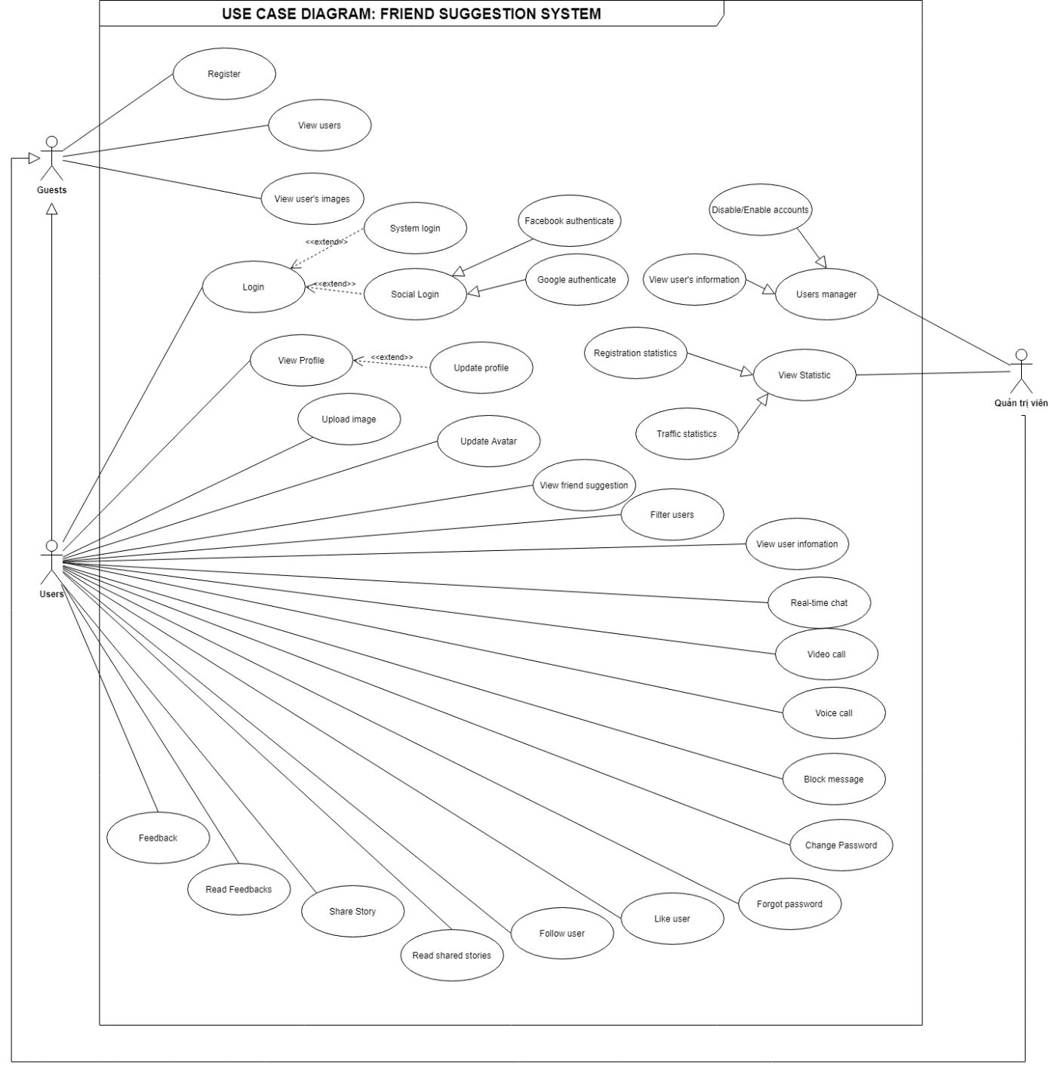

1. Use case diagram
2. The functions of system

|  |  |  |  |  |
| --- | --- | --- | --- | --- |
| Use case Id | Use cases | Guest | User logged in | Admin |
| UC_1 | View the list of the most liked people | X | X | X |
| UC_2 | View the list of newcomers | X | X | X |
| UC_3 | Sign up to receive information via email | X | X | X |
| UC_4 | Register an account | X |  |  |
| UC_5 | Login with system account |  | X | X |
| UC_6 | Login with Facebook account |  |  |  |
| UC_7 | Password retrieval |  | X | X |
| UC_8 | Change password |  | X | X |
| UC_9 | View user's photo | X | X | X |
| UC_10 | View personal information |  | X | X |
| UC_11 | Update personal information |  | X | X |
| UC_12 | View friends information |  | X | X |
| UC_13 | Post images |  | X | X |
| UC_14 | Update profile image |  | X | X |
| UC_15 | View friend suggestions |  | X | X |
| UC_16 | Filter/search users | X | X | X |
| UC_17 | Real-time messaging |  | X | X |
| UC_18 | Real-time Video Call |  |  |  |
| UC_19 | Block messaging |  | X | X |
| UC_20 | Favorite users |  | X | X |
| UC_21 | Follow users |  | X | X |
| UC_22 | User management |  |  | X |
| UC_23 | Lock/Unlock Account |  |  | X |
| UC_24 | View statistics |  |  | X |

### Use case description

#### Website platform

##### Post images

1. <Website> Post images

|  |  |  |  |
| --- | --- | --- | --- |
| USE CASE – 1 | | | |
| Use Case No. | UC_1 | Use Case Version | 1.0 |
| Use Case Name | Post images | | |
| Author | Lê Quốc Nguyên Vương | | |
| Date | 11/12/2020 | Priority | High |
| **Actor:**   * User logged in.   **Summary:**   * Allows users to add personal photos.   **Goal:**   * Users can add photos.   **Preconditions:**   * User must log in to the system.   **Post conditions:**   * Success: the user can add photos to the list of photos.   **Main Success Scenario:**   |  |  |  | | --- | --- | --- | | **Step** | **Actor Action** | **System Response** | | 1 | Users click on the User Icon in the right corner of the screen. | Redirect to the user's profile page. | | 2 | Click "Add Image" button. | The system appears a dialog box to drop photos and use the message "Upload your pictures". | | 3 | User selects image (with png extension). | The system will add the image to the backend. |   **Alternative Scenario:**   |  |  |  | | --- | --- | --- | | **No** | **Actor Action** | **System Response** | | 1 | Users post photos with different extensions png and jpg. | The image will be corrupted in the photo list. |   **Relationship:**  **Business Rules:**   * User logged in. * Select the correct Icon on the right corner of the screen, then click post image. | | | |

##### Filter/search users

1. <Website> Filter/search users

|  |  |  |  |
| --- | --- | --- | --- |
| USE CASE – 2 | | | |
| Use Case No. | UC_2 | Use Case Version | 1.0 |
| Use Case Name | Filter/search users | | |
| Author | Nguyễn Thành Tâm | | |
| Date | 11/12/2020 | Priority | High |
| **Actor:**   * All users.   **Summary:**   * Allows users to find friends with desired characteristics such as education, age, gender, etc.   **Goal:**   * Filter out people with desired characteristics.   **Triggers:**N/A  **Preconditions:**N/A  **Post conditions:**   * Success: The list of filtered people appears. * Fail: Could not find the desired people.   **Main Success Scenario:**   |  |  |  | | --- | --- | --- | | **Step** | **Actor Action** | **System Response** | | 1 | Click on "Search on the Navigator bar". | Redirect to user filter page. | | 2 | Choose the characteristics of the desired people. | The tags that the user selects appear in the tag bar. | | 3 | Click “Filter user”. | The system loads and displays a list of users with matching characteristics. |   **Alternative Scenario:**  **Exceptions:**   |  |  |  | | --- | --- | --- | | **No** | **Actor Action** | **System Response** | | 1 | User selects “Filter users” (Not updated profile). | No people were found matching the request. |     **Relationship:**  **Business Rules:** | | | |

##### Detect image

1. <Website> Detect image

|  |  |  |  |
| --- | --- | --- | --- |
| USE CASE – 3 | | | |
| Use Case No. | UC_3 | Use Case Version | 1.0 |
| Use Case Name | Detect image | | |
| Author | Nguyễn Thành Tâm | | |
| Date | 05/07/2021 | Priority | High |
| **Actor:**   * All users.   **Summary:**   * When a user posts an image, the image will be evaluated, if it meets the conditions, it will be published.   **Goal:**   * Pictures are properly rated. Pictures are properly rated. Prevent bad images and allow non-bad images.   **Triggers:**N/A  **Preconditions:**N/A  **Post conditions:**   * Success: Image uploaded successfully. * Fail: Image blocked by detection service.   **Main Success Scenario:**   |  |  |  | | --- | --- | --- | | **Step** | **Actor Action** | **System Response** | | 1 | Upload an image | Load spinner.  Upload image to main server, then the image is evaluated by the detection service, then the rating will be returned, then the condition will be retrieved from the database, then compare the rating with the condition. |   **Alternative Scenario:**   |  |  |  | | --- | --- | --- | | **No** | **Actor Action** | **System Response** | | 1 |  | The image does not meet the conditions, report images for violation and under review. | | 2 |  | The image meet the conditions, successful upload notification. | | | | |

##### Real-time messaging

1. <Website> Real-time messaging

|  |  |  |  |
| --- | --- | --- | --- |
| USE CASE – 4 | | | |
| Use Case No. | UC_4 | Use Case Version | 1.0 |
| Use Case Name | Real-time messaging | | |
| Author | Nguyễn Thành Tâm | | |
| Date | 11/12/2020 | Priority | High |
| **Actor:**   * User logged in.   **Summary:**   * Allows users to message each other real-time.   **Goal:**   * Can chat real-time while both are online.   **Triggers:**N/A  **Preconditions:**N/A  **Post conditions:**   * Success: The message was sent successfully, and the receiver received the notification. * Fail: Report server error.   **Main Success Scenario:**   |  |  |  | | --- | --- | --- | | **Step** | **Actor Action** | **System Response** | | 1 | View a user's profile then tap the message button. | Pop up is displayed. | | 2 | Enter the text of the message. | The message content is displayed. | | 3 | Click the button “Send Message”. | Your message has been sent to “username”. |   **Alternative Scenario:**  **Exceptions:**   |  |  |  | | --- | --- | --- | | **No** | **Actor Action** | **System Response** | | 1 | Click the button “Send Message”  (Message blocked) | Message: “Cannot send message at this time”. |     **Relationship:**  **Business Rules:** | | | |

##### Real-time Voice/Video Call

1. <Website> Real-time Voice/Video Call

|  |  |  |  |
| --- | --- | --- | --- |
| USE CASE – 5 | | | |
| Use Case No. | UC_5 | Use Case Version | 1.0 |
| Use Case Name | Real-time Voice/Video call | | |
| Author | Trần Gia Hân | | |
| Date | 25/03/2021 | Priority | High |
| **Actor:**   * User logged in.   **Summary:**   * Allows users to call video with each other real-time.   **Goal:**   * Can call video real-time while both are online.   **Triggers:**N/A  **Preconditions:**N/A  **Post conditions:**   * Success: Users can talk to each other via video call * Fail: Report server error.   **Main Success Scenario:**   |  |  |  | | --- | --- | --- | | **Step** | **Actor Action** | **System Response** | | 1 | View a user's profile then tap the message button. | Pop up is displayed. | | 2 | Click the button with the icon “Phone”. | The system will connect the video call with the other user. And the other user will get a notification. |   **Alternative Scenario:**  **Exceptions:**   |  |  |  | | --- | --- | --- | | **No** | **Actor Action** | **System Response** | | 1 | Click the button with the icon “Phone”.  (Account is locked or not online). | Message: “Cannot send message at this time”. |   **Relationship:**  **Business Rules:** | | | |

##### Block Video Call

1. <Website> Block Video Call

|  |  |  |  |
| --- | --- | --- | --- |
| USE CASE – 6 | | | |
| Use Case No. | UC_6 | Use Case Version | 1.0 |
| Use Case Name | Block messaging | | |
| Author | Trần Gia Hân | | |
| Date | 25/03/2021 | Priority | High |
| **Actor:**   * User logged in.   **Summary:**   * Allows users to block video call from a person.   **Goal:**   * Unable to receive or send video call to the blocked person.   **Preconditions:**N/A  **Post conditions:**   * Success: User successfully blocked.   **Main Success Scenario:**   |  |  |  | | --- | --- | --- | | **Step** | **Actor Action** | **System Response** | | 1 | User enters the messaging page. | The list of messengers is displayed. | | 2 | Click on a message from the person he wants to block. | Messages between 2 people are displayed. | | 3 | Click the button in the upper right corner | Dropdown is displayed. | | 4 | Click “Block Video call”. | Message: “Video call blocked from <Username>” |   **Relationship:**  **Business Rules:**User logged in. | | | |

#### Mobile platform

##### View users with similar suggestions

1. <Mobile> View users with similar suggestions

|  |  |  |  |
| --- | --- | --- | --- |
| USE CASE – 7 | | | |
| Use Case No. | UC_7 | Use Case Version | 1.0 |
| Use Case Name | View users with similar suggestions | | |
| Author | Trần Gia Hân | | |
| Date | 25/03/2021 | Priority | High |
| **Actor:**   * User logged in.   **Summary:**   * Allow users to view users with similar suggestions in Home Screen.   **Goal:**   * User can view users with similar suggestions.   **Triggers:**N/A  **Preconditions:**   * User must log into the system.   **Post conditions:**   * Success: Can view users with similar suggestions. * Fail: Cannot view.   **Main Success Scenario:**   |  |  |  | | --- | --- | --- | | **Step** | **Actor Action** | **System Response** | | 1 | Access Home tab on the navbar. | Redirect to Home screen. | | 2 | Click the button “Similar suggestion”. | Similar users are displayed as cards, with avatars and basic information. Drag right to see other users. | | 3 | Press “Heart” icon to follow/favorite.  Press “Profile” icon to view profile information. | The system changes the white icon to red and vice versa. That user's favorites will increase or decrease.  Redirect to user’s Profile Screen. | | 4 | Click “Follow” button, “Favorite” button. | The system will change the state for these 2 buttons. | | 5 | Click “Block” icon. | Block popup is displayed. | | 6 | Click “Relationship” at upper right corner. | List of relationship is displayed. | | 7 | Choose a relationship or not. | The relationship is marked. | | 8 | Click on dropdowns about Information, Hobby, Search. | Information of each type will be displayed. |   **Alternative Scenario:**  **Exceptions:**   |  |  |  | | --- | --- | --- | | **No** | **Actor Action** | **System Response** | | 1 | There are too few similarities | The system cannot find similar users to display. |   **Relationship:**  **Business Rules:** User must log into the system. | | | |

##### View a list of users near the area

1. <Mobile> View a list of users near the area

|  |  |  |  |
| --- | --- | --- | --- |
| USE CASE – 8 | | | |
| Use Case No. | UC_8 | Use Case Version | 1.0 |
| Use Case Name | View a list of users near the area | | |
| Author | Trần Gia Hân | | |
| Date | 25/03/2021 | Priority | High |
| **Actor:**   * User logged in.   **Summary:**   * Allow users to view a list of users near the area in Home Screen.   **Goal:**   * User can view a list of users near the area   **Triggers:**N/A  **Preconditions:**   * User must login to the system.   **Post conditions:**   * Success: Can view a list of users near the area. * Fail: Cannot view.   **Main Success Scenario:**   |  |  |  | | --- | --- | --- | | **Step** | **Actor Action** | **System Response** | | 1 | Access Home tab on the navbar. | Redirect to Home screen. | | 2 | Click the button “Users near the area”. | Suggested setting popup is displayed. | | 3 | Press “Setting” button. | Redirect to Search location settings Screen. | | 4 | Edit search information. | Information is displayed on textboxes. | | 5 | Press “Cancel” button.  Press “Save” button. | The system will delete the information that the user has just entered on textboxes.  The system will save the information and display the nearby users. | | 6 | Press “Heart” icon to follow/favorite.  Press “Profile” icon to view profile information. | The system changes the white icon to red and vice versa. That user's favorites will increase or decrease.  Redirect to user’s Profile Screen. | | 7 | Click “Follow” button, “Favorite” button. | The system will change the state for these 2 buttons. | | 8 | Click “Block” icon. | Block popup is display. | | 9 | Click “Relationship” at upper right corner. | List of relationship is displayed. | | 10 | Choose a relationship or not. | The relationship is marked. | | 11 | Click on dropdowns about Information, Hobby, Search. | Information of each type will be displayed. |   **Alternative Scenario:**  **Exceptions:**   |  |  |  | | --- | --- | --- | | **No** | **Actor Action** | **System Response** | | 1 | There are too few similarities. | The system cannot find similar users to display. |   **Relationship:**  **Business Rules:** User must log into the system. | | | |

##### View list of friends

1. <Mobile> View list of friends

|  |  |  |  |
| --- | --- | --- | --- |
| USE CASE – 9 | | | |
| Use Case No. | UC_9 | Use Case Version | 1.0 |
| Use Case Name | View list of friends | | |
| Author | Trần Gia Hân | | |
| Date | 25/03/2021 | Priority | High |
| **Actor:**   * User logged in.   **Summary:**   * Allows users to view list of friends.   **Goal:**   * User can see the list of friends.   **Triggers:** N/A  **Preconditions:**   * User must log into the system.   **Post conditions:**   * Success: View the list of friends. * Fail: Server error message.   **Main Success Scenario:**   |  |  |  | | --- | --- | --- | | **Step** | **Actor Action** | **System Response** | | 1 | Access Friend tab on the navbar. | Redirect to List of friends Screen. | | 2 | Enter name of friend. | The corresponding friends will be displayed. | | 3 | Click “Profile” button. | Redirect to friend’s Profile Screen. | | 4 | Click “Photo” button. | Redirect to the screen that user can view the photo of their friend. |   **Alternative Scenario:**  **Exceptions:**   |  |  |  | | --- | --- | --- | | **No** | **Actor Action** | **System Response** | | 1 | User entered the correct friend’s name, but the server crashed. | Message: “Server error”. | | 2 | User entered the incorrect friend’s name. | Message: “Cannot found”. |   **Relationship:** N/A  **Business Rules:** User must log into the system. | | | |

##### View list of conversations

1. <Mobile> View list of conversations

|  |  |  |  |
| --- | --- | --- | --- |
| USE CASE – 10 | | | |
| Use Case No. | UC_10 | Use Case Version | 1.0 |
| Use Case Name | View list of conversations | | |
| Author | Trần Gia Hân | | |
| Date | 25/03/2021 | Priority | High |
| **Actor:**   * User logged in.   **Summary:**   * Allows users to view list of conversations.   **Goal:**   * User can view list of conversations.   **Triggers:** N/A  **Preconditions:**   * User must log into the system.   **Post conditions:**   * Success: View list of conversations. * Fail: Server error message.   **Main Success Scenario:**   |  |  |  | | --- | --- | --- | | **Step** | **Actor Action** | **System Response** | | 1 | Access Message tab on the navbar. | Redirect to List of conversations Screen. | | 2 | Enter name of friend. | The corresponding conversation with friends will be displayed. | | 3 | Click on the conversation. | Redirect to Message Screen. Messages between two users are displayed. | | 4 | Type any message, attach image or icon.  Click “Send” icon. | Message, image, icon is displayed.  Message is sent. |   **Alternative Scenario:**  **Exceptions:**   |  |  |  | | --- | --- | --- | | **No** | **Actor Action** | **System Response** | | 1 | User entered the correct friend’s name, but the server crashed. | Message: “Server error”. | | 2 | User entered the incorrect friend’s name. | Message: “Cannot found”. |   **Relationship:** N/A  **Business Rules:** User must log into the system. | | | |

##### View user profile

1. <Mobile> View user profile

|  |  |  |  |
| --- | --- | --- | --- |
| USE CASE – 11 | | | |
| Use Case No. | UC_11 | Use Case Version | 1.0 |
| Use Case Name | View user profile | | |
| Author | Trần Gia Hân | | |
| Date | 25/03/2021 | Priority | High |
| **Actor:**   * User logged in.   **Summary:**   * Allows users to view user profile.   **Goal:**   * User can view user profile.   **Triggers:** N/A  **Preconditions:**   * User must log into the system.   **Post conditions:**   * Success: View user profile. * Fail: Server error message.   **Main Success Scenario:**   |  |  |  | | --- | --- | --- | | **Step** | **Actor Action** | **System Response** | | 1 | Access Profile tab on the navbar. | Redirect to Profile Screen of user. | | 2 | Click “Profile” button. | Redirect to Personal Profile Screen. User can view and edit their information on this screen. | | 3 | Click “Setting” button. | Redirect to Setting Screen of system. User can change password, view list of users blocked, search location settings. | | 4 | Click “Add images” button. | The system appears a dialog box to drop photos and use the message "Upload your pictures". | | 5 | Click “Post” button. | The system will save the posted images and display on the screen. |   **Alternative Scenario:**  **Exceptions:**   |  |  |  | | --- | --- | --- | | **No** | **Actor Action** | **System Response** | | 1 | The server crashed. | Message: “Server error”. |   **Relationship:** N/A  **Business Rules:** User must log into the system. | | | |

## Sequence diagram

### Post and detect images



1. <Sequence diagram> - Post images

### Real-time messaging



1. <Sequence diagram> - Real-time messaging

### Video call and voice call



1. <Sequence diagram> - Real-time Video call

## Database design



1. Database diagram

## User interface design

### Website platform

#### Chat

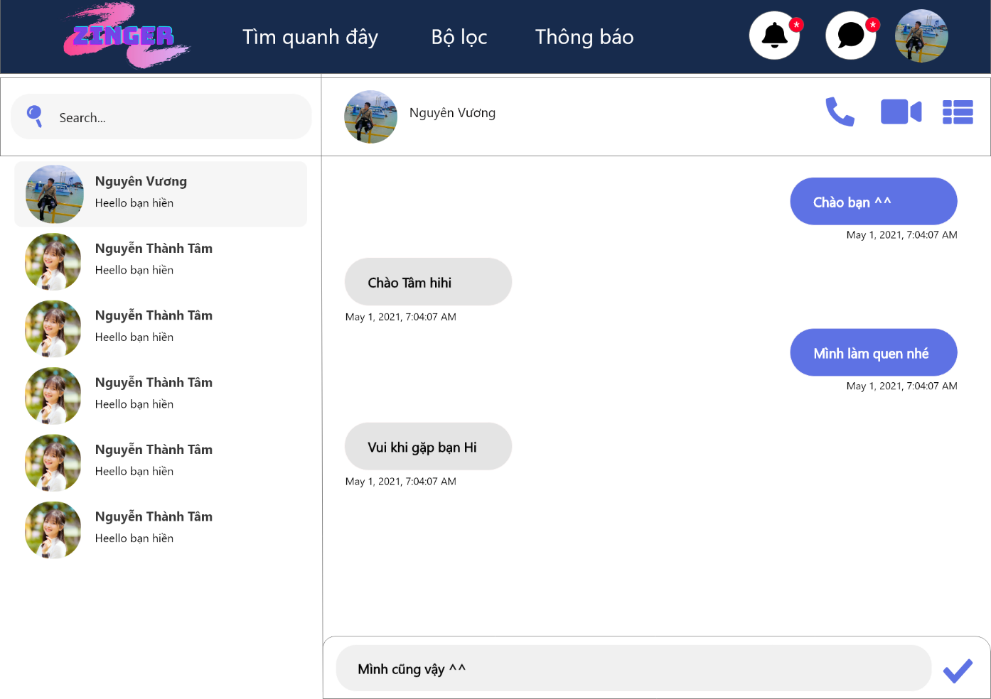

1. Chat Screen

#### Voice/Video call

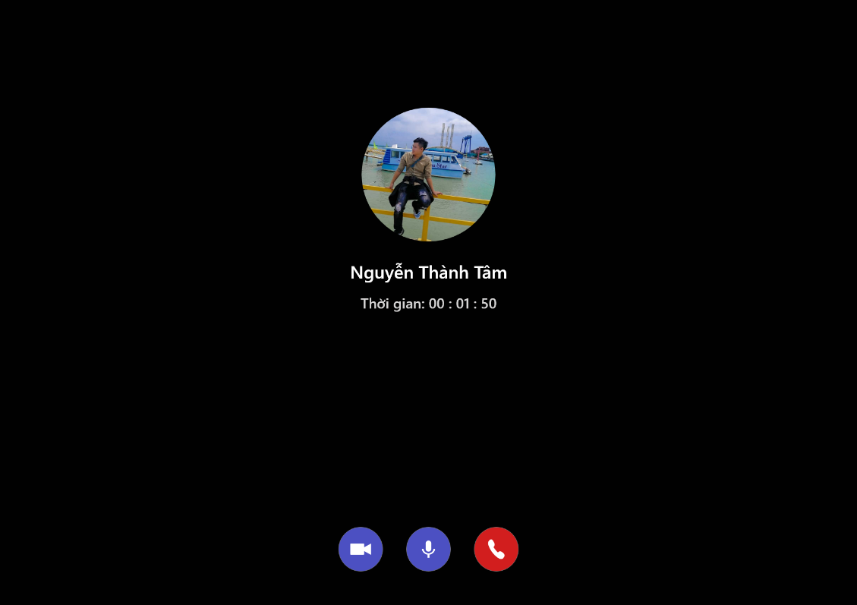

1. Voice call



1. Video call

#### Search friends

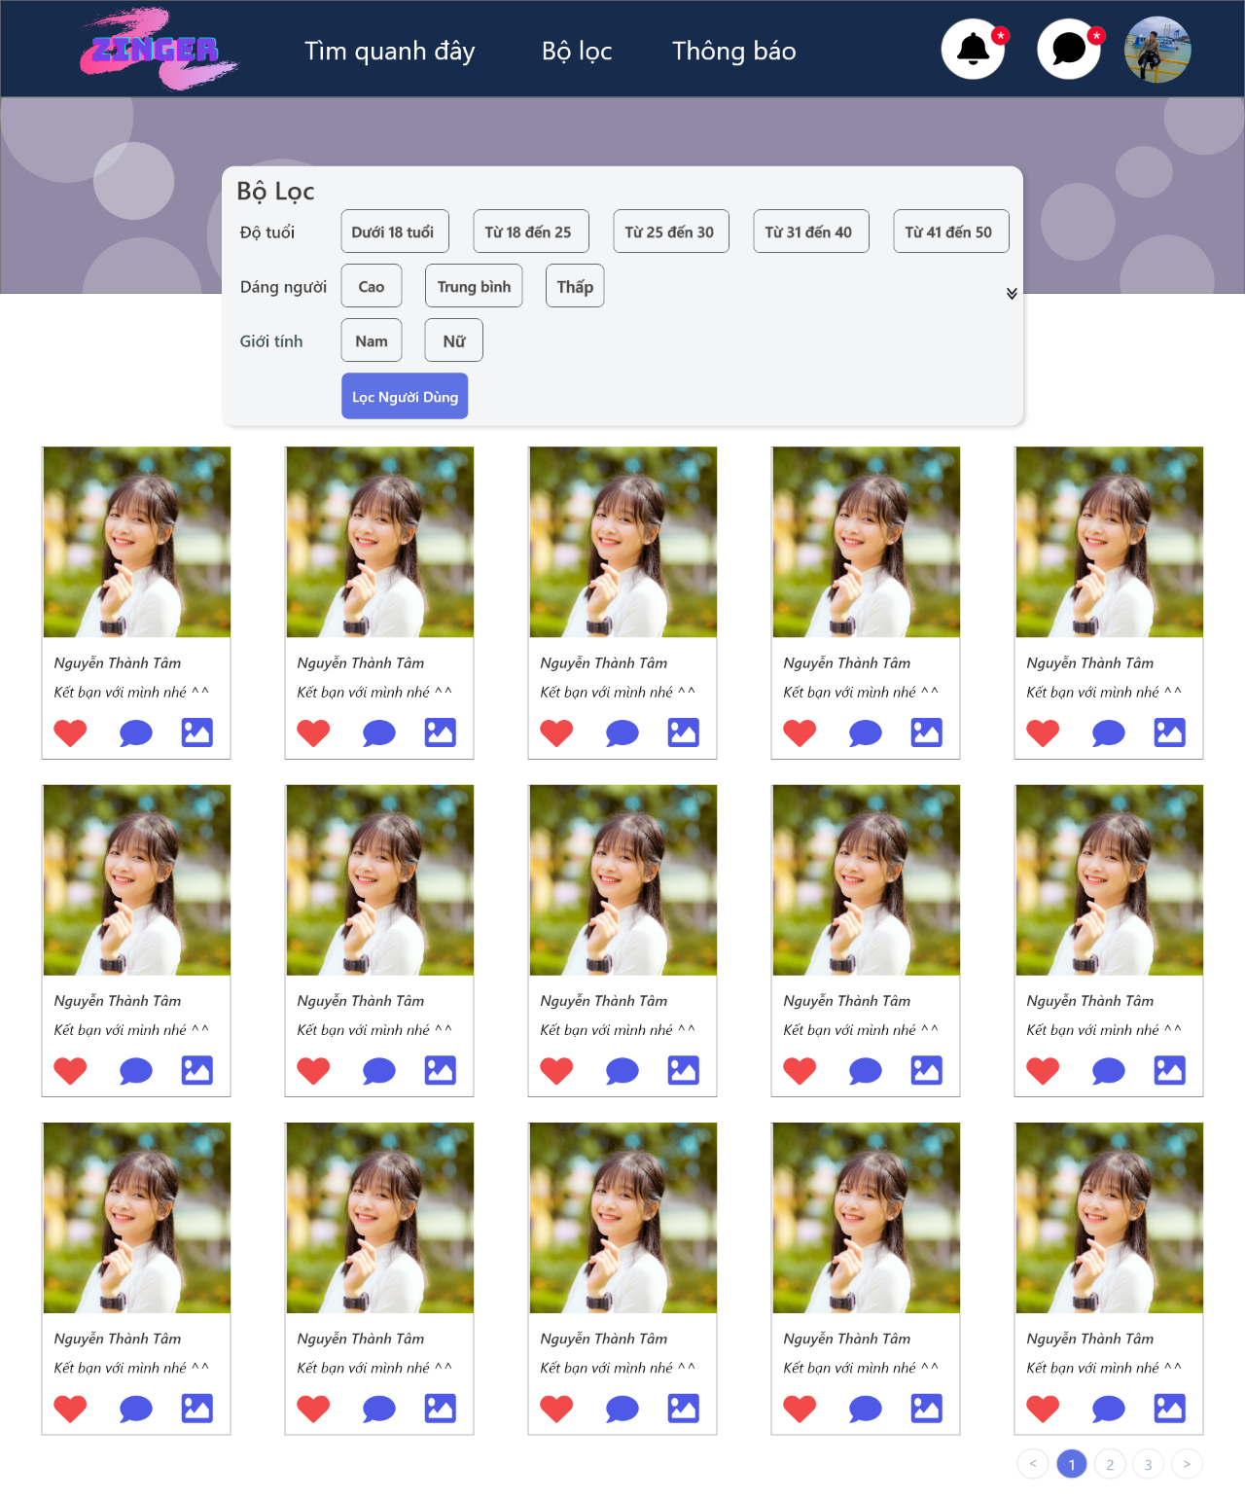

1. Search friends Screen

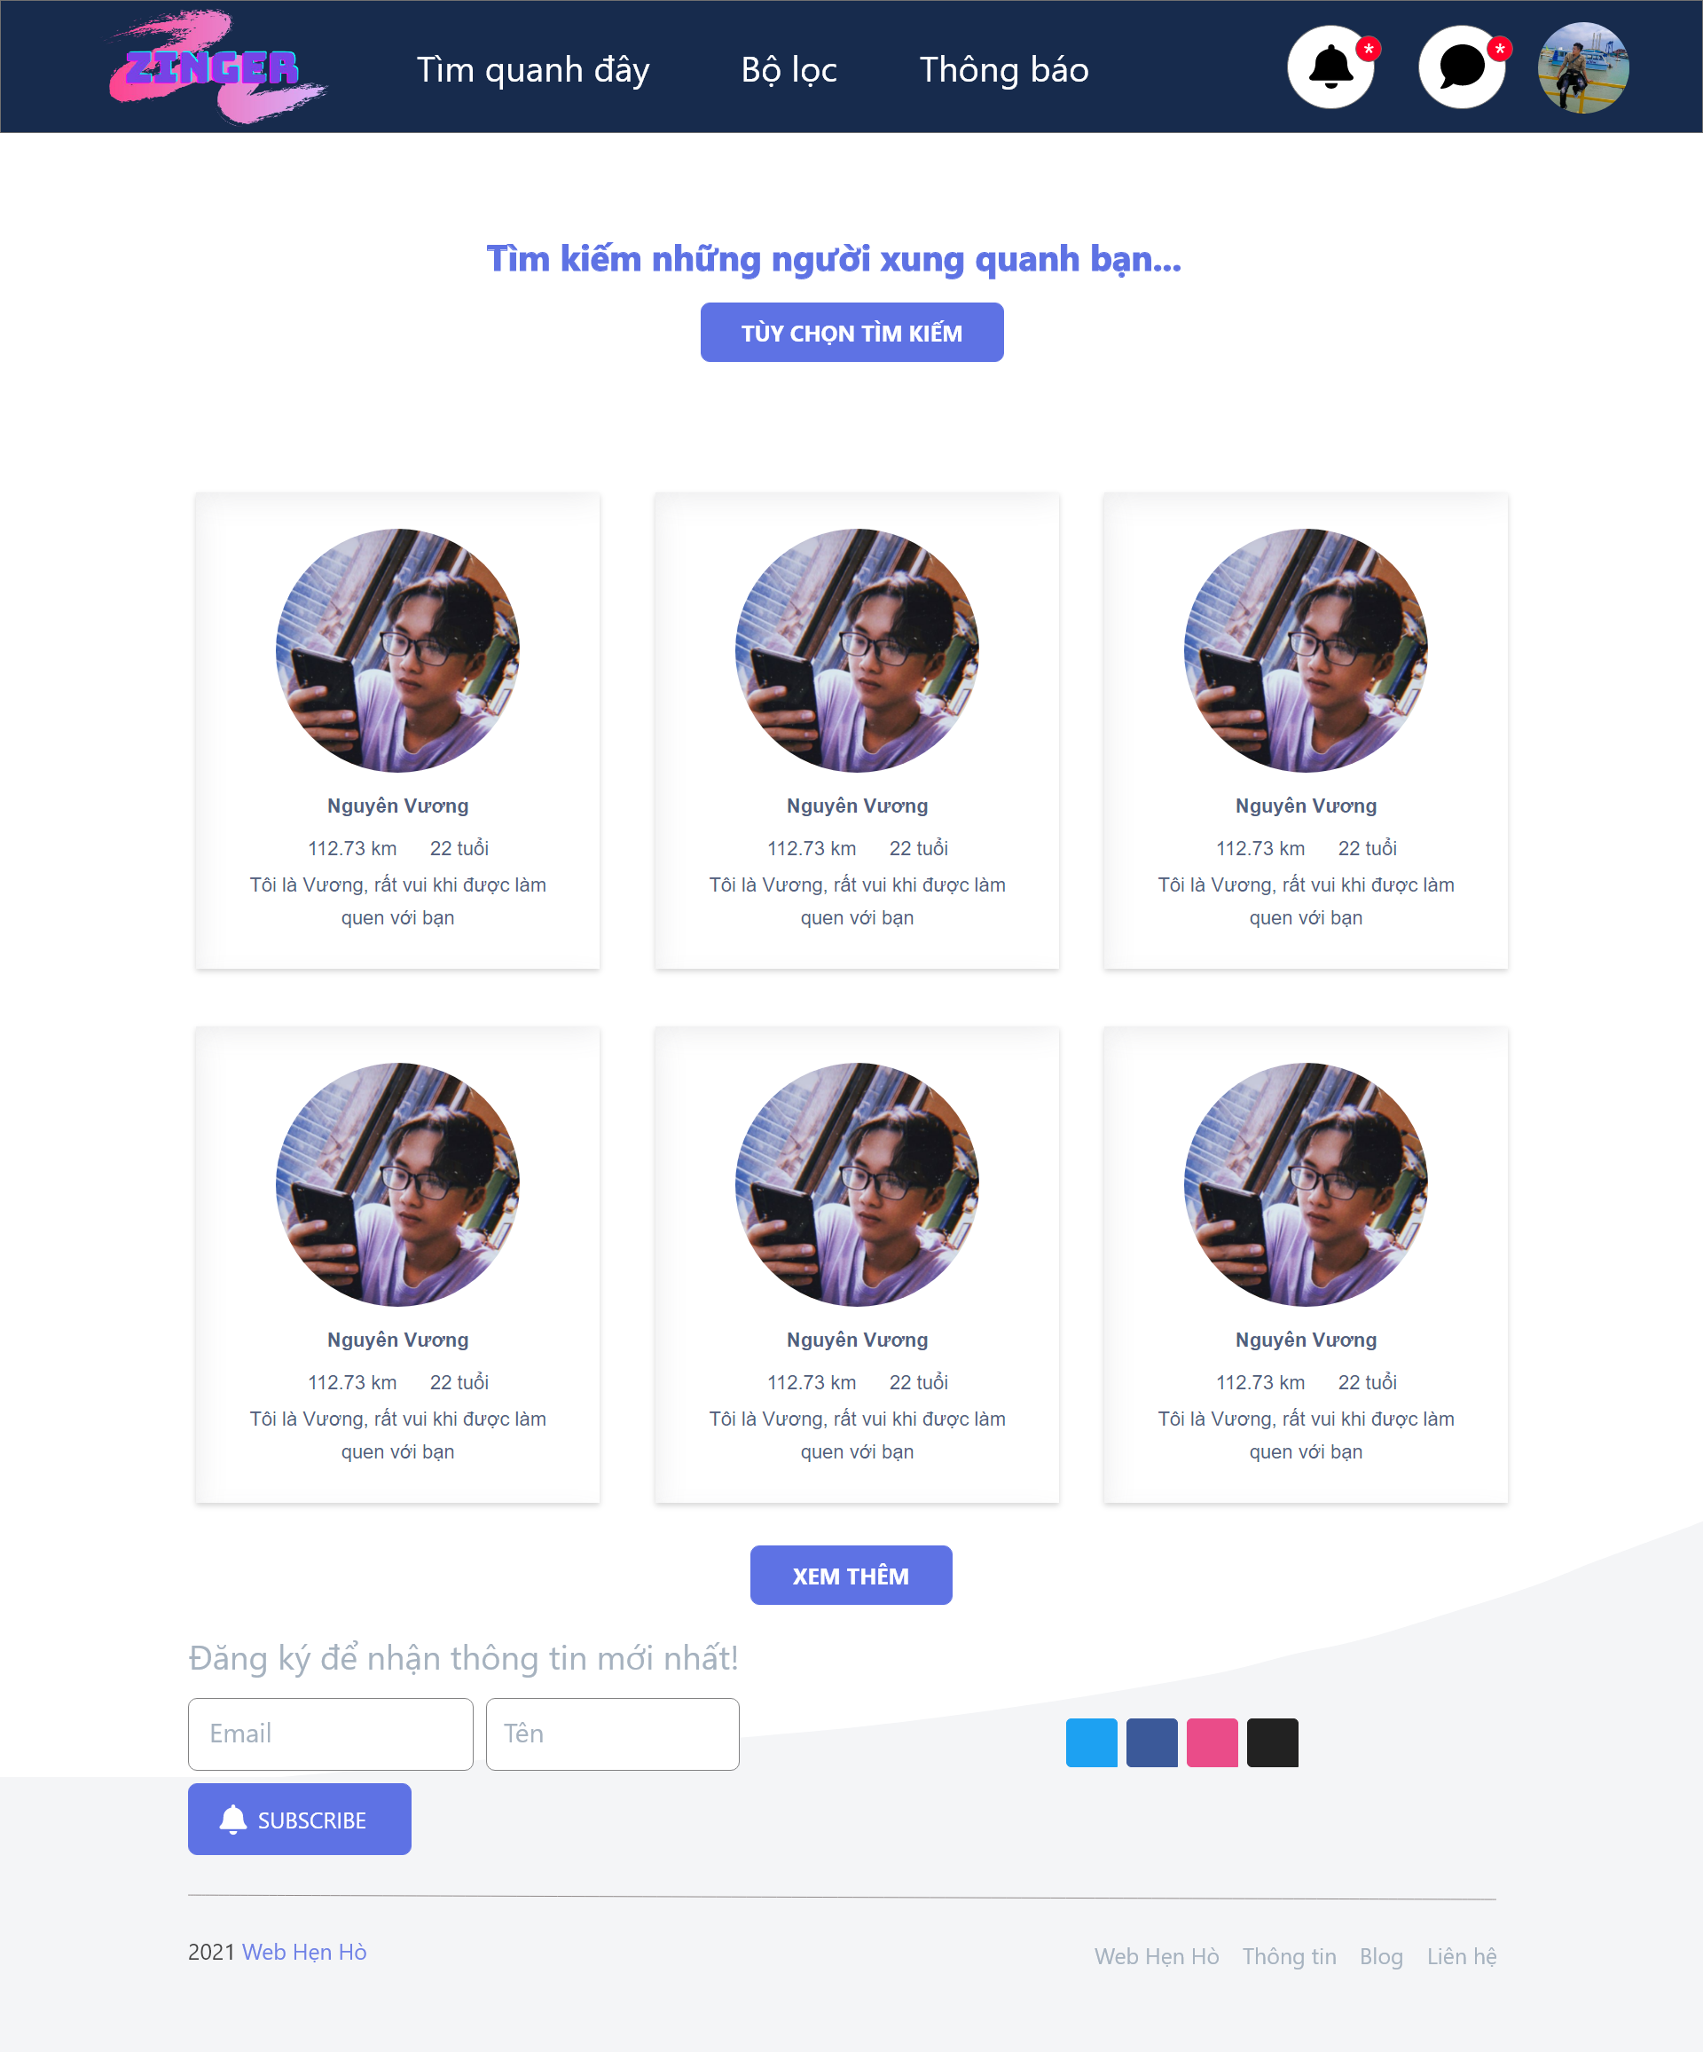

1. Result of search friends

#### Image filter configuration

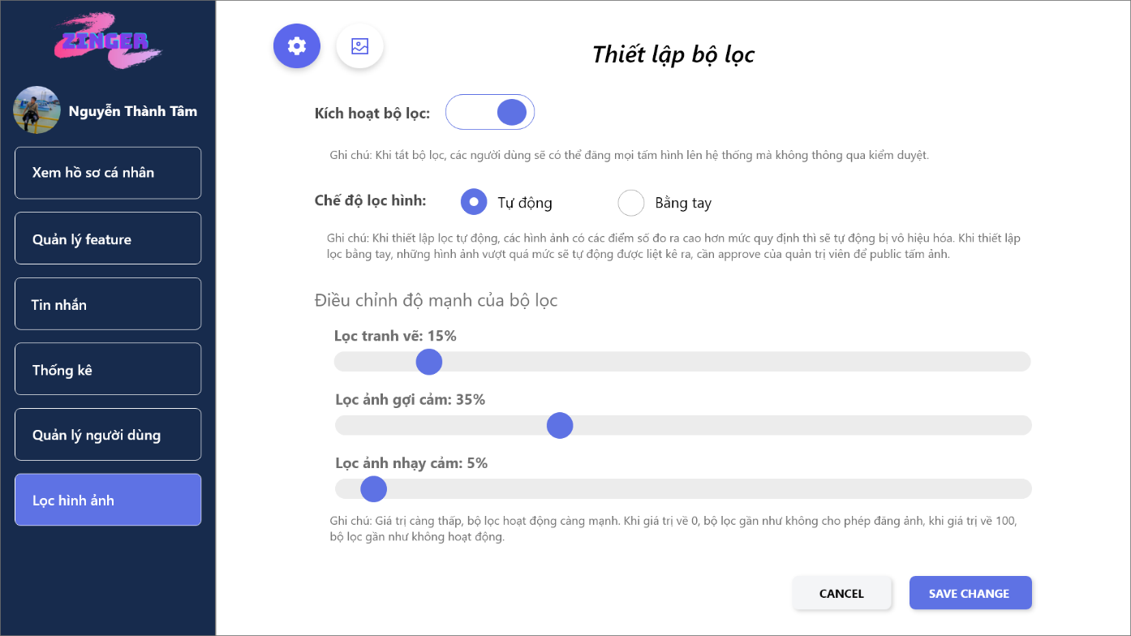

1. Images filter configuration

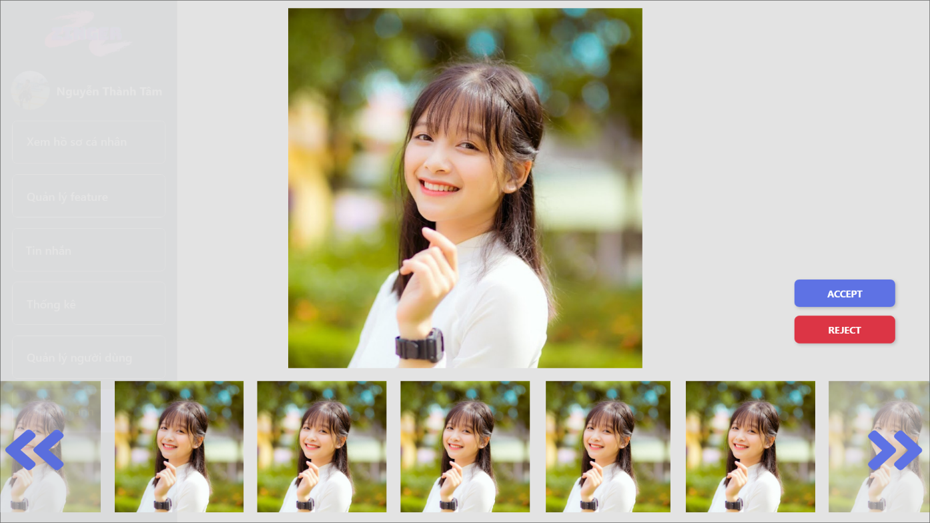

1. Approve the photos

### Mobile platform

#### Login Screen

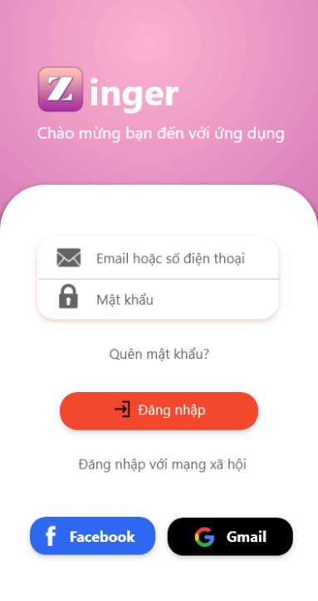

1. <Mobile> Login Screen

#### Zinger Screen (Home page)

|  |  |
| --- | --- |
|  |  |

1. <Mobile> Zinger Screen (Home page)

The HomePage screen will suggest similar objects to the user. In addition, if the user selects the mode to find objects by recent location, objects will be displayed according to the user's selected radius.

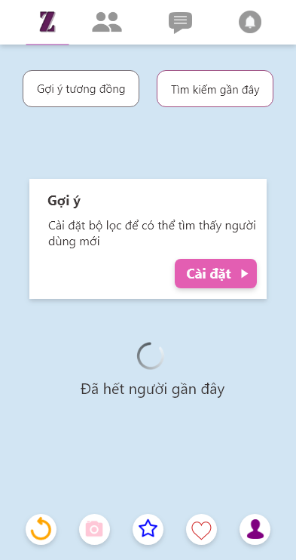

1. <Mobile> Filter setting Screen

#### Friends Screen

The screen shows a list of friends that the user has followed. User can view profile or image of tracked object.

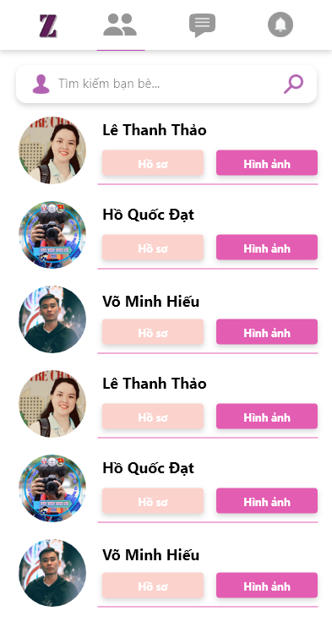

1. <Mobile> Friends Screen

#### Message Screen

This screen shows the list of friends who have messaged with the current user. Existing users can see the content of the latest message. If the user taps on a specific object, it will be taken to the messaging screen with that object.

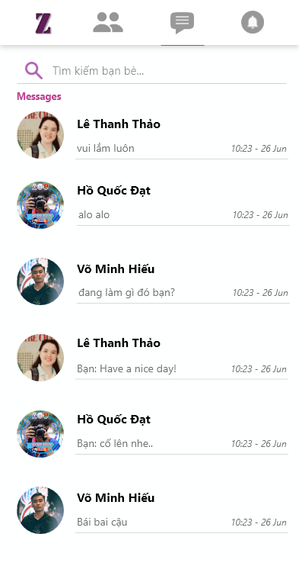

1. <Mobile> Message Screen

#### In Person Chat Screen

This screen shows the entire conversation between the user and the selected object. The user can message with the object in this screen.

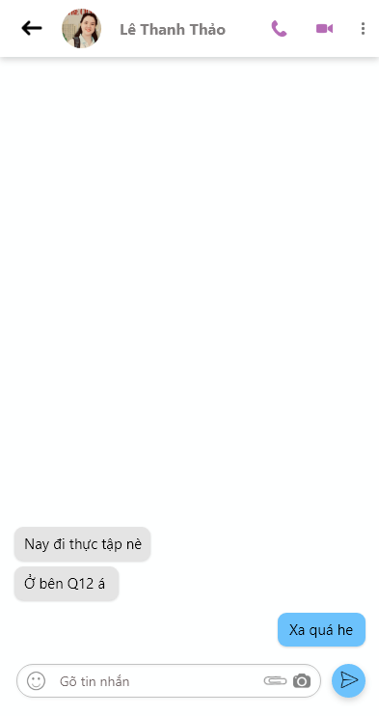

1. <Mobile> InPersonChat Screen

#### Notifications Screen

The screen shows the latest messages received from the object to the user.

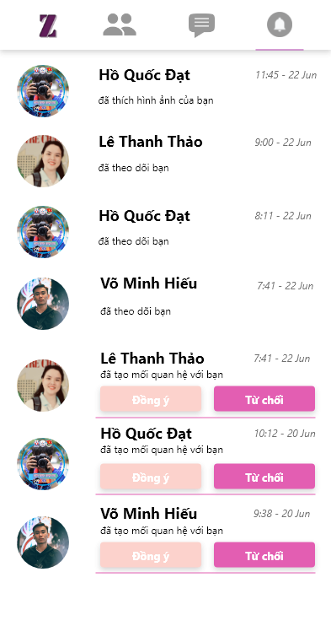

1. <Mobile> Notifications Screen

#### Profile Screen

The screen shows some current information of the account. User ability to add new images from the device side to post to the server. Users can view their detailed profile or go to other settings in the app.

|  |  |
| --- | --- |
|  |  |

1. <Mobile> Profile Screen

#### Profile Details Screen

|  |  |
| --- | --- |
|  |  |

1. <Mobile> ProfileDetails Screen

#### Setting Location Screen

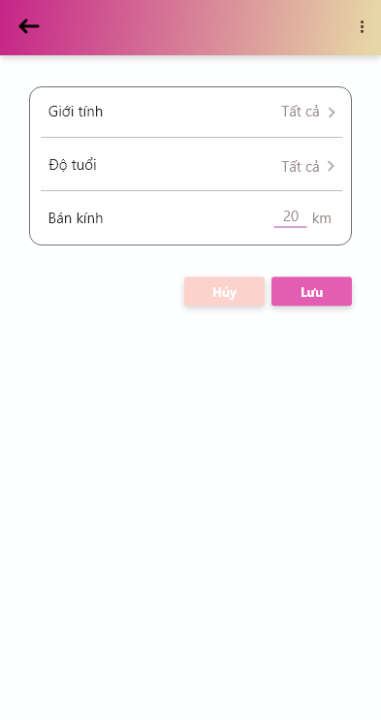

1. <Mobile> Setting Location Screen

#### Call Video Screen

|  |  |
| --- | --- |
|  |  |

1. Voice/Video calling Screen

Screen is calling with friends in two modes of video call and normal call.

# Chapter 4: INSTALL PRODUCT CODE

The website of the construction team will be a Single Page Application (SPA) website. Single Page Application is one of website develop trends. Although this concept has been around for more than a decade. Using SPA will be very efficient and save on bandwidth, as well as for a better user experience.

Specifically, the project will be divided into two separate parts, the back-end and the front-end.

* Back-end: an API service (using ASP.NET Core 3.x).
* Front-end:
* Website: using Angular 2 Framework.
* Mobile: using Flutter with Dart.

## Back-end

### 4.1.1 Onion Architecture

The Onion Architecture term was coined by Jeffrey Palermo in 2008. This architecture provides a better way to build applications for better testability, maintainability, and dependability on the infrastructures like databases and services. This architecture's main aim is to address the challenges faced with 3-tier architecture or n-tier architecture and to provide a solution for common problems, like coupling and separation of concerns.[6]

### 4.1.2 Architechture diagram

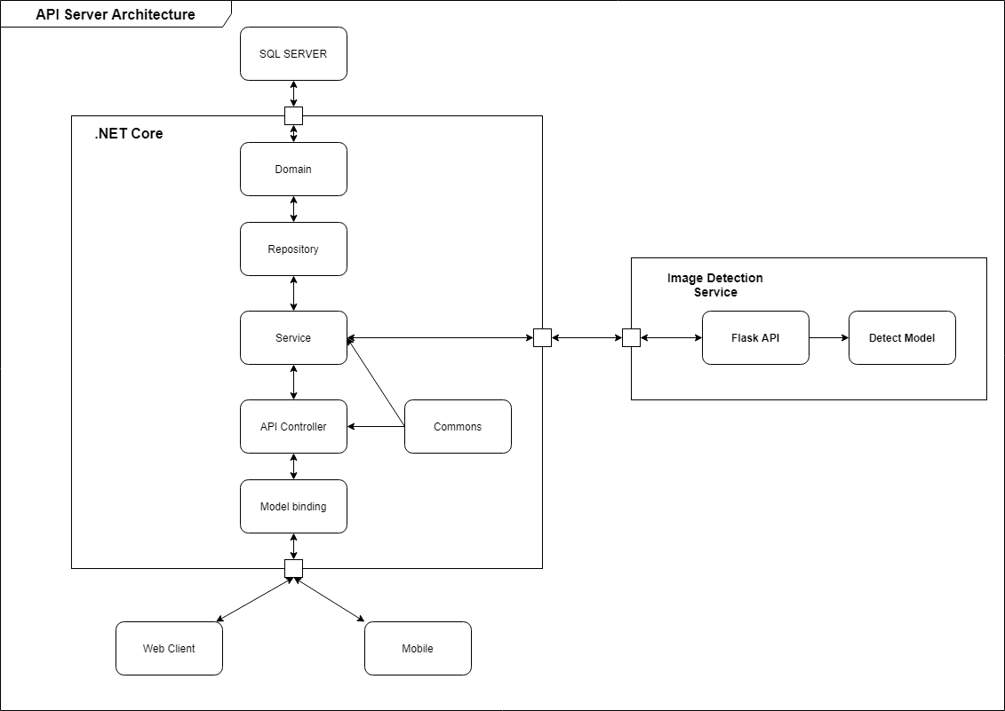

1. API Server Architecture diagram

### 4.1.3 Image detection service

With the advice of instructor, the images uploaded to the system need to be controlled to a certain extent, not allowing users to freely upload photos that violate social standards, fine customs. Therefore, the team has implemented a service to help detect and promptly prevent such behavior on the system.

After researching, the team collected data and performed training, but because of the characteristics of the data, it was "difficult" to find data and perform model validation. Therefore, the performance of the model is not high, and the team does not have the conditions and facilities to perform training by CNN with a large amount of data, so the team decided to use the model that has been trained and published on the Internet – Github.

#### 4.1.3.1 Detection model

- The model belongs to the classification group and is divided into 5 classes: 2 classes are safe (Drawings, Neutral), 1 class can be considered (Sexy), and 2 class are unsafe (Hentai, Porn).

* + Drawings: safe for work drawings – 15,566 samples.
  + Hentai: hentai and pornographic drawings – 4,611 samples.
  + Neutral: safe for work neutral images – 36873 samples.
  + Porn: pornographic images, sexual acts – 57,289 samples.
  + Sexy: sexually explicit images, not pornography – 15,957 samples.

- The dataset has a total of 130,296 JPG format images, with different sizes.

- Model’s input, output:

* + Input: Image, JPG, PNG, GIF format.
  + Output: Accuracy/classes, score is float number.

The data is trained using by CNN and Inception V3 network architecture - the famous CNN architecture developed by Google, which gives very high accuracy, safety and is more user-friendly.

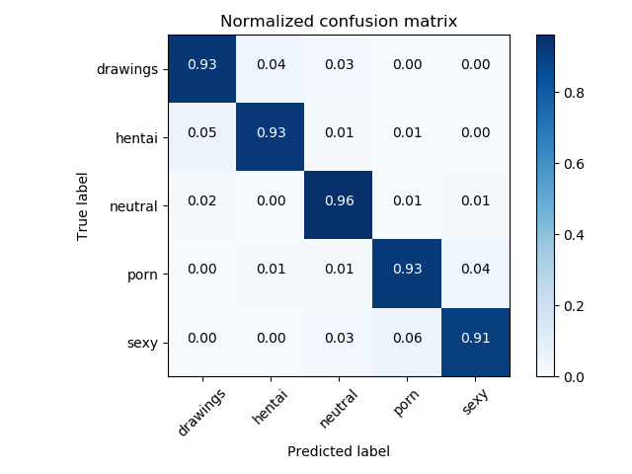

1. Confusion matrix

From the confusion matrix, we can see that the accuracy on each class is very high, over 93% and can meet the needs of the system.

#### 4.1.3.2 Flask API

Flask is a very lightweight Python Web Framework, the service only needs to perform a single task of making predictions and scores of images, so flask is a choice worth considering. After the user uploads the image, the image will be saved on the server, then the image will be sent to the Detect server and get the scores on each class, the scores will be compared with the administrator's config information, if the score is enough condition, that image will be published.

## Front-end

### Website platform

#### 4.2.1.1 Angular architecture

1. Angular Architecture

### Mobile platform

#### General architecture of mobile

The team using Flutter with Dart to build the front-end for mobile application. The following is a general description of the Flutter architecture for building application.

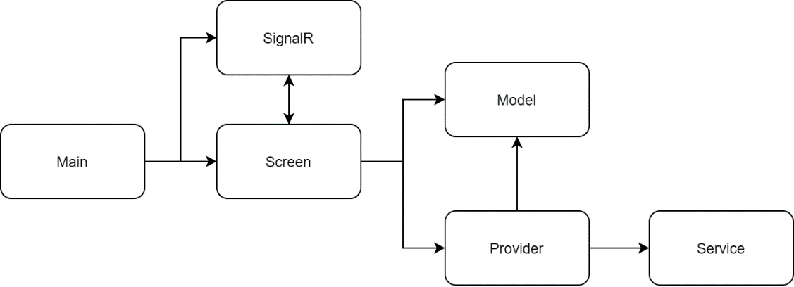

1. General architecture of mobile

#### Overview of mobile structure

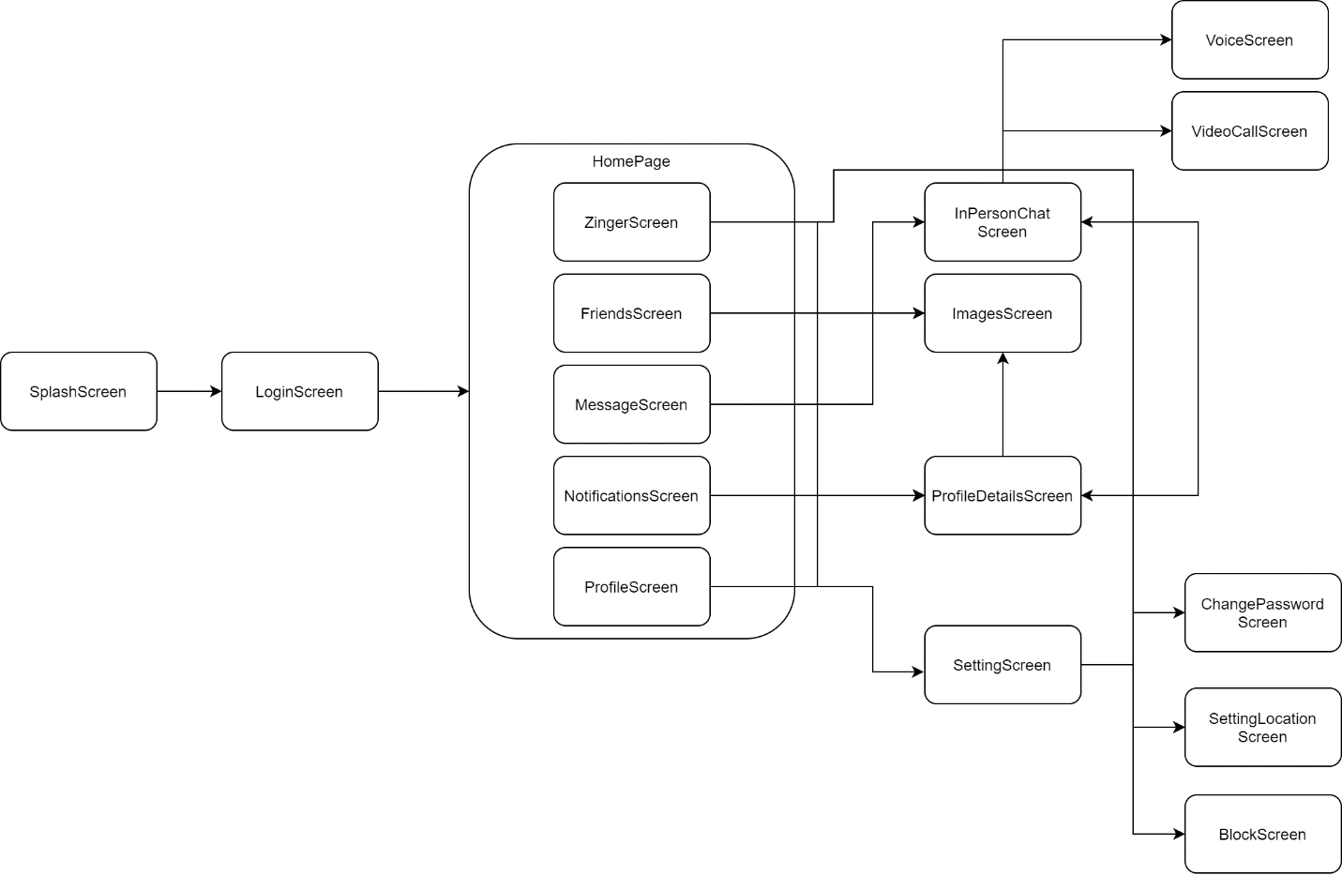

1. Overview of mobile structure

##### ZingerScreen

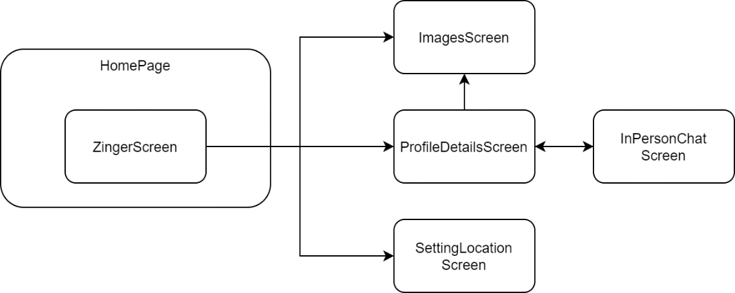

1. ZingerScreen

When the user is active on the ZingerScreen screen, user can activate functions to jump to the screens such as:

- View the details of another user, then the user will be redirected to the ProfileDetailsScreen screen.

- View another user's image, then the user will be redirected to the ImagesScreen screen to be able to see the entire image of the selected user.

- When the user uses the recent friend search function in the application, but the number of objects that can be found is exhausted. The system will suggest to the user to adjust the search attribute. Once the user accepts it will be redirected to the SettingLocationScreen screen and start updating the settings again.

##### FriendsScreen

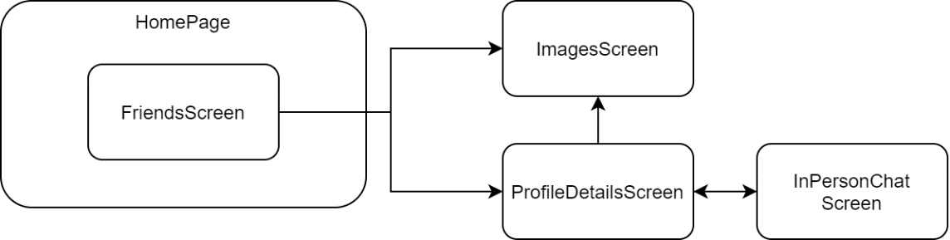

1. FriendsScreen

When the user is active on the FriendsScreen screen, user can see a list of other users that they are following in the application.

##### MessageScreen

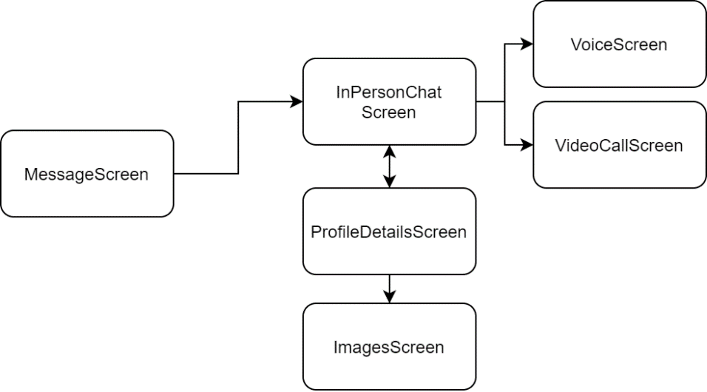

1. MessgaeScreen

When the user is active at the MessageScreen screen, the user can see a list of users who have sent messages. When clicking on a specific user, the user will be redirected to the InPersonChatScreen screen where they can start chatting with that person.

##### NotificationsScreen

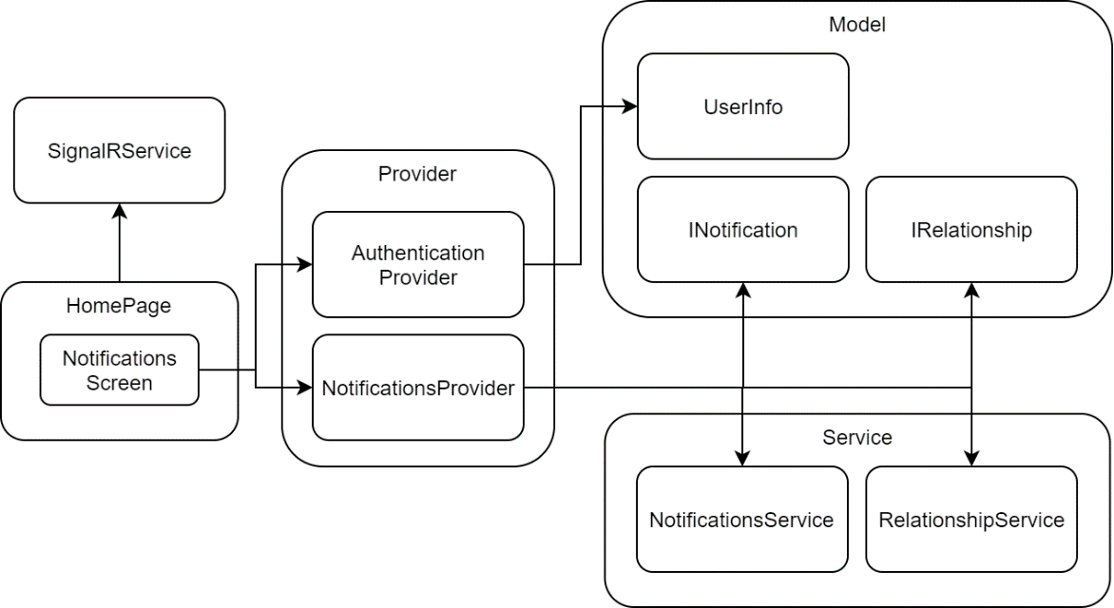

1. NotificationsScreen

The NotificationsScreen screen is a place for users to see notifications from other users that affect the user such as liking, following, liking pictures or creating relationships with other users. Therefore, NotificationsScreen connects to the Notifications Provider to store and process the functionality at the NotificationsScreen screen.

##### ProfileScreen

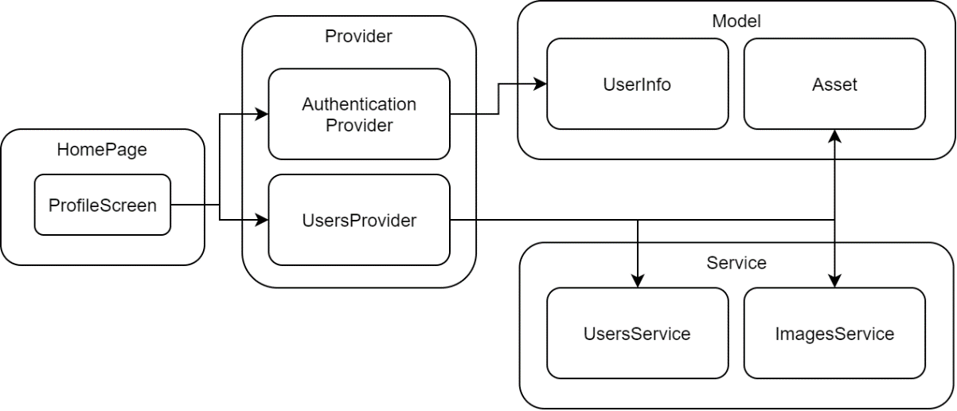

1. ProfileScreen

The ProfileScreen screen shows the user some basic information about the user themself. Provide functionality to users through the UsersProvider handler class. The user at the screen can post images from their device to the server side via the storage layer Asset and the connection layer, ImagesService.

##### AcceptCallScreen and VideoCallScreen

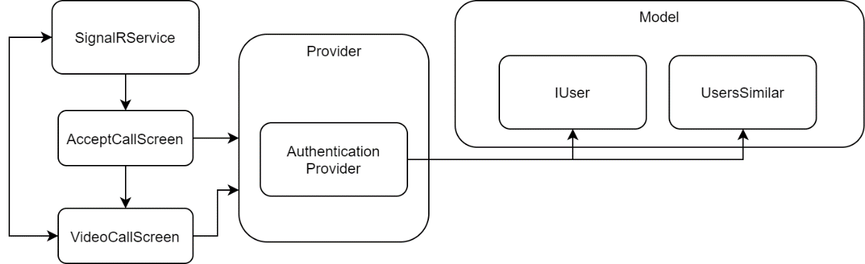

1. AcceptCallScreen and VideoCallScreen

When the user uses the calling function in the application, the information will be sent in real time at the SignalRService service, when receiving a notification that there is an incoming caller for the user, the application screen will forward to the AcceptCallScreen waiting screen.

If the user accepts the call, it will be forwarded to the VideoCallScreen screen. Information of the objects in the call will be stored in two object classes IUser and UserSimilar for easy access to get the necessary information.

While the users in VideoCallScreen screen, there will be communicate between frontend and backend to initiate call connection between two objects by using and receiving signal from SignalRService class. If the user is the one who starts the call, it will be directed to the VideoCallScreen screen and wait for the recipient to accept the call connection.

# 

# Chapter 5: COMPARATIVE RESULTS, EXPERIMENTS, ANALYSIS

## Comparative results

For both stages of project development: The Major Essay and the Graduation Dissertation. The team set out to build a Friend Suggestion System with the following basic functions:

* The application has ability to find friends based on similar features, such as interests, personality and age.
* The application has ability to real-time communicating, users can send real-time messages and video call to each other.
* Authenticate methods are required to ensure user information is kept confidential.

In the Major Essay phase, the team has completed some basic functions for the website:

* Login, register with confirmation by email.
* Completed the similarity calculation algorithm.
* Real-time messaging.
* User interaction: Like, follow, like photos.
* Management - updating profiles.
* Sign up for newsletter via MailChimp.
* Statistics - user management.

At the end of the development phase for the project, the team has completed a number of functions as follows:

* The team has successfully developed an application for making friends suggestions, which functions as a social network: Users were able to search and make friends through the website, especially using the system by mobile devices.
* User interfaces are improved for eye-catching and ease-to-use.
* Installed an SSL certificate that we can use third-party integrations that require a trusted connection.
* Used Deep Learning to detect the “bad” images which are not suitable for social networking and our application becomes healthier.
* Developed and integrated real-time notifications to users.
* Integrated Voice/Video call function.
* Developed on mobile platform with basic functions:
* Login with previously registered account (via website).
* View other users suggested based on compatibility, or search for the matching user within a certain range.
* View friends list, friends' profile information.
* View message list, send real-time messaging with any friends.
* Follow, favorite and create relationships with other users.
* View a list of notifications of user interactions.
* View user profile information.
* System function setting.
* Set the user search scope.
* Change password.
* View the list of blocked users, block or unblock user.

## Experiments

### Black-box testing

#### Website platform

##### Chat function

1. Chat function

|  |  |  |  |  |  |  |  |  |  |  |  |  |  |  |  |  |  |  |  |  |  |  |  |  |  |  |  |  |  |  |  |  |  |  |  |  |  |  |  |  |  |  |  |  |  |  |  |  |  |  |  |  |  |  |  |  |  |  |  |  |  |  |  |  |  |  |  |  |  |  |  |  |  |  |  |  |  |  |  |  |  |  |  |  |  |  |  |  |  |  |  |  |  |  |  |  |  |  |  |  |  |  |  |  |  |  |  |  |  |  |  |  |  |  |  |  |  |  |  |  |  |  |  |  |  |  |  |  |  |  |  |  |  |  |  |  |  |  |  |  |  |  |  |  |  |  |  |  |  |  |  |  |  |  |  |  |  |  |  |  |  |  |  |  |  |  |  |  |  |  |  |  |  |  |  |  |  |  |  |  |  |  |  |  |  |  |  |  |  |  |  |  |  |  |  |  |  |  |  |  |  |  |  |  |  |  |  |  |  |  |  |  |  |  |  |  |  |  |  |  |  |  |  |  |  |  |  |  |  |  |  |  |  |  |  |  |  |  |  |  |
| --- | --- | --- | --- | --- | --- | --- | --- | --- | --- | --- | --- | --- | --- | --- | --- | --- | --- | --- | --- | --- | --- | --- | --- | --- | --- | --- | --- | --- | --- | --- | --- | --- | --- | --- | --- | --- | --- | --- | --- | --- | --- | --- | --- | --- | --- | --- | --- | --- | --- | --- | --- | --- | --- | --- | --- | --- | --- | --- | --- | --- | --- | --- | --- | --- | --- | --- | --- | --- | --- | --- | --- | --- | --- | --- | --- | --- | --- | --- | --- | --- | --- | --- | --- | --- | --- | --- | --- | --- | --- | --- | --- | --- | --- | --- | --- | --- | --- | --- | --- | --- | --- | --- | --- | --- | --- | --- | --- | --- | --- | --- | --- | --- | --- | --- | --- | --- | --- | --- | --- | --- | --- | --- | --- | --- | --- | --- | --- | --- | --- | --- | --- | --- | --- | --- | --- | --- | --- | --- | --- | --- | --- | --- | --- | --- | --- | --- | --- | --- | --- | --- | --- | --- | --- | --- | --- | --- | --- | --- | --- | --- | --- | --- | --- | --- | --- | --- | --- | --- | --- | --- | --- | --- | --- | --- | --- | --- | --- | --- | --- | --- | --- | --- | --- | --- | --- | --- | --- | --- | --- | --- | --- | --- | --- | --- | --- | --- | --- | --- | --- | --- | --- | --- | --- | --- | --- | --- | --- | --- | --- | --- | --- | --- | --- | --- | --- | --- | --- | --- | --- | --- | --- | --- | --- | --- | --- | --- | --- | --- | --- | --- | --- | --- | --- | --- | --- | --- | --- | --- | --- | --- |
| |  |  |  |  |  |  |  |  |  |  |  |  |  | | --- | --- | --- | --- | --- | --- | --- | --- | --- | --- | --- | --- | --- | | **Test Case ID** | | ZW_1 | | | **Test Case Description** | | Test for chatting function | | | | | | | **Created By** | | TG_Han | | | **Reviewed By** | | LQN_Vuong | | **Version** | | 1.0 | | |  |  |  |  | | |  |  |  |  |  |  |  | | **QA Tester’s Log** | |  |  | | |  |  |  |  |  |  |  | |  |  |  |  | | |  |  |  |  |  |  |  | | **Tester's Name** | | TG_Han | | **Date Tested** | | | 06/07/2021 | | **Test Case (Pass/Fail/Not Executed)** | | Pass | | |  |  |  |  | | |  |  |  |  |  |  |  | | **S #** | **Prerequisites:** | | | | |  | **S #** | **Test Data** | | | | | | 1 | Access to Zinger website | | | | |  | 1 | Message = “Alo alo 1234” | | | | | | 2 | Login to the software successfully | | | | |  | 2 |  | | | | | | **Test Scenario** |  |  |  | | |  |  |  |  |  |  |  | |  |  |  |  | | |  |  |  |  |  |  |  | | **Step #** | **Step Details** | | **Expected Results** | | | | **Actual Results** | | | **Pass / Fail / Not executed / Suspended** | | | |  | | 1 | Redirect to Home page | | Home page is displayed. | | | | As expected | | | Pass | | |  | | 2 | Click on conversation icon at upper right corner. | | Chat Screen is displayed. List of conversations is also displayed. Displays the conversation with the user who messaged most recently. | | | | As expected | | | Pass | | |  | | 3 | Click on any username in the list on the left | | The conversation between the user and the other user is displayed. | | | | As expected | | | Pass | | |  | | 4 | Enter the message the user wants to send in the "Type a message" blank. | | The message is displayed on the textbox. | | | | As expected | | | Pass | | |  | | 5 | Press “Enter” button on keyboard | | The message is sent successfully to the other user and displayed on the conversation. | | | | As expected | | | Pass | | |  | |

##### Voice/Video call function

1. Voice/Video call function (1)

|  |  |  |  |  |  |  |  |  |  |  |  |  |  |  |  |  |  |  |  |  |  |  |  |  |  |  |  |  |  |  |  |  |  |  |  |  |  |  |  |  |  |  |  |  |  |  |  |  |  |  |  |  |  |  |  |  |  |  |  |  |  |  |  |  |  |  |  |  |  |  |  |  |  |  |  |  |  |  |  |  |  |  |  |  |  |  |  |  |  |  |  |  |  |  |  |  |  |  |  |  |  |  |  |  |  |  |  |  |  |  |  |  |  |  |  |  |  |  |  |  |  |  |  |  |  |  |  |  |  |  |  |  |  |  |  |  |  |  |  |  |  |  |  |  |  |  |  |  |  |  |  |  |  |  |  |  |  |  |  |  |  |  |  |  |  |  |  |  |  |  |  |  |  |  |  |  |  |  |  |  |  |  |  |  |  |  |  |  |  |  |  |  |  |  |  |  |  |  |  |  |  |  |  |  |  |  |  |  |  |  |  |  |  |  |  |  |  |  |  |  |  |  |  |  |  |  |  |  |  |  |  |  |  |
| --- | --- | --- | --- | --- | --- | --- | --- | --- | --- | --- | --- | --- | --- | --- | --- | --- | --- | --- | --- | --- | --- | --- | --- | --- | --- | --- | --- | --- | --- | --- | --- | --- | --- | --- | --- | --- | --- | --- | --- | --- | --- | --- | --- | --- | --- | --- | --- | --- | --- | --- | --- | --- | --- | --- | --- | --- | --- | --- | --- | --- | --- | --- | --- | --- | --- | --- | --- | --- | --- | --- | --- | --- | --- | --- | --- | --- | --- | --- | --- | --- | --- | --- | --- | --- | --- | --- | --- | --- | --- | --- | --- | --- | --- | --- | --- | --- | --- | --- | --- | --- | --- | --- | --- | --- | --- | --- | --- | --- | --- | --- | --- | --- | --- | --- | --- | --- | --- | --- | --- | --- | --- | --- | --- | --- | --- | --- | --- | --- | --- | --- | --- | --- | --- | --- | --- | --- | --- | --- | --- | --- | --- | --- | --- | --- | --- | --- | --- | --- | --- | --- | --- | --- | --- | --- | --- | --- | --- | --- | --- | --- | --- | --- | --- | --- | --- | --- | --- | --- | --- | --- | --- | --- | --- | --- | --- | --- | --- | --- | --- | --- | --- | --- | --- | --- | --- | --- | --- | --- | --- | --- | --- | --- | --- | --- | --- | --- | --- | --- | --- | --- | --- | --- | --- | --- | --- | --- | --- | --- | --- | --- | --- | --- | --- | --- | --- | --- | --- | --- | --- | --- | --- | --- | --- | --- | --- | --- | --- | --- | --- | --- | --- | --- | --- |
| |  |  |  |  |  |  |  |  |  |  |  |  |  | | --- | --- | --- | --- | --- | --- | --- | --- | --- | --- | --- | --- | --- | | **Test Case ID** | | ZW_2 | | | **Test Case Description** | | Test for Voice/Video call function (Call the other user) | | | | | | | **Created By** | | TG_Han | | | **Reviewed By** | | LQN_Vuong | | **Version** | | 1.0 | | |  |  |  |  | | |  |  |  |  |  |  |  | | **QA Tester’s Log** | |  |  | | |  |  |  |  |  |  |  | |  |  |  |  | | |  |  |  |  |  |  |  | | **Tester's Name** | | TG_Han | | **Date Tested** | | | 06/07/2021 | | **Test Case (Pass/Fail/Not Executed)** | | Pass | | |  |  |  |  | | |  |  |  |  |  |  |  | | |  |  | | --- | --- | | **S#** | **Prerequisites:** | | 1 | Access to Zinger website | | 2 | Login to the software successfully | | | | | | | | | | | | | | |  |  |  |  | | |  |  |  |  |  |  |  | | **Test Scenario** |  |  |  | | |  |  |  |  |  |  |  | |  |  |  |  | | |  |  |  |  |  |  |  | | **Step #** | **Step Details** | | **Expected Results** | | | | **Actual Results** | | | **Pass / Fail / Not executed / Suspended** | | | |  | | 1 | Redirect to Home page | | Home page is displayed. | | | | As expected | | | Pass | | |  | | 2 | Click on conversation icon at upper right corner. | | Chat Screen is displayed. List of conversations is also displayed. Displays the conversation with the user who messaged most recently. | | | | As expected | | | Pass | | |  | | 3 | Click on any username in the list on the left | | The conversation between the user and the other user is displayed. | | | | As expected | | | Pass | | |  | | 4 | Click on phone icon at upper right corner | | The system starts to connect and make voice call with the other party. | | | | As expected | | | Pass | | |  | | 5 | Click on camera icon at upper right corner | | The system starts to connect and make video call with the other party. | | | | As expected | | | Pass | | |  | |

1. Voice/Video call function (2)

|  |  |  |  |  |  |  |  |  |  |  |  |  |  |  |  |  |  |  |  |  |  |  |  |  |  |  |  |  |  |  |  |  |  |  |  |  |  |  |  |  |  |  |  |  |  |  |  |  |  |  |  |  |  |  |  |  |  |  |  |  |  |  |  |  |  |  |  |  |  |  |  |  |  |  |  |  |  |  |  |  |  |  |  |  |  |  |  |  |  |  |  |  |  |  |  |  |  |  |  |  |  |  |  |  |  |  |  |  |  |  |  |  |  |  |  |  |  |  |  |  |  |  |  |  |  |  |  |  |  |  |  |  |  |  |  |  |  |  |  |  |  |  |  |  |  |  |  |  |  |  |  |  |  |  |  |  |  |  |  |  |  |  |  |  |  |  |  |  |  |  |  |  |  |  |  |  |  |  |  |  |  |  |  |  |  |  |  |  |  |  |  |  |  |  |  |  |  |  |  |  |  |  |  |  |  |  |  |  |  |  |  |  |  |  |  |  |  |  |  |  |  |  |  |  |  |  |  |  |  |
| --- | --- | --- | --- | --- | --- | --- | --- | --- | --- | --- | --- | --- | --- | --- | --- | --- | --- | --- | --- | --- | --- | --- | --- | --- | --- | --- | --- | --- | --- | --- | --- | --- | --- | --- | --- | --- | --- | --- | --- | --- | --- | --- | --- | --- | --- | --- | --- | --- | --- | --- | --- | --- | --- | --- | --- | --- | --- | --- | --- | --- | --- | --- | --- | --- | --- | --- | --- | --- | --- | --- | --- | --- | --- | --- | --- | --- | --- | --- | --- | --- | --- | --- | --- | --- | --- | --- | --- | --- | --- | --- | --- | --- | --- | --- | --- | --- | --- | --- | --- | --- | --- | --- | --- | --- | --- | --- | --- | --- | --- | --- | --- | --- | --- | --- | --- | --- | --- | --- | --- | --- | --- | --- | --- | --- | --- | --- | --- | --- | --- | --- | --- | --- | --- | --- | --- | --- | --- | --- | --- | --- | --- | --- | --- | --- | --- | --- | --- | --- | --- | --- | --- | --- | --- | --- | --- | --- | --- | --- | --- | --- | --- | --- | --- | --- | --- | --- | --- | --- | --- | --- | --- | --- | --- | --- | --- | --- | --- | --- | --- | --- | --- | --- | --- | --- | --- | --- | --- | --- | --- | --- | --- | --- | --- | --- | --- | --- | --- | --- | --- | --- | --- | --- | --- | --- | --- | --- | --- | --- | --- | --- | --- | --- | --- | --- | --- | --- | --- | --- | --- | --- | --- | --- | --- | --- | --- | --- | --- | --- | --- |
| |  |  |  |  |  |  |  |  |  |  |  |  |  | | --- | --- | --- | --- | --- | --- | --- | --- | --- | --- | --- | --- | --- | | **Test Case ID** | | ZW_3 | | | **Test Case Description** | | Test for Voice/Video call function (Receive the call from other user) | | | | | | | **Created By** | | TG_Han | | | **Reviewed By** | | LQN_Vuong | | **Version** | | 1.0 | | |  |  |  |  | | |  |  |  |  |  |  |  | | **QA Tester’s Log** | |  |  | | |  |  |  |  |  |  |  | |  |  |  |  | | |  |  |  |  |  |  |  | | **Tester's Name** | | TG_Han | | **Date Tested** | | | 06/07/2021 | | **Test Case (Pass/Fail/Not Executed)** | | Pass | | |  |  |  |  | | |  |  |  |  |  |  |  | | **S #** | **Prerequisites:** | | | | |  | | 1 | Access to Zinger website | | | | |  | | 2 | Login to the software successfully | | | | |  | |  |  |  |  | | |  | | **Test Scenario** |  |  |  | | |  |  |  |  |  |  |  | |  |  |  |  | | |  |  |  |  |  |  |  | | **Step #** | **Step Details** | | **Expected Results** | | | | **Actual Results** | | | **Pass / Fail / Not executed / Suspended** | | | |  | | 1 | Redirect to Home page | | Home page is displayed. | | | | As expected | | | Pass | | |  | | 2 | At any page on the website, when receiving a notification of a voice/video call from another user | | The message is displayed on the screen. | | | | As expected | | | Pass | | |  | | 3 | Click on “Chấp nhận” button | | The call is connected between two users. | | | | As expected | | | Pass | | |  | | 4 | Click on “Từ chối” button | | The call is not be made and disconnected. | | | | As expected | | | Pass | | |  | | 5 | Click on red phone button | | The call is stopped. | | | | As expected | | | Pass | | |  | |

##### Post image on newsfeed function

1. Post image on newsfeed function

|  |  |  |  |  |  |  |  |  |  |  |  |  |  |  |  |  |  |  |  |  |  |  |  |  |  |  |  |  |  |  |  |  |  |  |  |  |  |  |  |  |  |  |  |  |  |  |  |  |  |  |  |  |  |  |  |  |  |  |  |  |  |  |  |  |  |  |  |  |  |  |  |  |  |  |  |  |  |  |  |  |  |  |  |  |  |  |  |  |  |  |  |  |  |  |  |  |  |  |  |  |  |  |  |  |  |  |  |  |  |  |  |  |  |  |  |  |  |  |  |  |  |  |  |  |  |  |  |  |  |  |  |  |  |  |  |  |  |  |  |  |  |  |  |  |  |  |  |  |  |  |  |  |  |  |  |  |  |  |  |  |  |  |  |  |  |  |  |  |  |  |  |  |  |  |  |  |  |  |  |  |  |  |  |  |  |  |  |  |  |  |  |  |  |  |  |  |  |  |  |  |  |  |  |  |  |  |  |  |  |  |  |  |  |  |  |  |  |  |  |  |  |  |  |  |  |  |  |  |  |  |  |  |  |  |  |  |  |  |  |  |  |  |  |  |  |  |  |  |  |  |  |  |  |  |  |  |  |  |  |  |  |  |  |  |  |  |  |  |  |  |  |  |  |  |  |  |  |  |  |  |  |  |  |  |  |  |  |  |  |  |  |  |  |  |
| --- | --- | --- | --- | --- | --- | --- | --- | --- | --- | --- | --- | --- | --- | --- | --- | --- | --- | --- | --- | --- | --- | --- | --- | --- | --- | --- | --- | --- | --- | --- | --- | --- | --- | --- | --- | --- | --- | --- | --- | --- | --- | --- | --- | --- | --- | --- | --- | --- | --- | --- | --- | --- | --- | --- | --- | --- | --- | --- | --- | --- | --- | --- | --- | --- | --- | --- | --- | --- | --- | --- | --- | --- | --- | --- | --- | --- | --- | --- | --- | --- | --- | --- | --- | --- | --- | --- | --- | --- | --- | --- | --- | --- | --- | --- | --- | --- | --- | --- | --- | --- | --- | --- | --- | --- | --- | --- | --- | --- | --- | --- | --- | --- | --- | --- | --- | --- | --- | --- | --- | --- | --- | --- | --- | --- | --- | --- | --- | --- | --- | --- | --- | --- | --- | --- | --- | --- | --- | --- | --- | --- | --- | --- | --- | --- | --- | --- | --- | --- | --- | --- | --- | --- | --- | --- | --- | --- | --- | --- | --- | --- | --- | --- | --- | --- | --- | --- | --- | --- | --- | --- | --- | --- | --- | --- | --- | --- | --- | --- | --- | --- | --- | --- | --- | --- | --- | --- | --- | --- | --- | --- | --- | --- | --- | --- | --- | --- | --- | --- | --- | --- | --- | --- | --- | --- | --- | --- | --- | --- | --- | --- | --- | --- | --- | --- | --- | --- | --- | --- | --- | --- | --- | --- | --- | --- | --- | --- | --- | --- | --- | --- | --- | --- | --- | --- | --- | --- | --- | --- | --- | --- | --- | --- | --- | --- | --- | --- | --- | --- | --- | --- | --- | --- | --- | --- | --- | --- | --- | --- | --- | --- | --- | --- | --- | --- | --- | --- | --- | --- | --- | --- | --- | --- | --- | --- | --- | --- | --- | --- | --- | --- | --- | --- | --- | --- | --- | --- | --- | --- | --- | --- | --- | --- | --- | --- |
| |  |  |  |  |  |  |  |  |  |  |  |  |  | | --- | --- | --- | --- | --- | --- | --- | --- | --- | --- | --- | --- | --- | | **Test Case ID** | | ZW_4 | | | **Test Case Description** | | Test for posting image on newsfeed function | | | | | | | **Created By** | | TG_Han | | | **Reviewed By** | | LQN_Vuong | | **Version** | | 1.0 | | |  |  |  |  | | |  |  |  |  |  |  |  | | **QA Tester’s Log** | |  |  | | |  |  |  |  |  |  |  | |  |  |  |  | | |  |  |  |  |  |  |  | | **Tester's Name** | | TG_Han | | **Date Tested** | | | 06/07/2021 | | **Test Case (Pass/Fail/Not Executed)** | | Pass | | |  |  |  |  | | |  |  |  |  |  |  |  | | **S #** | **Prerequisites:** | | | | |  | **S #** | **Test Data** | | | | | | 1 | Access to Zinger website | | | | |  | 1 | Image = “quansu.jpg” | | | | | | 2 | Login to the software successfully | | | | |  | 2 | Image = “mario.png” | | | | | |  |  | | | | |  | 3 | Image = “example.gif” | | | | | |  |  | | | | |  | 4 | Caption = “I’m Mario..” | | | | | |  |  |  |  | | |  |  |  |  |  |  |  | | | **Test Scenario** |  |  |  | | |  |  |  |  |  |  |  | |  |  |  |  | | |  |  |  |  |  |  |  | | **Step #** | **Step Details** | | **Expected Results** | | | | **Actual Results** | | | **Pass / Fail / Not executed / Suspended** | | | |  | | 1 | Redirect to Home page | | Home page is displayed. | | | | As expected | | | Pass | | |  | | 2 | Click on “Photo” icon | | The newsfeed screen is displayed. | | | | As expected | | | Pass | | |  | | 3 | Click on “Đăng hình ngay” button | | The image posting interface is displayed. | | | | As expected | | | Pass | | |  | | 4 | Drag and drop the image to the place to post or click on “Thêm hình ảnh” button | | The selected image is displayed where the image is posted. | | | | As expected | | | Pass | | |  | | 5 | Enter the caption into the textbox | | The caption is displayed on the textbox. | | | | As expected | | | Pass | | |  | | 6 | Click on “Cập nhật” button | | Post image successfully. | | | | Case 1: (quansu.jpg) – As expected  Case 2: (mario.png) - A message about browsing is displayed  Case 3: (example.gif) - A message about browsing is displayed | | | Case 1: Pass  Case 2: Fail  Case 3: Fail | | |  | |

##### Filter user function

1. Filter user function

|  |  |  |  |  |  |  |  |  |  |  |  |  |  |  |  |  |  |  |  |  |  |  |  |  |  |  |  |  |  |  |  |  |  |  |  |  |  |  |  |  |  |  |  |  |  |  |  |  |  |  |  |  |  |  |  |  |  |  |  |  |  |  |  |  |  |  |  |  |  |  |  |  |  |  |  |  |  |  |  |  |  |  |  |  |  |  |  |  |  |  |  |  |  |  |  |  |  |  |  |  |  |  |  |  |  |  |  |  |  |  |  |  |  |  |  |  |  |  |  |  |  |  |  |  |  |  |  |  |  |  |  |  |  |  |  |  |  |  |  |  |  |  |  |  |  |  |  |  |  |  |  |  |  |  |  |  |  |  |  |  |  |  |  |  |  |  |  |  |  |  |  |  |  |  |  |  |  |  |  |  |  |  |  |  |  |  |  |  |  |  |  |  |  |  |  |  |  |  |  |  |  |  |  |  |  |  |  |  |  |  |  |  |  |  |  |  |  |  |  |  |  |  |  |  |  |  |  |  |  |  |  |  |  |  |  |  |  |  |  |  |  |  |  |  |  |  |  |  |  |  |  |  |  |  |  |  |  |  |  |  |  |  |  |  |  |  |  |  |  |  |  |  |  |  |  |  |  |  |  |  |  |  |  |  |  |  |  |  |  |  |  |  |  |  |  |  |  |  |  |  |  |  |  |  |  |  |  |
| --- | --- | --- | --- | --- | --- | --- | --- | --- | --- | --- | --- | --- | --- | --- | --- | --- | --- | --- | --- | --- | --- | --- | --- | --- | --- | --- | --- | --- | --- | --- | --- | --- | --- | --- | --- | --- | --- | --- | --- | --- | --- | --- | --- | --- | --- | --- | --- | --- | --- | --- | --- | --- | --- | --- | --- | --- | --- | --- | --- | --- | --- | --- | --- | --- | --- | --- | --- | --- | --- | --- | --- | --- | --- | --- | --- | --- | --- | --- | --- | --- | --- | --- | --- | --- | --- | --- | --- | --- | --- | --- | --- | --- | --- | --- | --- | --- | --- | --- | --- | --- | --- | --- | --- | --- | --- | --- | --- | --- | --- | --- | --- | --- | --- | --- | --- | --- | --- | --- | --- | --- | --- | --- | --- | --- | --- | --- | --- | --- | --- | --- | --- | --- | --- | --- | --- | --- | --- | --- | --- | --- | --- | --- | --- | --- | --- | --- | --- | --- | --- | --- | --- | --- | --- | --- | --- | --- | --- | --- | --- | --- | --- | --- | --- | --- | --- | --- | --- | --- | --- | --- | --- | --- | --- | --- | --- | --- | --- | --- | --- | --- | --- | --- | --- | --- | --- | --- | --- | --- | --- | --- | --- | --- | --- | --- | --- | --- | --- | --- | --- | --- | --- | --- | --- | --- | --- | --- | --- | --- | --- | --- | --- | --- | --- | --- | --- | --- | --- | --- | --- | --- | --- | --- | --- | --- | --- | --- | --- | --- | --- | --- | --- | --- | --- | --- | --- | --- | --- | --- | --- | --- | --- | --- | --- | --- | --- | --- | --- | --- | --- | --- | --- | --- | --- | --- | --- | --- | --- | --- | --- | --- | --- | --- | --- | --- | --- | --- | --- | --- | --- | --- | --- | --- | --- | --- | --- | --- | --- | --- | --- | --- | --- | --- | --- | --- | --- | --- | --- | --- | --- | --- | --- | --- | --- | --- | --- | --- | --- | --- | --- | --- | --- | --- | --- | --- | --- | --- | --- |
| |  |  |  |  |  |  |  |  |  |  |  |  |  | | --- | --- | --- | --- | --- | --- | --- | --- | --- | --- | --- | --- | --- | | **Test Case ID** | | ZW_5 | | | **Test Case Description** | | Test for filtering user function | | | | | | | **Created By** | | TG_Han | | | **Reviewed By** | | LQN_Vuong | | **Version** | | 1.0 | | |  |  |  |  | | |  |  |  |  |  |  |  | | **QA Tester’s Log** | |  |  | | |  |  |  |  |  |  |  | |  |  |  |  | | |  |  |  |  |  |  |  | | **Tester's Name** | | TG_Han | | **Date Tested** | | | 06/07/2021 | | **Test Case (Pass/Fail/Not Executed)** | | Pass | | |  |  |  |  | | |  |  |  |  |  |  |  | | **S #** | **Prerequisites:** | | | | |  | **S #** | **Test Data** | | | | | | 1 | Access to Zinger website | | | | |  | 1 | Age = “Từ 18 đến 25” | | | | | | 2 | Login to the software successfully | | | | |  | 2 | Gender = “Nữ” | | | | | |  |  | | | | |  | 3 | Body shape = “Mảnh mai” | | | | | |  |  | | | | |  | 4 | Education = “Đại học” | | | | | |  |  |  |  | | |  |  |  | | | | | | **Test Scenario** |  |  |  | | |  |  |  |  |  |  |  | |  |  |  |  | | |  |  |  |  |  |  |  | | **Step #** | **Step Details** | | **Expected Results** | | | | **Actual Results** | | | **Pass / Fail / Not executed / Suspended** | | | |  | | 1 | Redirect to Home page | | Home page is displayed. | | | | As expected | | | Pass | | |  | | 2 | Click on “Bộ lọc” button on navbar | | The filter interface is displayed. | | | | As expected | | | Pass | | |  | | 3 | Click to select age: “Từ 18 đến 25” | | The range of age is selected. | | | | As expected | | | Pass | | |  | | 4 | Click to select gender: “Nữ” | | The gender is selected. | | | | As expected | | | Pass | | |  | | 5 | Click to select body shape: “Mảnh mai” | | The body shape is selected. | | | | As expected | | | Pass | | |  | | 6 | Click to select education: “Đại học” | | The education is selected | | | | As expected | | | Pass | | |  | | 7 | Click on “Lọc người dùng” button | | Eligible users are displayed on the screen | | | | As expected | | | Pass | | |  | |

##### Set up the image detect filter function

1. Set up the image detect filter function

|  |  |  |  |  |  |  |  |  |  |  |  |  |  |  |  |  |  |  |  |  |  |  |  |  |  |  |  |  |  |  |  |  |  |  |  |  |  |  |  |  |  |  |  |  |  |  |  |  |  |  |  |  |  |  |  |  |  |  |  |  |  |  |  |  |  |  |  |  |  |  |  |  |  |  |  |  |  |  |  |  |  |  |  |  |  |  |  |  |  |  |  |  |  |  |  |  |  |  |  |  |  |  |  |  |  |  |  |  |  |  |  |  |  |  |  |  |  |  |  |  |  |  |  |  |  |  |  |  |  |  |  |  |  |  |  |  |  |  |  |  |  |  |  |  |  |  |  |  |  |  |  |  |  |  |  |  |  |  |  |  |  |  |  |  |  |  |  |  |  |  |  |  |  |  |  |  |  |  |  |  |  |  |  |  |  |  |  |  |  |  |  |  |  |  |  |  |  |  |  |  |  |  |  |  |  |  |  |  |  |  |  |  |  |  |  |  |  |  |  |  |  |  |  |  |  |  |  |  |  |  |  |  |  |  |  |  |  |  |  |  |  |  |  |  |  |  |  |  |  |  |  |  |  |  |  |  |  |  |  |  |  |  |  |  |  |  |  |  |  |  |  |  |  |  |  |  |  |  |  |  |  |  |  |  |  |  |  |  |  |  |  |  |  |  |  |  |  |  |  |  |  |  |  |  |  |  |  |  |  |  |  |  |  |  |  |  |  |  |  |  |  |
| --- | --- | --- | --- | --- | --- | --- | --- | --- | --- | --- | --- | --- | --- | --- | --- | --- | --- | --- | --- | --- | --- | --- | --- | --- | --- | --- | --- | --- | --- | --- | --- | --- | --- | --- | --- | --- | --- | --- | --- | --- | --- | --- | --- | --- | --- | --- | --- | --- | --- | --- | --- | --- | --- | --- | --- | --- | --- | --- | --- | --- | --- | --- | --- | --- | --- | --- | --- | --- | --- | --- | --- | --- | --- | --- | --- | --- | --- | --- | --- | --- | --- | --- | --- | --- | --- | --- | --- | --- | --- | --- | --- | --- | --- | --- | --- | --- | --- | --- | --- | --- | --- | --- | --- | --- | --- | --- | --- | --- | --- | --- | --- | --- | --- | --- | --- | --- | --- | --- | --- | --- | --- | --- | --- | --- | --- | --- | --- | --- | --- | --- | --- | --- | --- | --- | --- | --- | --- | --- | --- | --- | --- | --- | --- | --- | --- | --- | --- | --- | --- | --- | --- | --- | --- | --- | --- | --- | --- | --- | --- | --- | --- | --- | --- | --- | --- | --- | --- | --- | --- | --- | --- | --- | --- | --- | --- | --- | --- | --- | --- | --- | --- | --- | --- | --- | --- | --- | --- | --- | --- | --- | --- | --- | --- | --- | --- | --- | --- | --- | --- | --- | --- | --- | --- | --- | --- | --- | --- | --- | --- | --- | --- | --- | --- | --- | --- | --- | --- | --- | --- | --- | --- | --- | --- | --- | --- | --- | --- | --- | --- | --- | --- | --- | --- | --- | --- | --- | --- | --- | --- | --- | --- | --- | --- | --- | --- | --- | --- | --- | --- | --- | --- | --- | --- | --- | --- | --- | --- | --- | --- | --- | --- | --- | --- | --- | --- | --- | --- | --- | --- | --- | --- | --- | --- | --- | --- | --- | --- | --- | --- | --- | --- | --- | --- | --- | --- | --- | --- | --- | --- | --- | --- | --- | --- | --- | --- | --- | --- | --- | --- | --- | --- | --- | --- | --- | --- | --- | --- | --- | --- | --- | --- | --- | --- | --- | --- | --- | --- | --- | --- | --- | --- |
| |  |  |  |  |  |  |  |  |  |  |  |  |  | | --- | --- | --- | --- | --- | --- | --- | --- | --- | --- | --- | --- | --- | | **Test Case ID** | | ZW_6 | | | **Test Case Description** | | Test for setting up the image detection filter function | | | | | | | **Created By** | | TG_Han | | | **Reviewed By** | | LQN_Vuong | | **Version** | | 1.0 | | |  |  |  |  | | |  |  |  |  |  |  |  | | **QA Tester’s Log** | |  |  | | |  |  |  |  |  |  |  | |  |  |  |  | | |  |  |  |  |  |  |  | | **Tester's Name** | | TG_Han | | **Date Tested** | | | 06/07/2021 | | **Test Case (Pass/Fail/Not Executed)** | | Pass | | |  |  |  |  | | |  |  |  |  |  |  |  | | **S #** | **Prerequisites:** | | | | |  | **S #** | **Test Data** | | | | | | 1 | Access to Zinger website | | | | |  | 1 | Image filtering method = “Tự động” | | | | | | 2 | Login to the software successfully | | | | |  | 2 | Gender = “Nữ” | | | | | |  |  | | | | |  | 3 | Body shape = “Mảnh mai” | | | | | |  |  | | | | |  | 4 | Education = “Đại học” | | | | | |  |  |  |  | | |  |  |  | | | | | | **Test Scenario** |  |  |  | | |  |  |  |  |  |  |  | |  |  |  |  | | |  |  |  |  |  |  |  | | **Step #** | **Step Details** | | **Expected Results** | | | | **Actual Results** | | | **Pass / Fail / Not executed / Suspended** | | | |  | | 1 | Redirect to Home page | | Home page is displayed. | | | | As expected | | | Pass | | |  | | 2 | Click on Avatar at upper right corner | | Other functions are displayed. | | | | As expected | | | Pass | | |  | | 3 | Click on “Quản lý người dùng” | | The user management interface is displayed. | | | | As expected | | | Pass | | |  | | 4 | Click on “Lọc hình ảnh” button | | The image filter interface is displayed. | | | | As expected | | | Pass | | |  | | 5 | Click to turn on the filter | | Filter is activated. | | | | As expected | | | Pass | | |  | | 6 | Click to select the method of filter: “Tự động” | | The method is selected. | | | | As expected | | | Pass | | |  | | 7 | Adjust the filter's strong/weak parameters | | The parameters is displayed on scroll bar. | | | | As expected | | | Pass | | |  | | 8 | Click on “Lưu” button | | Adjustments are saved. | | | | As expected | | | Pass | | |  | |

#### Mobile platform

##### Login function

1. <Mobile> - Login function

|  |  |  |  |  |  |  |  |  |  |  |  |  |  |  |  |  |  |  |  |  |  |  |  |  |  |  |  |  |  |  |  |  |  |  |  |  |  |  |  |  |  |  |  |  |  |  |  |  |  |  |  |  |  |  |  |  |  |  |  |  |  |  |  |  |  |  |  |  |  |  |  |  |  |  |  |  |  |  |  |  |  |  |  |  |  |  |  |  |  |  |  |  |  |  |  |  |  |  |  |  |  |  |  |  |  |  |  |  |  |  |  |  |  |  |  |  |  |  |  |  |  |  |  |  |  |  |  |  |  |  |  |  |  |  |  |  |  |  |  |  |  |  |  |  |  |  |  |  |  |  |  |  |  |  |  |  |  |  |  |  |  |  |  |  |  |  |  |  |  |  |  |  |  |  |  |  |  |  |  |  |  |  |  |  |  |  |  |  |  |  |  |  |  |  |  |  |  |  |  |  |  |  |  |  |  |  |  |  |  |  |  |  |  |  |  |  |  |  |  |  |  |  |  |  |  |  |  |  |  |  |  |  |  |  |  |  |  |  |  |  |  |  |  |  |  |  |  |  |  |  |  |  |  |  |  |  |  |  |  |  |  |  |  |  |  |  |  |  |  |  |  |  |  |  |  |  |  |  |  |  |  |  |  |  |  |  |  |  |  |  |  |  |  |  |  |  |  |  |  |  |  |  |  |  |  |  |  |  |  |  |  |  |  |  |  |  |  |  |  |  |  |  |  |  |  |  |  |  |  |  |  |  |  |  |  |  |  |  |  |  |  |  |  |  |  |  |  |  |  |  |  |  |  |  |  |  |  |  |  |  |  |  |  |  |  |  |  |  |  |  |  |  |  |  |  |  |  |  |  |  |  |  |  |
| --- | --- | --- | --- | --- | --- | --- | --- | --- | --- | --- | --- | --- | --- | --- | --- | --- | --- | --- | --- | --- | --- | --- | --- | --- | --- | --- | --- | --- | --- | --- | --- | --- | --- | --- | --- | --- | --- | --- | --- | --- | --- | --- | --- | --- | --- | --- | --- | --- | --- | --- | --- | --- | --- | --- | --- | --- | --- | --- | --- | --- | --- | --- | --- | --- | --- | --- | --- | --- | --- | --- | --- | --- | --- | --- | --- | --- | --- | --- | --- | --- | --- | --- | --- | --- | --- | --- | --- | --- | --- | --- | --- | --- | --- | --- | --- | --- | --- | --- | --- | --- | --- | --- | --- | --- | --- | --- | --- | --- | --- | --- | --- | --- | --- | --- | --- | --- | --- | --- | --- | --- | --- | --- | --- | --- | --- | --- | --- | --- | --- | --- | --- | --- | --- | --- | --- | --- | --- | --- | --- | --- | --- | --- | --- | --- | --- | --- | --- | --- | --- | --- | --- | --- | --- | --- | --- | --- | --- | --- | --- | --- | --- | --- | --- | --- | --- | --- | --- | --- | --- | --- | --- | --- | --- | --- | --- | --- | --- | --- | --- | --- | --- | --- | --- | --- | --- | --- | --- | --- | --- | --- | --- | --- | --- | --- | --- | --- | --- | --- | --- | --- | --- | --- | --- | --- | --- | --- | --- | --- | --- | --- | --- | --- | --- | --- | --- | --- | --- | --- | --- | --- | --- | --- | --- | --- | --- | --- | --- | --- | --- | --- | --- | --- | --- | --- | --- | --- | --- | --- | --- | --- | --- | --- | --- | --- | --- | --- | --- | --- | --- | --- | --- | --- | --- | --- | --- | --- | --- | --- | --- | --- | --- | --- | --- | --- | --- | --- | --- | --- | --- | --- | --- | --- | --- | --- | --- | --- | --- | --- | --- | --- | --- | --- | --- | --- | --- | --- | --- | --- | --- | --- | --- | --- | --- | --- | --- | --- | --- | --- | --- | --- | --- | --- | --- | --- | --- | --- | --- | --- | --- | --- | --- | --- | --- | --- | --- | --- | --- | --- | --- | --- | --- | --- | --- | --- | --- | --- | --- | --- | --- | --- | --- | --- | --- | --- | --- | --- | --- | --- | --- | --- | --- | --- | --- | --- | --- | --- | --- | --- | --- | --- | --- | --- | --- | --- | --- | --- | --- | --- | --- | --- | --- | --- | --- | --- | --- | --- | --- | --- | --- | --- | --- | --- | --- | --- | --- | --- | --- | --- | --- | --- | --- | --- | --- |
| |  |  |  |  |  |  |  |  |  |  |  |  |  |  |  |  |  |  |  |  |  |  | | --- | --- | --- | --- | --- | --- | --- | --- | --- | --- | --- | --- | --- | --- | --- | --- | --- | --- | --- | --- | --- | --- | | **Test Case ID** | | ZM_1 | | | | | **Test Case Description** | | | Test for logging in function | | | | | | | | | | | | | **Created By** | | LQN_Vuong | | | | | **Reviewed By** | | | TG_Han | | | | **Version** | | | | 1.0 | | | | |  |  |  | |  | | | |  | |  | |  | |  | |  | |  | |  | | | **QA Tester’s Log** | |  | |  | | | |  | |  | |  | |  | |  | |  | |  | | |  |  | |  | |  | | | |  | |  | |  | |  | |  | |  | |  | | | **Tester's Name** | | LQN_Vuong | | | | **Date Tested** | | | | 06/07/2021 | | | | **Test Case (Pass/Fail/Not Executed)** | | | | Pass | | | | |  |  |  | |  | | | |  | |  | |  | |  | |  | |  | |  | | | **S #** | **Prerequisites:** | | | | | | |  | | **S #** | | **Test Data** | | | | | | | | | | | 1 | Open the ZingerMobile software application | | | | | | |  | | 1 | | Email = “tien@gmail.com”  Password = “1111” | | | | | | | | | | |  |  | | | | | | |  | | 2 | | Email = “tien@gmail.com”  Password = “2222” | | | | | | | | | | |  |  | | | | | | |  | | 3 | | Email = “”  Password = “” | | | | | | | | | | | **Test Scenario** |  |  | |  | | | |  | |  | |  | |  | |  | |  | |  | | |  |  |  | |  | | | |  | |  | |  | |  | |  | |  | |  | | | **Step #** | **Step Details** | | | **Expected Results** | | | | | | **Actual Results** | | | | | | **Pass / Fail / Not executed / Suspended** | | | | | | |  | | | 1 | Enter email in the empty box | | | Email was filled in successfully | | | | | | As expected | | | | | | Pass | | | | | |  | | | 2 | Enter password in the empty box | | | Password is successfully filled in as * | | | | | | As expected | | | | | | Pass | | | | | |  | | | 3 | Press on “Đăng nhập” button | | | The system will check the login information | | | | | | As expected | | | | | | Pass | | | | | |  | | |

##### Post image function

1. <Mobile> - Post image function

|  |  |  |  |  |  |  |  |  |  |  |  |  |  |  |  |  |  |  |  |  |  |  |  |  |  |  |  |  |  |  |  |  |  |  |  |  |  |  |  |  |  |  |  |  |  |  |  |  |  |  |  |  |  |  |  |  |  |  |  |  |  |  |  |  |  |  |  |  |  |  |  |  |  |  |  |  |  |  |  |  |  |  |  |  |  |  |  |  |  |  |  |  |  |  |  |  |  |  |  |  |  |  |  |  |  |  |  |  |  |  |  |  |  |  |  |  |  |  |  |  |  |  |  |  |  |  |  |  |  |  |  |  |  |  |  |  |  |  |  |  |  |  |  |  |  |  |  |  |  |  |  |  |  |  |  |  |  |  |  |  |  |  |  |  |  |  |  |  |  |  |  |  |  |  |  |  |  |  |  |  |  |  |  |  |  |  |  |  |  |  |  |  |  |  |  |  |  |  |  |  |  |  |  |  |  |  |  |  |  |  |  |  |  |  |  |  |  |  |  |  |  |  |  |  |  |  |  |  |  |  |  |  |  |  |  |  |  |  |  |  |  |  |  |  |  |  |  |  |  |  |  |  |  |  |  |  |  |  |  |  |  |  |  |  |  |  |  |  |  |  |  |  |  |  |  |  |  |  |  |  |  |  |  |  |  |  |  |  |  |  |  |  |  |  |  |  |  |  |  |  |  |  |  |  |  |  |  |  |  |  |  |  |  |  |  |  |  |  |  |  |  |  |  |  |  |  |  |  |  |  |  |  |  |  |  |  |  |  |  |  |  |  |  |  |  |  |  |  |  |  |  |  |  |  |  |  |  |  |  |  |  |  |  |  |  |  |  |  |  |  |  |  |  |  |  |  |  |  |  |  |  |  |  |  |  |  |  |  |  |  |  |  |  |  |  |  |  |  |  |  |  |  |  |  |  |  |  |  |  |  |
| --- | --- | --- | --- | --- | --- | --- | --- | --- | --- | --- | --- | --- | --- | --- | --- | --- | --- | --- | --- | --- | --- | --- | --- | --- | --- | --- | --- | --- | --- | --- | --- | --- | --- | --- | --- | --- | --- | --- | --- | --- | --- | --- | --- | --- | --- | --- | --- | --- | --- | --- | --- | --- | --- | --- | --- | --- | --- | --- | --- | --- | --- | --- | --- | --- | --- | --- | --- | --- | --- | --- | --- | --- | --- | --- | --- | --- | --- | --- | --- | --- | --- | --- | --- | --- | --- | --- | --- | --- | --- | --- | --- | --- | --- | --- | --- | --- | --- | --- | --- | --- | --- | --- | --- | --- | --- | --- | --- | --- | --- | --- | --- | --- | --- | --- | --- | --- | --- | --- | --- | --- | --- | --- | --- | --- | --- | --- | --- | --- | --- | --- | --- | --- | --- | --- | --- | --- | --- | --- | --- | --- | --- | --- | --- | --- | --- | --- | --- | --- | --- | --- | --- | --- | --- | --- | --- | --- | --- | --- | --- | --- | --- | --- | --- | --- | --- | --- | --- | --- | --- | --- | --- | --- | --- | --- | --- | --- | --- | --- | --- | --- | --- | --- | --- | --- | --- | --- | --- | --- | --- | --- | --- | --- | --- | --- | --- | --- | --- | --- | --- | --- | --- | --- | --- | --- | --- | --- | --- | --- | --- | --- | --- | --- | --- | --- | --- | --- | --- | --- | --- | --- | --- | --- | --- | --- | --- | --- | --- | --- | --- | --- | --- | --- | --- | --- | --- | --- | --- | --- | --- | --- | --- | --- | --- | --- | --- | --- | --- | --- | --- | --- | --- | --- | --- | --- | --- | --- | --- | --- | --- | --- | --- | --- | --- | --- | --- | --- | --- | --- | --- | --- | --- | --- | --- | --- | --- | --- | --- | --- | --- | --- | --- | --- | --- | --- | --- | --- | --- | --- | --- | --- | --- | --- | --- | --- | --- | --- | --- | --- | --- | --- | --- | --- | --- | --- | --- | --- | --- | --- | --- | --- | --- | --- | --- | --- | --- | --- | --- | --- | --- | --- | --- | --- | --- | --- | --- | --- | --- | --- | --- | --- | --- | --- | --- | --- | --- | --- | --- | --- | --- | --- | --- | --- | --- | --- | --- | --- | --- | --- | --- | --- | --- | --- | --- | --- | --- | --- | --- | --- | --- | --- | --- | --- | --- | --- | --- | --- | --- | --- | --- | --- | --- | --- | --- | --- | --- | --- | --- | --- | --- | --- | --- | --- | --- | --- | --- | --- | --- | --- | --- | --- | --- | --- | --- | --- | --- | --- | --- | --- | --- | --- | --- | --- | --- | --- | --- | --- | --- | --- | --- | --- |
| |  |  |  |  |  |  |  |  |  |  |  |  |  |  |  |  |  |  |  |  |  | | --- | --- | --- | --- | --- | --- | --- | --- | --- | --- | --- | --- | --- | --- | --- | --- | --- | --- | --- | --- | --- | | **Test Case ID** | | ZM_2 | | | | | **Test Case Description** | | | Test for posting image function | | | | | | | | | | | | **Created By** | | LQN_Vuong | | | | | **Reviewed By** | | | TG_Han | | | | **Version** | | | 1.0 | | | | |  |  |  | |  | | | |  | |  | |  | |  | |  |  | |  | | | **QA Tester’s Log** | |  | |  | | | |  | |  | |  | |  | |  |  | |  | | |  |  | |  | |  | | | |  | |  | |  | |  |  | |  | |  | | | **Tester's Name** | | LQN_Vuong | | | | **Date Tested** | | | | 06/07/2021 | | | | **Test Case (Pass/Fail/Not Executed)** | | | Pass | | | | |  |  |  | |  | | | |  | |  | |  | |  | |  |  | |  | | | **S #** | **Prerequisites:** | | | | | | |  | | **S #** | | **Test Data** | | | | | | | | | | 1 | Open the ZingerMobile software application | | | | | | |  | | 1 | | Description = “Dog Hucky”  Two images | | | | | | | | | | 2 | Login to the software successfully | | | | | | |  | | 2 | | Description = “”  Two images | | | | | | | | | |  |  | | | | | | |  | | 3 | | Description = “”  Six images | | | | | | | | | |  |  | | | | | | |  | |  | |  | | | | | | | | | | **Test Scenario** |  |  | |  | | | |  | |  | |  | |  | |  |  | |  | | |  |  |  | |  | | | |  | |  | |  | |  | |  |  | |  | | | **Step #** | **Step Details** | | | **Expected Results** | | | | | | **Actual Results** | | | | | | **Pass / Fail / Not executed / Suspended** | | | | | |  | | | 1 | Press on add image button | | | The phone's photo album selection screen appears | | | | | | As expected | | | | | | Pass | | | | |  | | | 2 | Select the image that users want to upload from your phone | | | The selected images are displayed on the application screen for users to view. | | | | | | As expected | | | | | | Pass | | | | |  | | | 3 | Enter a description when posting pictures on the system | | | Image description is filled in successfully | | | | | | As expected | | | | | | Pass | | | | |  | | | 4 | Press on “Cập nhật” button to start uploading images to the system | | | The image uploaded to the system successfully, displays a successful message box. | | | | | | (Case 1) As expected  (Case 2) As expected  (Case 3) Image upload failed | | | | | | Fail | | | | |  | | |

##### Delete selected image function

1. <Mobile> - Delete selected image function

|  |  |  |  |  |  |  |  |  |  |  |  |  |  |  |  |  |  |  |  |  |  |  |  |  |  |  |  |  |  |  |  |  |  |  |  |  |  |  |  |  |  |  |  |  |  |  |  |  |  |  |  |  |  |  |  |  |  |  |  |  |  |  |  |  |  |  |  |  |  |  |  |  |  |  |  |  |  |  |  |  |  |  |  |  |  |  |  |  |  |  |  |  |  |  |  |  |  |  |  |  |  |  |  |  |  |  |  |  |  |  |  |  |  |  |  |  |  |  |  |  |  |  |  |  |  |  |  |  |  |  |  |  |  |  |  |  |  |  |  |  |  |  |  |  |  |  |  |  |  |  |  |  |  |  |  |  |  |  |  |  |  |  |  |  |  |  |  |  |  |  |  |  |  |  |  |  |  |  |  |  |  |  |  |  |  |  |  |  |  |  |  |  |  |  |  |  |  |  |  |  |  |  |  |  |  |  |  |  |  |  |  |  |  |  |  |  |  |  |  |  |  |  |  |  |  |  |  |  |  |  |  |  |  |  |  |  |  |  |  |  |  |  |  |  |  |  |  |  |  |  |  |  |  |  |  |  |  |  |  |  |  |  |  |  |  |  |  |  |  |  |  |  |  |  |  |  |  |  |  |  |  |  |  |  |  |  |  |  |  |  |  |  |  |  |  |  |  |
| --- | --- | --- | --- | --- | --- | --- | --- | --- | --- | --- | --- | --- | --- | --- | --- | --- | --- | --- | --- | --- | --- | --- | --- | --- | --- | --- | --- | --- | --- | --- | --- | --- | --- | --- | --- | --- | --- | --- | --- | --- | --- | --- | --- | --- | --- | --- | --- | --- | --- | --- | --- | --- | --- | --- | --- | --- | --- | --- | --- | --- | --- | --- | --- | --- | --- | --- | --- | --- | --- | --- | --- | --- | --- | --- | --- | --- | --- | --- | --- | --- | --- | --- | --- | --- | --- | --- | --- | --- | --- | --- | --- | --- | --- | --- | --- | --- | --- | --- | --- | --- | --- | --- | --- | --- | --- | --- | --- | --- | --- | --- | --- | --- | --- | --- | --- | --- | --- | --- | --- | --- | --- | --- | --- | --- | --- | --- | --- | --- | --- | --- | --- | --- | --- | --- | --- | --- | --- | --- | --- | --- | --- | --- | --- | --- | --- | --- | --- | --- | --- | --- | --- | --- | --- | --- | --- | --- | --- | --- | --- | --- | --- | --- | --- | --- | --- | --- | --- | --- | --- | --- | --- | --- | --- | --- | --- | --- | --- | --- | --- | --- | --- | --- | --- | --- | --- | --- | --- | --- | --- | --- | --- | --- | --- | --- | --- | --- | --- | --- | --- | --- | --- | --- | --- | --- | --- | --- | --- | --- | --- | --- | --- | --- | --- | --- | --- | --- | --- | --- | --- | --- | --- | --- | --- | --- | --- | --- | --- | --- | --- | --- | --- | --- | --- | --- | --- | --- | --- | --- | --- | --- | --- | --- | --- | --- | --- | --- | --- | --- | --- | --- | --- | --- | --- | --- | --- | --- | --- | --- | --- | --- | --- | --- | --- | --- | --- | --- | --- | --- | --- | --- | --- | --- | --- | --- | --- | --- | --- | --- | --- | --- | --- | --- | --- | --- | --- | --- | --- | --- | --- | --- | --- | --- | --- | --- | --- | --- | --- |
| |  |  |  |  |  |  |  |  |  |  |  |  |  |  |  |  |  |  |  |  |  |  | | --- | --- | --- | --- | --- | --- | --- | --- | --- | --- | --- | --- | --- | --- | --- | --- | --- | --- | --- | --- | --- | --- | | **Test Case ID** | | ZM_3 | | | | | **Test Case Description** | | | Test for deleting selected image function | | | | | | | | | | | | | **Created By** | | LQN_Vuong | | | | | **Reviewed By** | | | TG_Han | | | | **Version** | | | | 1.0 | | | | |  |  |  | |  | | | |  | |  | |  | |  | |  | |  | |  | | | **QA Tester’s Log** | |  | |  | | | |  | |  | |  | |  | |  | |  | |  | | |  |  | |  | |  | | | |  | |  | |  | |  | |  | |  | |  | | | **Tester's Name** | | LQN_Vuong | | | | **Date Tested** | | | | 06/07/2021 | | | | **Test Case (Pass/Fail/Not Executed)** | | | | Pass | | | | |  |  |  | |  | | | |  | |  | |  | |  | |  | |  | |  | | | **S #** | **Prerequisites:** | | | | | | |  | | | 1 | Open the ZingerMobile software application | | | | | | |  | | | 2 | Login to the software successfully | | | | | | |  | | | 3 | Select the function “Thêm ảnh” | | | | | | |  | | | 4 | Select any number of images from the phone album | | | | | | |  | | | **Test Scenario** |  |  | |  | | | |  | |  | |  | |  | |  | |  | |  | | |  |  |  | |  | | | |  | |  | |  | |  | |  | |  | |  | | | **Step #** | **Step Details** | | | **Expected Results** | | | | | | **Actual Results** | | | | | | **Pass / Fail / Not executed / Suspended** | | | | | | |  | | | 1 | Press on the image that users want to delete in the list of selected images | | | The selected image is removed from the list. If there is only one image left in the list, exit image posting mode. | | | | | | As expected | | | | | | Pass | | | | | |  | | |

##### Update profile function

1. <Mobile> - Update profile function

|  |  |  |  |  |  |  |  |  |  |  |  |  |  |  |  |  |  |  |  |  |  |  |  |  |  |  |  |  |  |  |  |  |  |  |  |  |  |  |  |  |  |  |  |  |  |  |  |  |  |  |  |  |  |  |  |  |  |  |  |  |  |  |  |  |  |  |  |  |  |  |  |  |  |  |  |  |  |  |  |  |  |  |  |  |  |  |  |  |  |  |  |  |  |  |  |  |  |  |  |  |  |  |  |  |  |  |  |  |  |  |  |  |  |  |  |  |  |  |  |  |  |  |  |  |  |  |  |  |  |  |  |  |  |  |  |  |  |  |  |  |  |  |  |  |  |  |  |  |  |  |  |  |  |  |  |  |  |  |  |  |  |  |  |  |  |  |  |  |  |  |  |  |  |  |  |  |  |  |  |  |  |  |  |  |  |  |  |  |  |  |  |  |  |  |  |  |  |  |  |  |  |  |  |  |  |  |  |  |  |  |  |  |  |  |  |  |  |  |  |  |  |  |  |  |  |  |  |  |  |  |  |  |  |  |  |  |  |  |  |  |  |  |  |  |  |  |  |  |  |  |  |  |  |  |  |  |  |  |  |  |  |  |  |  |  |  |  |  |  |  |  |  |  |  |  |  |  |  |  |  |  |  |  |  |  |  |  |  |  |  |  |  |  |  |  |  |  |  |  |  |  |  |  |  |  |  |  |  |  |  |  |  |  |  |  |  |  |  |  |  |  |  |  |  |  |  |  |  |  |  |  |  |  |  |  |  |  |  |  |  |  |  |  |  |  |  |  |  |  |  |  |  |  |  |  |  |  |  |  |  |  |  |  |  |  |  |  |  |  |  |  |  |  |  |  |  |  |  |  |  |  |  |  |  |  |  |  |  |  |  |  |  |  |  |  |  |  |  |  |  |  |  |  |  |  |  |  |  |  |
| --- | --- | --- | --- | --- | --- | --- | --- | --- | --- | --- | --- | --- | --- | --- | --- | --- | --- | --- | --- | --- | --- | --- | --- | --- | --- | --- | --- | --- | --- | --- | --- | --- | --- | --- | --- | --- | --- | --- | --- | --- | --- | --- | --- | --- | --- | --- | --- | --- | --- | --- | --- | --- | --- | --- | --- | --- | --- | --- | --- | --- | --- | --- | --- | --- | --- | --- | --- | --- | --- | --- | --- | --- | --- | --- | --- | --- | --- | --- | --- | --- | --- | --- | --- | --- | --- | --- | --- | --- | --- | --- | --- | --- | --- | --- | --- | --- | --- | --- | --- | --- | --- | --- | --- | --- | --- | --- | --- | --- | --- | --- | --- | --- | --- | --- | --- | --- | --- | --- | --- | --- | --- | --- | --- | --- | --- | --- | --- | --- | --- | --- | --- | --- | --- | --- | --- | --- | --- | --- | --- | --- | --- | --- | --- | --- | --- | --- | --- | --- | --- | --- | --- | --- | --- | --- | --- | --- | --- | --- | --- | --- | --- | --- | --- | --- | --- | --- | --- | --- | --- | --- | --- | --- | --- | --- | --- | --- | --- | --- | --- | --- | --- | --- | --- | --- | --- | --- | --- | --- | --- | --- | --- | --- | --- | --- | --- | --- | --- | --- | --- | --- | --- | --- | --- | --- | --- | --- | --- | --- | --- | --- | --- | --- | --- | --- | --- | --- | --- | --- | --- | --- | --- | --- | --- | --- | --- | --- | --- | --- | --- | --- | --- | --- | --- | --- | --- | --- | --- | --- | --- | --- | --- | --- | --- | --- | --- | --- | --- | --- | --- | --- | --- | --- | --- | --- | --- | --- | --- | --- | --- | --- | --- | --- | --- | --- | --- | --- | --- | --- | --- | --- | --- | --- | --- | --- | --- | --- | --- | --- | --- | --- | --- | --- | --- | --- | --- | --- | --- | --- | --- | --- | --- | --- | --- | --- | --- | --- | --- | --- | --- | --- | --- | --- | --- | --- | --- | --- | --- | --- | --- | --- | --- | --- | --- | --- | --- | --- | --- | --- | --- | --- | --- | --- | --- | --- | --- | --- | --- | --- | --- | --- | --- | --- | --- | --- | --- | --- | --- | --- | --- | --- | --- | --- | --- | --- | --- | --- | --- | --- | --- | --- | --- | --- | --- | --- | --- | --- | --- | --- | --- | --- | --- | --- | --- | --- | --- | --- | --- | --- | --- | --- | --- | --- | --- | --- | --- | --- | --- | --- | --- | --- | --- | --- | --- | --- | --- | --- | --- | --- | --- | --- | --- | --- | --- | --- | --- | --- | --- | --- | --- | --- | --- | --- | --- | --- | --- | --- | --- | --- | --- |
| |  |  |  |  |  |  |  |  |  |  |  |  |  |  |  |  |  |  |  |  |  |  | | --- | --- | --- | --- | --- | --- | --- | --- | --- | --- | --- | --- | --- | --- | --- | --- | --- | --- | --- | --- | --- | --- | | **Test Case ID** | | ZM_4 | | | | | **Test Case Description** | | | Test for updating profile function | | | | | | | | | | | | | **Created By** | | LQN_Vuong | | | | | **Reviewed By** | | | TG_Han | | | | **Version** | | | | 1.0 | | | | |  |  |  | |  | | | |  | |  | |  | |  | |  | |  | |  | | | **QA Tester’s Log** | |  | |  | | | |  | |  | |  | |  | |  | |  | |  | | |  |  | |  | |  | | | |  | |  | |  | |  | |  | |  | |  | | | **Tester's Name** | | LQN_Vuong | | | | **Date Tested** | | | | 06/07/2021 | | | | **Test Case (Pass/Fail/Not Executed)** | | | | Pass | | | | |  |  |  | |  | | | |  | |  | |  | |  | |  | |  | |  | | | **S #** | **Prerequisites:** | | | | | | |  | | **S #** | | **Test Data** | | | | | | | | | | | 1 | Open the ZingerMobile software application | | | | | | |  | | 1 | | Full name = “LM.Tiến”  Brithday = “01/06/1999”  Sport = “Normal”  Suggest Gender = “Female” | | | | | | | | | | | 2 | Login to the software successfully | | | | | | |  | |  | |  | | | | | | | | | | | **Test Scenario** |  |  | |  | | | |  | |  | |  | |  | |  | |  | |  | | |  |  |  | |  | | | |  | |  | |  | |  | |  | |  | |  | | | **Step #** | **Step Details** | | | **Expected Results** | | | | | | **Actual Results** | | | | | | **Pass / Fail / Not executed / Suspended** | | | | | | |  | | | 1 | Press the profile button in the Profile screen | | | Redirect to “Chi tiết cá nhân” Screen. | | | | | | As expected | | | | | | Pass | | | | | |  | | | 2 | Press on “Thông Tin” | | | Hiển thị các giá trị nằm trong chủ đề thông tin của người dùng | | | | | | As expected | | | | | | Pass | | | | | |  | | | 3 | Press on “Chỉnh sửa” icon | | | The software changes the color of people's values, allowing users to change their information. | | | | | | As expected | | | | | | Pass | | | | | |  | | | 4 | Select the information that user wants to update and change it | | | Information changed successfully. | | | | | | As expected | | | | | | Pass | | | | | |  | | | 5 | Press on “Cập nhật” button. | | | The information starts to be updated on the server side, showing a success message dialog. | | | | | | As expected | | | | | | Pass | | | | | |  | | |

##### View recommended friends

1. <Mobile> - View recommended friends function

|  |  |  |  |  |  |  |  |  |  |  |  |  |  |  |  |  |  |  |  |  |  |  |  |  |  |  |  |  |  |  |  |  |  |  |  |  |  |  |  |  |  |  |  |  |  |  |  |  |  |  |  |  |  |  |  |  |  |  |  |  |  |  |  |  |  |  |  |  |  |  |  |  |  |  |  |  |  |  |  |  |  |  |  |  |  |  |  |  |  |  |  |  |  |  |  |  |  |  |  |  |  |  |  |  |  |  |  |  |  |  |  |  |  |  |  |  |  |  |  |  |  |  |  |  |  |  |  |  |  |  |  |  |  |  |  |  |  |  |  |  |  |  |  |  |  |  |  |  |  |  |  |  |  |  |  |  |  |  |  |  |  |  |  |  |  |  |  |  |  |  |  |  |  |  |  |  |  |  |  |  |  |  |  |  |  |  |  |  |  |  |  |  |  |  |  |  |  |  |  |  |  |  |  |  |  |  |  |  |  |  |  |  |  |  |  |  |  |  |  |  |  |  |  |  |  |  |  |  |  |  |  |  |  |  |  |  |  |  |  |  |  |  |  |  |  |  |  |  |  |  |  |  |  |  |  |  |  |  |  |  |  |  |  |  |  |  |  |  |  |  |  |  |  |  |  |  |  |  |  |  |  |  |  |  |  |  |  |  |  |  |  |  |  |  |  |  |  |  |  |  |  |  |  |  |  |  |  |  |  |  |  |  |  |  |  |  |  |  |  |  |  |  |  |  |  |
| --- | --- | --- | --- | --- | --- | --- | --- | --- | --- | --- | --- | --- | --- | --- | --- | --- | --- | --- | --- | --- | --- | --- | --- | --- | --- | --- | --- | --- | --- | --- | --- | --- | --- | --- | --- | --- | --- | --- | --- | --- | --- | --- | --- | --- | --- | --- | --- | --- | --- | --- | --- | --- | --- | --- | --- | --- | --- | --- | --- | --- | --- | --- | --- | --- | --- | --- | --- | --- | --- | --- | --- | --- | --- | --- | --- | --- | --- | --- | --- | --- | --- | --- | --- | --- | --- | --- | --- | --- | --- | --- | --- | --- | --- | --- | --- | --- | --- | --- | --- | --- | --- | --- | --- | --- | --- | --- | --- | --- | --- | --- | --- | --- | --- | --- | --- | --- | --- | --- | --- | --- | --- | --- | --- | --- | --- | --- | --- | --- | --- | --- | --- | --- | --- | --- | --- | --- | --- | --- | --- | --- | --- | --- | --- | --- | --- | --- | --- | --- | --- | --- | --- | --- | --- | --- | --- | --- | --- | --- | --- | --- | --- | --- | --- | --- | --- | --- | --- | --- | --- | --- | --- | --- | --- | --- | --- | --- | --- | --- | --- | --- | --- | --- | --- | --- | --- | --- | --- | --- | --- | --- | --- | --- | --- | --- | --- | --- | --- | --- | --- | --- | --- | --- | --- | --- | --- | --- | --- | --- | --- | --- | --- | --- | --- | --- | --- | --- | --- | --- | --- | --- | --- | --- | --- | --- | --- | --- | --- | --- | --- | --- | --- | --- | --- | --- | --- | --- | --- | --- | --- | --- | --- | --- | --- | --- | --- | --- | --- | --- | --- | --- | --- | --- | --- | --- | --- | --- | --- | --- | --- | --- | --- | --- | --- | --- | --- | --- | --- | --- | --- | --- | --- | --- | --- | --- | --- | --- | --- | --- | --- | --- | --- | --- | --- | --- | --- | --- | --- | --- | --- | --- | --- | --- | --- | --- | --- | --- | --- | --- | --- | --- | --- | --- | --- | --- | --- | --- | --- | --- | --- | --- | --- | --- | --- | --- | --- | --- | --- | --- | --- | --- | --- | --- | --- | --- | --- |
| |  |  |  |  |  |  |  |  |  |  |  |  |  |  |  |  |  |  |  |  |  |  | | --- | --- | --- | --- | --- | --- | --- | --- | --- | --- | --- | --- | --- | --- | --- | --- | --- | --- | --- | --- | --- | --- | | **Test Case ID** | | ZM_5 | | | | | **Test Case Description** | | | Test for viewing recommended friends function | | | | | | | | | | | | | **Created By** | | LQN_Vuong | | | | | **Reviewed By** | | | TG_Han | | | | **Version** | | | | 1.0 | | | | |  |  |  | |  | | | |  | |  | |  | |  | |  | |  | |  | | | **QA Tester’s Log** | |  | |  | | | |  | |  | |  | |  | |  | |  | |  | | |  |  | |  | |  | | | |  | |  | |  | |  | |  | |  | |  | | | **Tester's Name** | | LQN_Vuong | | | | **Date Tested** | | | | 06/07/2021 | | | | **Test Case (Pass/Fail/Not Executed)** | | | | Pass | | | | |  |  |  | |  | | | |  | |  | |  | |  | |  | |  | |  | | | **S #** | **Prerequisites:** | | | | | | |  | | | 1 | Open the ZingerMobile software application | | | | | | |  | | | 2 | Login to the software successfully | | | | | | |  | | | **Test Scenario** |  |  | |  | | | |  | |  | |  | |  | |  | |  | |  | | |  |  |  | |  | | | |  | |  | |  | |  | |  | |  | |  | | | **Step #** | **Step Details** | | | **Expected Results** | | | | | | **Actual Results** | | | | | | **Pass / Fail / Not executed / Suspended** | | | | | | |  | | | 1 | Press on Zinger icon on the menu tab | | | Redirect to “Zinger” Screen. | | | | | | As expected | | | | | | Pass | | | | | |  | | | 2 | Press on “Gợi ý tương đồng” button | | | Display suggested object information to the user. If the suggested object is exhausted, the user will be notified. | | | | | | As expected | | | | | | Pass | | | | | |  | | | 3 | Hold the object's picture card and drag it to the right or left to see the next person | | | Display object’s information. | | | | | | As expected | | | | | | Pass | | | | | |  | | |

##### Search friend by location function

1. <Mobile> - Search friend by location function

|  |  |  |  |  |  |  |  |  |  |  |  |  |  |  |  |  |  |  |  |  |  |  |  |  |  |  |  |  |  |  |  |  |  |  |  |  |  |  |  |  |  |  |  |  |  |  |  |  |  |  |  |  |  |  |  |  |  |  |  |  |  |  |  |  |  |  |  |  |  |  |  |  |  |  |  |  |  |  |  |  |  |  |  |  |  |  |  |  |  |  |  |  |  |  |  |  |  |  |  |  |  |  |  |  |  |  |  |  |  |  |  |  |  |  |  |  |  |  |  |  |  |  |  |  |  |  |  |  |  |  |  |  |  |  |  |  |  |  |  |  |  |  |  |  |  |  |  |  |  |  |  |  |  |  |  |  |  |  |  |  |  |  |  |  |  |  |  |  |  |  |  |  |  |  |  |  |  |  |  |  |  |  |  |  |  |  |  |  |  |  |  |  |  |  |  |  |  |  |  |  |  |  |  |  |  |  |  |  |  |  |  |  |  |  |  |  |  |  |  |  |  |  |  |  |  |  |  |  |  |  |  |  |  |  |  |  |  |  |  |  |  |  |  |  |  |  |  |  |  |  |  |  |  |  |  |  |  |  |  |  |  |  |  |  |  |  |  |  |  |  |  |  |  |  |  |  |  |  |  |  |  |  |  |  |  |  |  |  |  |  |  |  |  |  |  |  |  |  |  |  |  |  |  |  |  |  |  |  |  |  |  |  |  |  |  |  |  |  |  |  |  |  |  |  |  |
| --- | --- | --- | --- | --- | --- | --- | --- | --- | --- | --- | --- | --- | --- | --- | --- | --- | --- | --- | --- | --- | --- | --- | --- | --- | --- | --- | --- | --- | --- | --- | --- | --- | --- | --- | --- | --- | --- | --- | --- | --- | --- | --- | --- | --- | --- | --- | --- | --- | --- | --- | --- | --- | --- | --- | --- | --- | --- | --- | --- | --- | --- | --- | --- | --- | --- | --- | --- | --- | --- | --- | --- | --- | --- | --- | --- | --- | --- | --- | --- | --- | --- | --- | --- | --- | --- | --- | --- | --- | --- | --- | --- | --- | --- | --- | --- | --- | --- | --- | --- | --- | --- | --- | --- | --- | --- | --- | --- | --- | --- | --- | --- | --- | --- | --- | --- | --- | --- | --- | --- | --- | --- | --- | --- | --- | --- | --- | --- | --- | --- | --- | --- | --- | --- | --- | --- | --- | --- | --- | --- | --- | --- | --- | --- | --- | --- | --- | --- | --- | --- | --- | --- | --- | --- | --- | --- | --- | --- | --- | --- | --- | --- | --- | --- | --- | --- | --- | --- | --- | --- | --- | --- | --- | --- | --- | --- | --- | --- | --- | --- | --- | --- | --- | --- | --- | --- | --- | --- | --- | --- | --- | --- | --- | --- | --- | --- | --- | --- | --- | --- | --- | --- | --- | --- | --- | --- | --- | --- | --- | --- | --- | --- | --- | --- | --- | --- | --- | --- | --- | --- | --- | --- | --- | --- | --- | --- | --- | --- | --- | --- | --- | --- | --- | --- | --- | --- | --- | --- | --- | --- | --- | --- | --- | --- | --- | --- | --- | --- | --- | --- | --- | --- | --- | --- | --- | --- | --- | --- | --- | --- | --- | --- | --- | --- | --- | --- | --- | --- | --- | --- | --- | --- | --- | --- | --- | --- | --- | --- | --- | --- | --- | --- | --- | --- | --- | --- | --- | --- | --- | --- | --- | --- | --- | --- | --- | --- | --- | --- | --- | --- | --- | --- | --- | --- | --- | --- | --- | --- | --- | --- | --- | --- | --- | --- | --- | --- | --- | --- | --- | --- | --- | --- | --- | --- | --- | --- |
| |  |  |  |  |  |  |  |  |  |  |  |  |  |  |  |  |  |  |  |  |  |  | | --- | --- | --- | --- | --- | --- | --- | --- | --- | --- | --- | --- | --- | --- | --- | --- | --- | --- | --- | --- | --- | --- | | **Test Case ID** | | ZM_5 | | | | | **Test Case Description** | | | Test for searching friend by location function | | | | | | | | | | | | | **Created By** | | LQN_Vuong | | | | | **Reviewed By** | | | TG_Han | | | | **Version** | | | | 1.0 | | | | |  |  |  | |  | | | |  | |  | |  | |  | |  | |  | |  | | | **QA Tester’s Log** | |  | |  | | | |  | |  | |  | |  | |  | |  | |  | | |  |  | |  | |  | | | |  | |  | |  | |  | |  | |  | |  | | | **Tester's Name** | | LQN_Vuong | | | | **Date Tested** | | | | 06/07/2021 | | | | **Test Case (Pass/Fail/Not Executed)** | | | | Pass | | | | |  |  |  | |  | | | |  | |  | |  | |  | |  | |  | |  | | | **S #** | **Prerequisites:** | | | | | | |  | | | 1 | Open the ZingerMobile software application | | | | | | |  | | | 2 | Login to the software successfully | | | | | | |  | | | **Test Scenario** |  |  | |  | | | |  | |  | |  | |  | |  | |  | |  | | |  |  |  | |  | | | |  | |  | |  | |  | |  | |  | |  | | | **Step #** | **Step Details** | | | **Expected Results** | | | | | | **Actual Results** | | | | | | **Pass / Fail / Not executed / Suspended** | | | | | | |  | | | 1 | Press on Zinger icon on the menu tab | | | Redirect to “Zinger” Screen. | | | | | | As expected | | | | | | Pass | | | | | |  | | | 2 | Press on “Bạn bè gần đây” button | | | Display searched object information by surrounding location. If the object is searched, the user will be notified. | | | | | | As expected | | | | | | Pass | | | | | |  | | | 3 | Hold the object's picture card and drag it to the right or left to see the next person | | | Display object’s information. | | | | | | As expected | | | | | | Pass | | | | | |  | | |

##### Like user function

1. <Mobile> - Like user function

|  |  |  |  |  |  |  |  |  |  |  |  |  |  |  |  |  |  |  |  |  |  |  |  |  |  |  |  |  |  |  |  |  |  |  |  |  |  |  |  |  |  |  |  |  |  |  |  |  |  |  |  |  |  |  |  |  |  |  |  |  |  |  |  |  |  |  |  |  |  |  |  |  |  |  |  |  |  |  |  |  |  |  |  |  |  |  |  |  |  |  |  |  |  |  |  |  |  |  |  |  |  |  |  |  |  |  |  |  |  |  |  |  |  |  |  |  |  |  |  |  |  |  |  |  |  |  |  |  |  |  |  |  |  |  |  |  |  |  |  |  |  |  |  |  |  |  |  |  |  |  |  |  |  |  |  |  |  |  |  |  |  |  |  |  |  |  |  |  |  |  |  |  |  |  |  |  |  |  |  |  |  |  |  |  |  |  |  |  |  |  |  |  |  |  |  |  |  |  |  |  |  |  |  |  |  |  |  |  |  |  |  |  |  |  |  |  |  |  |  |  |  |  |  |  |  |  |  |  |  |  |  |  |  |  |  |  |  |  |  |  |  |  |  |  |  |  |  |  |  |  |  |  |  |  |  |  |  |  |  |  |  |  |  |  |  |  |  |  |  |  |  |  |  |  |  |  |  |  |  |  |  |  |  |  |  |  |  |  |  |  |  |  |  |  |  |  |  |  |  |  |  |  |  |  |  |  |  |  |  |  |  |  |  |  |  |  |  |  |  |  |  |  |  |  |  |  |  |  |  |  |  |  |  |  |  |
| --- | --- | --- | --- | --- | --- | --- | --- | --- | --- | --- | --- | --- | --- | --- | --- | --- | --- | --- | --- | --- | --- | --- | --- | --- | --- | --- | --- | --- | --- | --- | --- | --- | --- | --- | --- | --- | --- | --- | --- | --- | --- | --- | --- | --- | --- | --- | --- | --- | --- | --- | --- | --- | --- | --- | --- | --- | --- | --- | --- | --- | --- | --- | --- | --- | --- | --- | --- | --- | --- | --- | --- | --- | --- | --- | --- | --- | --- | --- | --- | --- | --- | --- | --- | --- | --- | --- | --- | --- | --- | --- | --- | --- | --- | --- | --- | --- | --- | --- | --- | --- | --- | --- | --- | --- | --- | --- | --- | --- | --- | --- | --- | --- | --- | --- | --- | --- | --- | --- | --- | --- | --- | --- | --- | --- | --- | --- | --- | --- | --- | --- | --- | --- | --- | --- | --- | --- | --- | --- | --- | --- | --- | --- | --- | --- | --- | --- | --- | --- | --- | --- | --- | --- | --- | --- | --- | --- | --- | --- | --- | --- | --- | --- | --- | --- | --- | --- | --- | --- | --- | --- | --- | --- | --- | --- | --- | --- | --- | --- | --- | --- | --- | --- | --- | --- | --- | --- | --- | --- | --- | --- | --- | --- | --- | --- | --- | --- | --- | --- | --- | --- | --- | --- | --- | --- | --- | --- | --- | --- | --- | --- | --- | --- | --- | --- | --- | --- | --- | --- | --- | --- | --- | --- | --- | --- | --- | --- | --- | --- | --- | --- | --- | --- | --- | --- | --- | --- | --- | --- | --- | --- | --- | --- | --- | --- | --- | --- | --- | --- | --- | --- | --- | --- | --- | --- | --- | --- | --- | --- | --- | --- | --- | --- | --- | --- | --- | --- | --- | --- | --- | --- | --- | --- | --- | --- | --- | --- | --- | --- | --- | --- | --- | --- | --- | --- | --- | --- | --- | --- | --- | --- | --- | --- | --- | --- | --- | --- | --- | --- | --- | --- | --- | --- | --- | --- | --- | --- | --- | --- | --- | --- | --- | --- | --- | --- | --- | --- | --- | --- | --- | --- | --- | --- | --- | --- | --- | --- | --- | --- | --- | --- | --- | --- | --- | --- | --- |
| |  |  |  |  |  |  |  |  |  |  |  |  |  |  |  |  |  |  |  |  |  |  | | --- | --- | --- | --- | --- | --- | --- | --- | --- | --- | --- | --- | --- | --- | --- | --- | --- | --- | --- | --- | --- | --- | | **Test Case ID** | | ZM_7 | | | | | **Test Case Description** | | | Test for liking user function | | | | | | | | | | | | | **Created By** | | LQN_Vuong | | | | | **Reviewed By** | | | TG_Han | | | | **Version** | | | | 1.0 | | | | |  |  |  | |  | | | |  | |  | |  | |  | |  | |  | |  | | | **QA Tester’s Log** | |  | |  | | | |  | |  | |  | |  | |  | |  | |  | | |  |  | |  | |  | | | |  | |  | |  | |  | |  | |  | |  | | | **Tester's Name** | | LQN_Vuong | | | | **Date Tested** | | | | 06/07/2021 | | | | **Test Case (Pass/Fail/Not Executed)** | | | | Pass | | | | |  |  |  | |  | | | |  | |  | |  | |  | |  | |  | |  | | | **S #** | **Prerequisites:** | | | | | | |  | | **S #** | | **Test Data** | | | | | | | | | | | 1 | Open the ZingerMobile software application | | | | | | |  | | 1 | | Surfing 2 object and choose. | | | | | | | | | | | 2 | Login to the software successfully | | | | | | |  | | 2 | | Surfing 3 object and choose. | | | | | | | | | | | 3 | At the Zinger Screen | | | | | | |  | |  | |  | | | | | | | | | | | **Test Scenario** |  |  | |  | | | |  | |  | |  | |  | |  | |  | |  | | |  |  |  | |  | | | |  | |  | |  | |  | |  | |  | |  | | | **Step #** | **Step Details** | | | **Expected Results** | | | | | | **Actual Results** | | | | | | **Pass / Fail / Not executed / Suspended** | | | | | | |  | | | 1 | Press on heart icon | | | The number of user favorites is changed. If you don't like it, it will increase by one and vice versa | | | | | | As expected | | | | | | Pass | | | | | |  | | |

##### Follow user function

1. <Mobile> - Follow user function

|  |  |  |  |  |  |  |  |  |  |  |  |  |  |  |  |  |  |  |  |  |  |  |  |  |  |  |  |  |  |  |  |  |  |  |  |  |  |  |  |  |  |  |  |  |  |  |  |  |  |  |  |  |  |  |  |  |  |  |  |  |  |  |  |  |  |  |  |  |  |  |  |  |  |  |  |  |  |  |  |  |  |  |  |  |  |  |  |  |  |  |  |  |  |  |  |  |  |  |  |  |  |  |  |  |  |  |  |  |  |  |  |  |  |  |  |  |  |  |  |  |  |  |  |  |  |  |  |  |  |  |  |  |  |  |  |  |  |  |  |  |  |  |  |  |  |  |  |  |  |  |  |  |  |  |  |  |  |  |  |  |  |  |  |  |  |  |  |  |  |  |  |  |  |  |  |  |  |  |  |  |  |  |  |  |  |  |  |  |  |  |  |  |  |  |  |  |  |  |  |  |  |  |  |  |  |  |  |  |  |  |  |  |  |  |  |  |  |  |  |  |  |  |  |  |  |  |  |  |  |  |  |  |  |  |  |  |  |  |  |  |  |  |  |  |  |  |  |  |  |  |  |  |  |  |  |  |  |  |  |  |  |  |  |  |  |  |  |  |  |  |  |  |  |  |  |  |  |  |  |  |  |  |  |  |  |  |  |  |  |  |  |  |  |  |  |  |  |  |  |  |  |  |  |  |  |  |  |  |  |  |  |  |  |  |  |  |  |  |  |  |  |  |  |  |  |  |  |  |  |  |  |  |  |  |  |
| --- | --- | --- | --- | --- | --- | --- | --- | --- | --- | --- | --- | --- | --- | --- | --- | --- | --- | --- | --- | --- | --- | --- | --- | --- | --- | --- | --- | --- | --- | --- | --- | --- | --- | --- | --- | --- | --- | --- | --- | --- | --- | --- | --- | --- | --- | --- | --- | --- | --- | --- | --- | --- | --- | --- | --- | --- | --- | --- | --- | --- | --- | --- | --- | --- | --- | --- | --- | --- | --- | --- | --- | --- | --- | --- | --- | --- | --- | --- | --- | --- | --- | --- | --- | --- | --- | --- | --- | --- | --- | --- | --- | --- | --- | --- | --- | --- | --- | --- | --- | --- | --- | --- | --- | --- | --- | --- | --- | --- | --- | --- | --- | --- | --- | --- | --- | --- | --- | --- | --- | --- | --- | --- | --- | --- | --- | --- | --- | --- | --- | --- | --- | --- | --- | --- | --- | --- | --- | --- | --- | --- | --- | --- | --- | --- | --- | --- | --- | --- | --- | --- | --- | --- | --- | --- | --- | --- | --- | --- | --- | --- | --- | --- | --- | --- | --- | --- | --- | --- | --- | --- | --- | --- | --- | --- | --- | --- | --- | --- | --- | --- | --- | --- | --- | --- | --- | --- | --- | --- | --- | --- | --- | --- | --- | --- | --- | --- | --- | --- | --- | --- | --- | --- | --- | --- | --- | --- | --- | --- | --- | --- | --- | --- | --- | --- | --- | --- | --- | --- | --- | --- | --- | --- | --- | --- | --- | --- | --- | --- | --- | --- | --- | --- | --- | --- | --- | --- | --- | --- | --- | --- | --- | --- | --- | --- | --- | --- | --- | --- | --- | --- | --- | --- | --- | --- | --- | --- | --- | --- | --- | --- | --- | --- | --- | --- | --- | --- | --- | --- | --- | --- | --- | --- | --- | --- | --- | --- | --- | --- | --- | --- | --- | --- | --- | --- | --- | --- | --- | --- | --- | --- | --- | --- | --- | --- | --- | --- | --- | --- | --- | --- | --- | --- | --- | --- | --- | --- | --- | --- | --- | --- | --- | --- | --- | --- | --- | --- | --- | --- | --- | --- | --- | --- | --- | --- | --- | --- | --- | --- | --- | --- | --- | --- | --- | --- | --- |
| |  |  |  |  |  |  |  |  |  |  |  |  |  |  |  |  |  |  |  |  |  |  | | --- | --- | --- | --- | --- | --- | --- | --- | --- | --- | --- | --- | --- | --- | --- | --- | --- | --- | --- | --- | --- | --- | | **Test Case ID** | | ZM_8 | | | | | **Test Case Description** | | | Test for following user function | | | | | | | | | | | | | **Created By** | | LQN_Vuong | | | | | **Reviewed By** | | | TG_Han | | | | **Version** | | | | 1.0 | | | | |  |  |  | |  | | | |  | |  | |  | |  | |  | |  | |  | | | **QA Tester’s Log** | |  | |  | | | |  | |  | |  | |  | |  | |  | |  | | |  |  | |  | |  | | | |  | |  | |  | |  | |  | |  | |  | | | **Tester's Name** | | LQN_Vuong | | | | **Date Tested** | | | | 06/07/2021 | | | | **Test Case (Pass/Fail/Not Executed)** | | | | Pass | | | | |  |  |  | |  | | | |  | |  | |  | |  | |  | |  | |  | | | **S #** | **Prerequisites:** | | | | | | |  | | **S #** | | **Test Data** | | | | | | | | | | | 1 | Open the ZingerMobile software application | | | | | | |  | | 1 | | Surfing 2 object and choose. | | | | | | | | | | | 2 | Login to the software successfully | | | | | | |  | | 2 | | Surfing 3 object and choose. | | | | | | | | | | | 3 | At the Zinger Screen | | | | | | |  | |  | |  | | | | | | | | | | | **Test Scenario** |  |  | |  | | | |  | |  | |  | |  | |  | |  | |  | | |  |  |  | |  | | | |  | |  | |  | |  | |  | |  | |  | | | **Step #** | **Step Details** | | | **Expected Results** | | | | | | **Actual Results** | | | | | | **Pass / Fail / Not executed / Suspended** | | | | | | |  | | | 1 | Press on star icon | | | The user's follower count increases by one. | | | | | | As expected | | | | | | Pass | | | | | |  | | |

##### View user’s profile function

1. <Mobile> - View user’s profile function

|  |  |  |  |  |  |  |  |  |  |  |  |  |  |  |  |  |  |  |  |  |  |  |  |  |  |  |  |  |  |  |  |  |  |  |  |  |  |  |  |  |  |  |  |  |  |  |  |  |  |  |  |  |  |  |  |  |  |  |  |  |  |  |  |  |  |  |  |  |  |  |  |  |  |  |  |  |  |  |  |  |  |  |  |  |  |  |  |  |  |  |  |  |  |  |  |  |  |  |  |  |  |  |  |  |  |  |  |  |  |  |  |  |  |  |  |  |  |  |  |  |  |  |  |  |  |  |  |  |  |  |  |  |  |  |  |  |  |  |  |  |  |  |  |  |  |  |  |  |  |  |  |  |  |  |  |  |  |  |  |  |  |  |  |  |  |  |  |  |  |  |  |  |  |  |  |  |  |  |  |  |  |  |  |  |  |  |  |  |  |  |  |  |  |  |  |  |  |  |  |  |  |  |  |  |  |  |  |  |  |  |  |  |  |  |  |  |  |  |  |  |  |  |  |  |  |  |  |  |  |  |  |  |  |  |  |  |  |  |  |  |  |  |  |  |  |  |  |  |  |  |  |  |  |  |  |  |  |  |  |  |  |  |  |  |  |  |  |  |  |  |  |  |  |  |  |  |  |  |  |  |  |  |  |  |  |  |  |  |  |  |  |  |  |  |  |  |  |  |  |  |  |  |  |  |  |  |  |  |  |  |  |  |  |  |  |  |  |  |  |  |  |  |  |  |  |  |  |  |  |  |  |  |  |  |  |
| --- | --- | --- | --- | --- | --- | --- | --- | --- | --- | --- | --- | --- | --- | --- | --- | --- | --- | --- | --- | --- | --- | --- | --- | --- | --- | --- | --- | --- | --- | --- | --- | --- | --- | --- | --- | --- | --- | --- | --- | --- | --- | --- | --- | --- | --- | --- | --- | --- | --- | --- | --- | --- | --- | --- | --- | --- | --- | --- | --- | --- | --- | --- | --- | --- | --- | --- | --- | --- | --- | --- | --- | --- | --- | --- | --- | --- | --- | --- | --- | --- | --- | --- | --- | --- | --- | --- | --- | --- | --- | --- | --- | --- | --- | --- | --- | --- | --- | --- | --- | --- | --- | --- | --- | --- | --- | --- | --- | --- | --- | --- | --- | --- | --- | --- | --- | --- | --- | --- | --- | --- | --- | --- | --- | --- | --- | --- | --- | --- | --- | --- | --- | --- | --- | --- | --- | --- | --- | --- | --- | --- | --- | --- | --- | --- | --- | --- | --- | --- | --- | --- | --- | --- | --- | --- | --- | --- | --- | --- | --- | --- | --- | --- | --- | --- | --- | --- | --- | --- | --- | --- | --- | --- | --- | --- | --- | --- | --- | --- | --- | --- | --- | --- | --- | --- | --- | --- | --- | --- | --- | --- | --- | --- | --- | --- | --- | --- | --- | --- | --- | --- | --- | --- | --- | --- | --- | --- | --- | --- | --- | --- | --- | --- | --- | --- | --- | --- | --- | --- | --- | --- | --- | --- | --- | --- | --- | --- | --- | --- | --- | --- | --- | --- | --- | --- | --- | --- | --- | --- | --- | --- | --- | --- | --- | --- | --- | --- | --- | --- | --- | --- | --- | --- | --- | --- | --- | --- | --- | --- | --- | --- | --- | --- | --- | --- | --- | --- | --- | --- | --- | --- | --- | --- | --- | --- | --- | --- | --- | --- | --- | --- | --- | --- | --- | --- | --- | --- | --- | --- | --- | --- | --- | --- | --- | --- | --- | --- | --- | --- | --- | --- | --- | --- | --- | --- | --- | --- | --- | --- | --- | --- | --- | --- | --- | --- | --- | --- | --- | --- | --- | --- | --- | --- | --- | --- | --- | --- | --- | --- | --- | --- | --- | --- | --- | --- | --- |
| |  |  |  |  |  |  |  |  |  |  |  |  |  |  |  |  |  |  |  |  |  |  | | --- | --- | --- | --- | --- | --- | --- | --- | --- | --- | --- | --- | --- | --- | --- | --- | --- | --- | --- | --- | --- | --- | | **Test Case ID** | | ZM_9 | | | | | **Test Case Description** | | | Test for viewing user’s profile function | | | | | | | | | | | | | **Created By** | | LQN_Vuong | | | | | **Reviewed By** | | | TG_Han | | | | **Version** | | | | 1.0 | | | | |  |  |  | |  | | | |  | |  | |  | |  | |  | |  | |  | | | **QA Tester’s Log** | |  | |  | | | |  | |  | |  | |  | |  | |  | |  | | |  |  | |  | |  | | | |  | |  | |  | |  | |  | |  | |  | | | **Tester's Name** | | LQN_Vuong | | | | **Date Tested** | | | | 06/07/2021 | | | | **Test Case (Pass/Fail/Not Executed)** | | | | Pass | | | | |  |  |  | |  | | | |  | |  | |  | |  | |  | |  | |  | | | **S #** | **Prerequisites:** | | | | | | |  | | **S #** | | **Test Data** | | | | | | | | | | | 1 | Open the ZingerMobile software application | | | | | | |  | | 1 | | Surfing 2 object and choose. | | | | | | | | | | | 2 | Login to the software successfully | | | | | | |  | | 2 | | Surfing 3 object and choose. | | | | | | | | | | | 3 | At the Zinger Screen | | | | | | |  | |  | |  | | | | | | | | | | | **Test Scenario** |  |  | |  | | | |  | |  | |  | |  | |  | |  | |  | | |  |  |  | |  | | | |  | |  | |  | |  | |  | |  | |  | | | **Step #** | **Step Details** | | | **Expected Results** | | | | | | **Actual Results** | | | | | | **Pass / Fail / Not executed / Suspended** | | | | | | |  | | | 1 | Press on user icon | | | Redirect to “Chi tiết cá nhân” Screen. Display information of selected object. | | | | | | As expected | | | | | | Pass | | | | | |  | | |

##### Block user function

1. <Mobile> - Block user function

|  |  |  |  |  |  |  |  |  |  |  |  |  |  |  |  |  |  |  |  |  |  |  |  |  |  |  |  |  |  |  |  |  |  |  |  |  |  |  |  |  |  |  |  |  |  |  |  |  |  |  |  |  |  |  |  |  |  |  |  |  |  |  |  |  |  |  |  |  |  |  |  |  |  |  |  |  |  |  |  |  |  |  |  |  |  |  |  |  |  |  |  |  |  |  |  |  |  |  |  |  |  |  |  |  |  |  |  |  |  |  |  |  |  |  |  |  |  |  |  |  |  |  |  |  |  |  |  |  |  |  |  |  |  |  |  |  |  |  |  |  |  |  |  |  |  |  |  |  |  |  |  |  |  |  |  |  |  |  |  |  |  |  |  |  |  |  |  |  |  |  |  |  |  |  |  |  |  |  |  |  |  |  |  |  |  |  |  |  |  |  |  |  |  |  |  |  |  |  |  |  |  |  |  |  |  |  |  |  |  |  |  |  |  |  |  |  |  |  |  |  |  |  |  |  |  |  |  |  |  |  |  |  |  |  |  |  |  |  |  |  |  |  |  |  |  |  |  |  |  |  |  |  |  |  |  |  |  |  |  |  |  |  |  |  |  |  |  |  |  |  |  |  |  |  |  |  |  |  |  |  |  |  |  |  |  |  |  |  |  |  |  |  |  |  |  |  |  |  |  |  |  |  |  |  |  |  |  |  |  |  |  |  |  |  |  |  |  |  |  |  |  |  |  |  |  |  |  |  |  |  |  |  |  |  |  |  |  |  |  |  |  |  |  |  |  |  |  |  |  |  |  |  |  |  |  |  |  |  |  |
| --- | --- | --- | --- | --- | --- | --- | --- | --- | --- | --- | --- | --- | --- | --- | --- | --- | --- | --- | --- | --- | --- | --- | --- | --- | --- | --- | --- | --- | --- | --- | --- | --- | --- | --- | --- | --- | --- | --- | --- | --- | --- | --- | --- | --- | --- | --- | --- | --- | --- | --- | --- | --- | --- | --- | --- | --- | --- | --- | --- | --- | --- | --- | --- | --- | --- | --- | --- | --- | --- | --- | --- | --- | --- | --- | --- | --- | --- | --- | --- | --- | --- | --- | --- | --- | --- | --- | --- | --- | --- | --- | --- | --- | --- | --- | --- | --- | --- | --- | --- | --- | --- | --- | --- | --- | --- | --- | --- | --- | --- | --- | --- | --- | --- | --- | --- | --- | --- | --- | --- | --- | --- | --- | --- | --- | --- | --- | --- | --- | --- | --- | --- | --- | --- | --- | --- | --- | --- | --- | --- | --- | --- | --- | --- | --- | --- | --- | --- | --- | --- | --- | --- | --- | --- | --- | --- | --- | --- | --- | --- | --- | --- | --- | --- | --- | --- | --- | --- | --- | --- | --- | --- | --- | --- | --- | --- | --- | --- | --- | --- | --- | --- | --- | --- | --- | --- | --- | --- | --- | --- | --- | --- | --- | --- | --- | --- | --- | --- | --- | --- | --- | --- | --- | --- | --- | --- | --- | --- | --- | --- | --- | --- | --- | --- | --- | --- | --- | --- | --- | --- | --- | --- | --- | --- | --- | --- | --- | --- | --- | --- | --- | --- | --- | --- | --- | --- | --- | --- | --- | --- | --- | --- | --- | --- | --- | --- | --- | --- | --- | --- | --- | --- | --- | --- | --- | --- | --- | --- | --- | --- | --- | --- | --- | --- | --- | --- | --- | --- | --- | --- | --- | --- | --- | --- | --- | --- | --- | --- | --- | --- | --- | --- | --- | --- | --- | --- | --- | --- | --- | --- | --- | --- | --- | --- | --- | --- | --- | --- | --- | --- | --- | --- | --- | --- | --- | --- | --- | --- | --- | --- | --- | --- | --- | --- | --- | --- | --- | --- | --- | --- | --- | --- | --- | --- | --- | --- | --- | --- | --- | --- | --- | --- | --- | --- | --- | --- | --- | --- | --- | --- | --- | --- | --- | --- | --- | --- | --- | --- | --- | --- | --- | --- | --- | --- | --- | --- | --- | --- | --- | --- |
| |  |  |  |  |  |  |  |  |  |  |  |  |  |  |  |  |  |  |  |  |  |  | | --- | --- | --- | --- | --- | --- | --- | --- | --- | --- | --- | --- | --- | --- | --- | --- | --- | --- | --- | --- | --- | --- | | **Test Case ID** | | ZM_10 | | | | | **Test Case Description** | | | Test for blocking user function | | | | | | | | | | | | | **Created By** | | LQN_Vuong | | | | | **Reviewed By** | | | TG_Han | | | | **Version** | | | | 1.0 | | | | |  |  |  | |  | | | |  | |  | |  | |  | |  | |  | |  | | | **QA Tester’s Log** | |  | |  | | | |  | |  | |  | |  | |  | |  | |  | | |  |  | |  | |  | | | |  | |  | |  | |  | |  | |  | |  | | | **Tester's Name** | | LQN_Vuong | | | | **Date Tested** | | | | 06/07/2021 | | | | **Test Case (Pass/Fail/Not Executed)** | | | | Pass | | | | |  |  |  | |  | | | |  | |  | |  | |  | |  | |  | |  | | | **S #** | **Prerequisites:** | | | | | | |  | | | 1 | Open the ZingerMobile software application | | | | | | |  | | | 2 | Login to the software successfully | | | | | | |  | | | 3 | Selected the object and at the Detailed Profile Screen | | | | | | |  | | | **Test Scenario** |  |  | |  | | | |  | |  | |  | |  | |  | |  | |  | | |  |  |  | |  | | | |  | |  | |  | |  | |  | |  | |  | | | **Step #** | **Step Details** | | | **Expected Results** | | | | | | **Actual Results** | | | | | | **Pass / Fail / Not executed / Suspended** | | | | | | |  | | | 1 | Press on block icon | | | Display a confirmation dialog box. | | | | | | As expected | | | | | | Pass | | | | | |  | | | 2 | Press on “Đồng ý” button | | | Implement user blocking function. | | | | | | As expected | | | | | | Pass | | | | | |  | | | 3 |  | | | Exit the Detailed Profile Screen. | | | | | | As expected | | | | | | Pass | | | | | |  | | | 4 |  | | | Display message blocked user successfully. | | | | | | As expected | | | | | | Pass | | | | | |  | | |

##### Search followed friend function

1. <Mobile> - Search followed friends function

|  |  |  |  |  |  |  |  |  |  |  |  |  |  |  |  |  |  |  |  |  |  |  |  |  |  |  |  |  |  |  |  |  |  |  |  |  |  |  |  |  |  |  |  |  |  |  |  |  |  |  |  |  |  |  |  |  |  |  |  |  |  |  |  |  |  |  |  |  |  |  |  |  |  |  |  |  |  |  |  |  |  |  |  |  |  |  |  |  |  |  |  |  |  |  |  |  |  |  |  |  |  |  |  |  |  |  |  |  |  |  |  |  |  |  |  |  |  |  |  |  |  |  |  |  |  |  |  |  |  |  |  |  |  |  |  |  |  |  |  |  |  |  |  |  |  |  |  |  |  |  |  |  |  |  |  |  |  |  |  |  |  |  |  |  |  |  |  |  |  |  |  |  |  |  |  |  |  |  |  |  |  |  |  |  |  |  |  |  |  |  |  |  |  |  |  |  |  |  |  |  |  |  |  |  |  |  |  |  |  |  |  |  |  |  |  |  |  |  |  |  |  |  |  |  |  |  |  |  |  |  |  |  |  |  |  |  |  |  |  |  |  |  |  |  |  |  |  |  |  |  |  |  |  |  |  |  |  |  |  |  |  |  |  |  |  |  |  |  |  |  |  |  |  |  |  |  |  |  |  |  |  |  |  |  |  |  |  |  |  |  |  |  |  |  |  |  |  |  |  |  |  |  |  |  |  |  |  |  |  |  |  |  |  |  |  |  |  |  |  |  |  |  |  |  |  |  |  |  |  |  |  |  |  |  |  |  |  |  |  |  |  |  |  |  |  |  |  |  |  |  |  |  |  |  |  |  |  |  |  |  |  |  |  |  |  |  |  |  |  |  |  |  |  |  |  |  |  |  |  |  |  |  |  |  |  |  |  |  |  |  |  |  |  |  |  |  |  |  |  |  |  |  |  |  |  |  |  |
| --- | --- | --- | --- | --- | --- | --- | --- | --- | --- | --- | --- | --- | --- | --- | --- | --- | --- | --- | --- | --- | --- | --- | --- | --- | --- | --- | --- | --- | --- | --- | --- | --- | --- | --- | --- | --- | --- | --- | --- | --- | --- | --- | --- | --- | --- | --- | --- | --- | --- | --- | --- | --- | --- | --- | --- | --- | --- | --- | --- | --- | --- | --- | --- | --- | --- | --- | --- | --- | --- | --- | --- | --- | --- | --- | --- | --- | --- | --- | --- | --- | --- | --- | --- | --- | --- | --- | --- | --- | --- | --- | --- | --- | --- | --- | --- | --- | --- | --- | --- | --- | --- | --- | --- | --- | --- | --- | --- | --- | --- | --- | --- | --- | --- | --- | --- | --- | --- | --- | --- | --- | --- | --- | --- | --- | --- | --- | --- | --- | --- | --- | --- | --- | --- | --- | --- | --- | --- | --- | --- | --- | --- | --- | --- | --- | --- | --- | --- | --- | --- | --- | --- | --- | --- | --- | --- | --- | --- | --- | --- | --- | --- | --- | --- | --- | --- | --- | --- | --- | --- | --- | --- | --- | --- | --- | --- | --- | --- | --- | --- | --- | --- | --- | --- | --- | --- | --- | --- | --- | --- | --- | --- | --- | --- | --- | --- | --- | --- | --- | --- | --- | --- | --- | --- | --- | --- | --- | --- | --- | --- | --- | --- | --- | --- | --- | --- | --- | --- | --- | --- | --- | --- | --- | --- | --- | --- | --- | --- | --- | --- | --- | --- | --- | --- | --- | --- | --- | --- | --- | --- | --- | --- | --- | --- | --- | --- | --- | --- | --- | --- | --- | --- | --- | --- | --- | --- | --- | --- | --- | --- | --- | --- | --- | --- | --- | --- | --- | --- | --- | --- | --- | --- | --- | --- | --- | --- | --- | --- | --- | --- | --- | --- | --- | --- | --- | --- | --- | --- | --- | --- | --- | --- | --- | --- | --- | --- | --- | --- | --- | --- | --- | --- | --- | --- | --- | --- | --- | --- | --- | --- | --- | --- | --- | --- | --- | --- | --- | --- | --- | --- | --- | --- | --- | --- | --- | --- | --- | --- | --- | --- | --- | --- | --- | --- | --- | --- | --- | --- | --- | --- | --- | --- | --- | --- | --- | --- | --- | --- | --- | --- | --- | --- | --- | --- | --- | --- | --- | --- | --- | --- | --- | --- | --- | --- | --- | --- | --- | --- | --- | --- | --- | --- | --- | --- | --- | --- | --- | --- | --- | --- | --- | --- | --- | --- | --- | --- | --- | --- | --- | --- | --- | --- | --- | --- | --- | --- | --- | --- | --- | --- | --- | --- | --- | --- | --- | --- | --- | --- |
| |  |  |  |  |  |  |  |  |  |  |  |  |  |  |  |  |  |  |  |  |  |  | | --- | --- | --- | --- | --- | --- | --- | --- | --- | --- | --- | --- | --- | --- | --- | --- | --- | --- | --- | --- | --- | --- | | **Test Case ID** | | ZM_11 | | | | | **Test Case Description** | | | Test for searching followed friends function | | | | | | | | | | | | | **Created By** | | LQN_Vuong | | | | | **Reviewed By** | | | TG_Han | | | | **Version** | | | | 1.0 | | | | |  |  |  | |  | | | |  | |  | |  | |  | |  | |  | |  | | | **QA Tester’s Log** | |  | |  | | | |  | |  | |  | |  | |  | |  | |  | | |  |  | |  | |  | | | |  | |  | |  | |  | |  | |  | |  | | | **Tester's Name** | | LQN_Vuong | | | | **Date Tested** | | | | 06/07/2021 | | | | **Test Case (Pass/Fail/Not Executed)** | | | | Pass | | | | |  |  |  | |  | | | |  | |  | |  | |  | |  | |  | |  | | | **S #** | **Prerequisites:** | | | | | | |  | | **S #** | | **Test Data** | | | | | | | | | | | 1 | Open the ZingerMobile software application | | | | | | |  | | 1 | | Fullname = “Ta” | | | | | | | | | | | 2 | Login to the software successfully | | | | | | |  | |  | |  | | | | | | | | | | |  |  | | | | | | |  | |  | |  | | | | | | | | | | | **Test Scenario** |  |  | |  | | | |  | |  | |  | |  | |  | |  | |  | | |  |  |  | |  | | | |  | |  | |  | |  | |  | |  | |  | | | **Step #** | **Step Details** | | | **Expected Results** | | | | | | **Actual Results** | | | | | | **Pass / Fail / Not executed / Suspended** | | | | | | |  | | | 1 | Press on user icon on the menu tab | | | Redirect to Friend Screen. | | | | | | As expected | | | | | | Pass | | | | | |  | | | 2 | Press on searching bar | | | Displays the search mode and previous search results. | | | | | | As expected | | | | | | Pass | | | | | |  | | | 3 | Enter the name that user wants to search | | | Displays a list of objects with matching names. | | | | | | As expected | | | | | | Pass | | | | | |  | | | 4 | Press on the object that user is looking for in the list of results | | | The screen displays information about the selected object. | | | | | | As expected | | | | | | Pass | | | | | |  | | |

##### Chat function

1. <Mobile> - Chat function

|  |  |  |  |  |  |  |  |  |  |  |  |  |  |  |  |  |  |  |  |  |  |  |  |  |  |  |  |  |  |  |  |  |  |  |  |  |  |  |  |  |  |  |  |  |  |  |  |  |  |  |  |  |  |  |  |  |  |  |  |  |  |  |  |  |  |  |  |  |  |  |  |  |  |  |  |  |  |  |  |  |  |  |  |  |  |  |  |  |  |  |  |  |  |  |  |  |  |  |  |  |  |  |  |  |  |  |  |  |  |  |  |  |  |  |  |  |  |  |  |  |  |  |  |  |  |  |  |  |  |  |  |  |  |  |  |  |  |  |  |  |  |  |  |  |  |  |  |  |  |  |  |  |  |  |  |  |  |  |  |  |  |  |  |  |  |  |  |  |  |  |  |  |  |  |  |  |  |  |  |  |  |  |  |  |  |  |  |  |  |  |  |  |  |  |  |  |  |  |  |  |  |  |  |  |  |  |  |  |  |  |  |  |  |  |  |  |  |  |  |  |  |  |  |  |  |  |  |  |  |  |  |  |  |  |  |  |  |  |  |  |  |  |  |  |  |  |  |  |  |  |  |  |  |  |  |  |  |  |  |  |  |  |  |  |  |  |  |  |  |  |  |  |  |  |  |  |  |  |  |  |  |  |  |  |  |  |  |  |  |  |  |  |  |  |  |  |  |  |  |  |  |  |  |  |  |  |  |  |  |  |  |  |  |  |  |  |  |  |  |  |  |  |  |  |  |  |  |  |  |  |  |  |  |  |  |  |  |  |  |  |  |  |  |  |  |  |  |  |  |  |  |  |  |  |  |  |  |  |  |  |  |  |  |  |  |  |  |  |  |  |  |  |  |  |  |  |  |  |  |  |  |  |  |  |  |  |  |  |  |  |  |  |  |  |  |  |  |  |  |  |  |  |  |  |  |  |  |
| --- | --- | --- | --- | --- | --- | --- | --- | --- | --- | --- | --- | --- | --- | --- | --- | --- | --- | --- | --- | --- | --- | --- | --- | --- | --- | --- | --- | --- | --- | --- | --- | --- | --- | --- | --- | --- | --- | --- | --- | --- | --- | --- | --- | --- | --- | --- | --- | --- | --- | --- | --- | --- | --- | --- | --- | --- | --- | --- | --- | --- | --- | --- | --- | --- | --- | --- | --- | --- | --- | --- | --- | --- | --- | --- | --- | --- | --- | --- | --- | --- | --- | --- | --- | --- | --- | --- | --- | --- | --- | --- | --- | --- | --- | --- | --- | --- | --- | --- | --- | --- | --- | --- | --- | --- | --- | --- | --- | --- | --- | --- | --- | --- | --- | --- | --- | --- | --- | --- | --- | --- | --- | --- | --- | --- | --- | --- | --- | --- | --- | --- | --- | --- | --- | --- | --- | --- | --- | --- | --- | --- | --- | --- | --- | --- | --- | --- | --- | --- | --- | --- | --- | --- | --- | --- | --- | --- | --- | --- | --- | --- | --- | --- | --- | --- | --- | --- | --- | --- | --- | --- | --- | --- | --- | --- | --- | --- | --- | --- | --- | --- | --- | --- | --- | --- | --- | --- | --- | --- | --- | --- | --- | --- | --- | --- | --- | --- | --- | --- | --- | --- | --- | --- | --- | --- | --- | --- | --- | --- | --- | --- | --- | --- | --- | --- | --- | --- | --- | --- | --- | --- | --- | --- | --- | --- | --- | --- | --- | --- | --- | --- | --- | --- | --- | --- | --- | --- | --- | --- | --- | --- | --- | --- | --- | --- | --- | --- | --- | --- | --- | --- | --- | --- | --- | --- | --- | --- | --- | --- | --- | --- | --- | --- | --- | --- | --- | --- | --- | --- | --- | --- | --- | --- | --- | --- | --- | --- | --- | --- | --- | --- | --- | --- | --- | --- | --- | --- | --- | --- | --- | --- | --- | --- | --- | --- | --- | --- | --- | --- | --- | --- | --- | --- | --- | --- | --- | --- | --- | --- | --- | --- | --- | --- | --- | --- | --- | --- | --- | --- | --- | --- | --- | --- | --- | --- | --- | --- | --- | --- | --- | --- | --- | --- | --- | --- | --- | --- | --- | --- | --- | --- | --- | --- | --- | --- | --- | --- | --- | --- | --- | --- | --- | --- | --- | --- | --- | --- | --- | --- | --- | --- | --- | --- | --- | --- | --- | --- | --- | --- | --- | --- | --- | --- | --- | --- | --- | --- | --- | --- | --- | --- | --- | --- | --- | --- | --- | --- | --- | --- | --- | --- | --- | --- | --- | --- | --- | --- | --- | --- | --- | --- | --- | --- | --- | --- | --- | --- | --- |
| |  |  |  |  |  |  |  |  |  |  |  |  |  |  |  |  |  |  |  |  |  |  | | --- | --- | --- | --- | --- | --- | --- | --- | --- | --- | --- | --- | --- | --- | --- | --- | --- | --- | --- | --- | --- | --- | | **Test Case ID** | | ZM_12 | | | | | **Test Case Description** | | | Test for chatting function | | | | | | | | | | | | | **Created By** | | LQN_Vuong | | | | | **Reviewed By** | | | TG_Han | | | | **Version** | | | | 1.0 | | | | |  |  |  | |  | | | |  | |  | |  | |  | |  | |  | |  | | | **QA Tester’s Log** | |  | |  | | | |  | |  | |  | |  | |  | |  | |  | | |  |  | |  | |  | | | |  | |  | |  | |  | |  | |  | |  | | | **Tester's Name** | | LQN_Vuong | | | | **Date Tested** | | | | 06/07/2021 | | | | **Test Case (Pass/Fail/Not Executed)** | | | | Pass | | | | |  |  |  | |  | | | |  | |  | |  | |  | |  | |  | |  | | | **S #** | **Prerequisites:** | | | | | | |  | | **S #** | | **Test Data** | | | | | | | | | | | 1 | Open the ZingerMobile software application | | | | | | |  | | 1 | | Message = “Hello” | | | | | | | | | | | 2 | Login to the software successfully | | | | | | |  | |  | |  | | | | | | | | | | |  |  | | | | | | |  | |  | |  | | | | | | | | | | | **Test Scenario** |  |  | |  | | | |  | |  | |  | |  | |  | |  | |  | | |  |  |  | |  | | | |  | |  | |  | |  | |  | |  | |  | | | **Step #** | **Step Details** | | | **Expected Results** | | | | | | **Actual Results** | | | | | | **Pass / Fail / Not executed / Suspended** | | | | | | |  | | | 1 | Press on “Message” icon on the menu tab | | | Redirect to Messages Screen. | | | | | | As expected | | | | | | Pass | | | | | |  | | | 2 | Select a friend to message | | | Redirect to the InPersonChat screen. Display message content between user and friend. | | | | | | As expected | | | | | | Pass | | | | | |  | | | 3 | Enter the message that wants to send | | | Message content is filled in successfully. | | | | | | As expected | | | | | | Pass | | | | | |  | | | 4 | Press on “Send” icon | | | The content is sent successfully and the content is displayed in the screen. | | | | | | As expected | | | | | | Pass | | | | | |  | | |

##### Voice/Video call function

1. <Mobile> - Voice/Video call function (1)

|  |  |  |  |  |  |  |  |  |  |  |  |  |  |  |  |  |  |  |  |  |  |  |  |  |  |  |  |  |  |  |  |  |  |  |  |  |  |  |  |  |  |  |  |  |  |  |  |  |  |  |  |  |  |  |  |  |  |  |  |  |  |  |  |  |  |  |  |  |  |  |  |  |  |  |  |  |  |  |  |  |  |  |  |  |  |  |  |  |  |  |  |  |  |  |  |  |  |  |  |  |  |  |  |  |  |  |  |  |  |  |  |  |  |  |  |  |  |  |  |  |  |  |  |  |  |  |  |  |  |  |  |  |  |  |  |  |  |  |  |  |  |  |  |  |  |  |  |  |  |  |  |  |  |  |  |  |  |  |  |  |  |  |  |  |  |  |  |  |  |  |  |  |  |  |  |  |  |  |  |  |  |  |  |  |  |  |  |  |  |  |  |  |  |  |  |  |  |  |  |  |  |  |  |  |  |  |  |  |  |  |  |  |  |  |  |  |  |  |  |  |  |  |  |  |  |  |  |  |  |  |  |  |  |  |  |  |  |  |  |  |  |  |  |  |  |  |  |  |  |  |  |  |  |  |  |  |  |  |  |  |  |  |  |  |  |  |  |  |  |  |  |  |  |  |  |  |  |  |  |  |  |  |  |  |  |  |  |  |  |  |  |  |  |  |  |  |  |  |  |  |  |  |  |  |  |  |  |  |  |  |  |  |  |  |  |  |  |  |  |  |  |  |  |  |  |  |  |  |  |  |  |  |  |  |  |  |  |  |  |  |  |  |  |  |  |  |  |  |  |  |  |  |  |  |  |  |  |  |  |
| --- | --- | --- | --- | --- | --- | --- | --- | --- | --- | --- | --- | --- | --- | --- | --- | --- | --- | --- | --- | --- | --- | --- | --- | --- | --- | --- | --- | --- | --- | --- | --- | --- | --- | --- | --- | --- | --- | --- | --- | --- | --- | --- | --- | --- | --- | --- | --- | --- | --- | --- | --- | --- | --- | --- | --- | --- | --- | --- | --- | --- | --- | --- | --- | --- | --- | --- | --- | --- | --- | --- | --- | --- | --- | --- | --- | --- | --- | --- | --- | --- | --- | --- | --- | --- | --- | --- | --- | --- | --- | --- | --- | --- | --- | --- | --- | --- | --- | --- | --- | --- | --- | --- | --- | --- | --- | --- | --- | --- | --- | --- | --- | --- | --- | --- | --- | --- | --- | --- | --- | --- | --- | --- | --- | --- | --- | --- | --- | --- | --- | --- | --- | --- | --- | --- | --- | --- | --- | --- | --- | --- | --- | --- | --- | --- | --- | --- | --- | --- | --- | --- | --- | --- | --- | --- | --- | --- | --- | --- | --- | --- | --- | --- | --- | --- | --- | --- | --- | --- | --- | --- | --- | --- | --- | --- | --- | --- | --- | --- | --- | --- | --- | --- | --- | --- | --- | --- | --- | --- | --- | --- | --- | --- | --- | --- | --- | --- | --- | --- | --- | --- | --- | --- | --- | --- | --- | --- | --- | --- | --- | --- | --- | --- | --- | --- | --- | --- | --- | --- | --- | --- | --- | --- | --- | --- | --- | --- | --- | --- | --- | --- | --- | --- | --- | --- | --- | --- | --- | --- | --- | --- | --- | --- | --- | --- | --- | --- | --- | --- | --- | --- | --- | --- | --- | --- | --- | --- | --- | --- | --- | --- | --- | --- | --- | --- | --- | --- | --- | --- | --- | --- | --- | --- | --- | --- | --- | --- | --- | --- | --- | --- | --- | --- | --- | --- | --- | --- | --- | --- | --- | --- | --- | --- | --- | --- | --- | --- | --- | --- | --- | --- | --- | --- | --- | --- | --- | --- | --- | --- | --- | --- | --- | --- | --- | --- | --- | --- | --- | --- | --- | --- | --- | --- | --- | --- | --- | --- | --- | --- | --- | --- | --- | --- | --- | --- | --- | --- | --- | --- | --- | --- | --- | --- | --- | --- | --- | --- | --- | --- | --- | --- | --- | --- | --- | --- | --- | --- | --- | --- | --- |
| |  |  |  |  |  |  |  |  |  |  |  |  |  |  |  |  |  |  |  |  |  |  | | --- | --- | --- | --- | --- | --- | --- | --- | --- | --- | --- | --- | --- | --- | --- | --- | --- | --- | --- | --- | --- | --- | | **Test Case ID** | | ZM_13 | | | | | **Test Case Description** | | | Test for Voice/Video call function (Call the other user) | | | | | | | | | | | | | **Created By** | | LQN_Vuong | | | | | **Reviewed By** | | | TG_Han | | | | **Version** | | | | 1.0 | | | | |  |  |  | |  | | | |  | |  | |  | |  | |  | |  | |  | | | **QA Tester’s Log** | |  | |  | | | |  | |  | |  | |  | |  | |  | |  | | |  |  | |  | |  | | | |  | |  | |  | |  | |  | |  | |  | | | **Tester's Name** | | LQN_Vuong | | | | **Date Tested** | | | | 06/07/2021 | | | | **Test Case (Pass/Fail/Not Executed)** | | | | Pass | | | | |  |  |  | |  | | | |  | |  | |  | |  | |  | |  | |  | | | **S #** | **Prerequisites:** | | | | | | |  | | **S #** | | **Test Data** | | | | | | | | | | | 1 | Open the ZingerMobile software application | | | | | | |  | | 1 | | Do the video call | | | | | | | | | | | 2 | Login to the software successfully | | | | | | |  | |  | |  | | | | | | | | | | | 3 | At the “InPersonChat” Screen with selected user | | | | | | |  | |  | |  | | | | | | | | | | | **Test Scenario** |  |  | |  | | | |  | |  | |  | |  | |  | |  | |  | | |  |  |  | |  | | | |  | |  | |  | |  | |  | |  | |  | | | **Step #** | **Step Details** | | | **Expected Results** | | | | | | **Actual Results** | | | | | | **Pass / Fail / Not executed / Suspended** | | | | | | |  | | | 1 | Press on camera icon to connect the call with selected user. | | | Redirect to Video Call Screen and waiting the user accept the call. | | | | | | As expected | | | | | | Pass | | | | | |  | | | 2 |  | | | Once the user accepts, the monitor displays the subject's video and can talk to each other. | | | | | | As expected | | | | | | Pass | | | | | |  | | |

1. <Mobile> - Voice/Video call function (2)

|  |  |  |  |  |  |  |  |  |  |  |  |  |  |  |  |  |  |  |  |  |  |  |  |  |  |  |  |  |  |  |  |  |  |  |  |  |  |  |  |  |  |  |  |  |  |  |  |  |  |  |  |  |  |  |  |  |  |  |  |  |  |  |  |  |  |  |  |  |  |  |  |  |  |  |  |  |  |  |  |  |  |  |  |  |  |  |  |  |  |  |  |  |  |  |  |  |  |  |  |  |  |  |  |  |  |  |  |  |  |  |  |  |  |  |  |  |  |  |  |  |  |  |  |  |  |  |  |  |  |  |  |  |  |  |  |  |  |  |  |  |  |  |  |  |  |  |  |  |  |  |  |  |  |  |  |  |  |  |  |  |  |  |  |  |  |  |  |  |  |  |  |  |  |  |  |  |  |  |  |  |  |  |  |  |  |  |  |  |  |  |  |  |  |  |  |  |  |  |  |  |  |  |  |  |  |  |  |  |  |  |  |  |  |  |  |  |  |  |  |  |  |  |  |  |  |  |  |  |  |  |  |  |  |  |  |  |  |  |  |  |  |  |  |  |  |  |  |  |  |  |  |  |  |  |  |  |  |  |  |  |  |  |  |  |  |  |  |  |  |  |  |  |  |  |  |  |  |  |  |  |  |  |  |  |  |  |  |  |  |  |  |  |  |  |  |  |  |  |  |  |  |  |  |  |  |  |  |  |  |  |  |
| --- | --- | --- | --- | --- | --- | --- | --- | --- | --- | --- | --- | --- | --- | --- | --- | --- | --- | --- | --- | --- | --- | --- | --- | --- | --- | --- | --- | --- | --- | --- | --- | --- | --- | --- | --- | --- | --- | --- | --- | --- | --- | --- | --- | --- | --- | --- | --- | --- | --- | --- | --- | --- | --- | --- | --- | --- | --- | --- | --- | --- | --- | --- | --- | --- | --- | --- | --- | --- | --- | --- | --- | --- | --- | --- | --- | --- | --- | --- | --- | --- | --- | --- | --- | --- | --- | --- | --- | --- | --- | --- | --- | --- | --- | --- | --- | --- | --- | --- | --- | --- | --- | --- | --- | --- | --- | --- | --- | --- | --- | --- | --- | --- | --- | --- | --- | --- | --- | --- | --- | --- | --- | --- | --- | --- | --- | --- | --- | --- | --- | --- | --- | --- | --- | --- | --- | --- | --- | --- | --- | --- | --- | --- | --- | --- | --- | --- | --- | --- | --- | --- | --- | --- | --- | --- | --- | --- | --- | --- | --- | --- | --- | --- | --- | --- | --- | --- | --- | --- | --- | --- | --- | --- | --- | --- | --- | --- | --- | --- | --- | --- | --- | --- | --- | --- | --- | --- | --- | --- | --- | --- | --- | --- | --- | --- | --- | --- | --- | --- | --- | --- | --- | --- | --- | --- | --- | --- | --- | --- | --- | --- | --- | --- | --- | --- | --- | --- | --- | --- | --- | --- | --- | --- | --- | --- | --- | --- | --- | --- | --- | --- | --- | --- | --- | --- | --- | --- | --- | --- | --- | --- | --- | --- | --- | --- | --- | --- | --- | --- | --- | --- | --- | --- | --- | --- | --- | --- | --- | --- | --- | --- | --- | --- | --- | --- | --- | --- | --- | --- | --- | --- | --- | --- | --- | --- | --- | --- | --- | --- | --- | --- | --- | --- | --- | --- | --- | --- | --- | --- | --- | --- | --- | --- | --- | --- | --- | --- | --- | --- | --- | --- | --- | --- | --- | --- | --- | --- | --- | --- | --- | --- | --- |
| |  |  |  |  |  |  |  |  |  |  |  |  |  |  |  |  |  |  |  |  |  |  | | --- | --- | --- | --- | --- | --- | --- | --- | --- | --- | --- | --- | --- | --- | --- | --- | --- | --- | --- | --- | --- | --- | | **Test Case ID** | | ZM_14 | | | | | **Test Case Description** | | | Test for accepting the call function | | | | | | | | | | | | | **Created By** | | LQN_Vuong | | | | | **Reviewed By** | | | TG_Han | | | | **Version** | | | | 1.0 | | | | |  |  |  | |  | | | |  | |  | |  | |  | |  | |  | |  | | | **QA Tester’s Log** | |  | |  | | | |  | |  | |  | |  | |  | |  | |  | | |  |  | |  | |  | | | |  | |  | |  | |  | |  | |  | |  | | | **Tester's Name** | | LQN_Vuong | | | | **Date Tested** | | | | 06/07/2021 | | | | **Test Case (Pass/Fail/Not Executed)** | | | | Pass | | | | |  |  |  | |  | | | |  | |  | |  | |  | |  | |  | |  | | | **S #** | **Prerequisites:** | | | | | | |  | | | 1 | Open the ZingerMobile software application | | | | | | |  | | | 2 | Login to the software successfully | | | | | | |  | | | 3 | Receive call notification from another user | | | | | | |  | | | **Test Scenario** |  |  | |  | | | |  | |  | |  | |  | |  | |  | |  | | |  |  |  | |  | | | |  | |  | |  | |  | |  | |  | |  | | | **Step #** | **Step Details** | | | **Expected Results** | | | | | | **Actual Results** | | | | | | **Pass / Fail / Not executed / Suspended** | | | | | | |  | | | 1 |  | | | Receive a video call, the user is rediected to AcceptCaller Screen. | | | | | | As expected | | | | | | Pass | | | | | |  | | | 2 | Press on green phone icon to accept the call | | | Redirect to the Video Call screen, which shows the user's video and can talk to each other. | | | | | | As expected | | | | | | Pass | | | | | |  | | |

1. <Mobile> Voice/Video call function (3)

|  |  |  |  |  |  |  |  |  |  |  |  |  |  |  |  |  |  |  |  |  |  |  |  |  |  |  |  |  |  |  |  |  |  |  |  |  |  |  |  |  |  |  |  |  |  |  |  |  |  |  |  |  |  |  |  |  |  |  |  |  |  |  |  |  |  |  |  |  |  |  |  |  |  |  |  |  |  |  |  |  |  |  |  |  |  |  |  |  |  |  |  |  |  |  |  |  |  |  |  |  |  |  |  |  |  |  |  |  |  |  |  |  |  |  |  |  |  |  |  |  |  |  |  |  |  |  |  |  |  |  |  |  |  |  |  |  |  |  |  |  |  |  |  |  |  |  |  |  |  |  |  |  |  |  |  |  |  |  |  |  |  |  |  |  |  |  |  |  |  |  |  |  |  |  |  |  |  |  |  |  |  |  |  |  |  |  |  |  |  |  |  |  |  |  |  |  |  |  |  |  |  |  |  |  |  |  |  |  |  |  |  |  |  |  |  |  |  |  |  |  |  |  |  |  |  |  |  |  |  |  |  |  |  |  |  |  |  |  |  |  |  |  |  |  |  |  |  |  |  |  |  |  |  |  |  |  |  |  |  |  |  |  |  |  |  |  |  |  |  |  |  |  |  |  |  |  |  |  |  |  |  |  |  |  |  |  |  |  |  |  |  |  |  |  |  |  |  |  |  |  |  |  |  |  |  |  |  |  |  |  |  |
| --- | --- | --- | --- | --- | --- | --- | --- | --- | --- | --- | --- | --- | --- | --- | --- | --- | --- | --- | --- | --- | --- | --- | --- | --- | --- | --- | --- | --- | --- | --- | --- | --- | --- | --- | --- | --- | --- | --- | --- | --- | --- | --- | --- | --- | --- | --- | --- | --- | --- | --- | --- | --- | --- | --- | --- | --- | --- | --- | --- | --- | --- | --- | --- | --- | --- | --- | --- | --- | --- | --- | --- | --- | --- | --- | --- | --- | --- | --- | --- | --- | --- | --- | --- | --- | --- | --- | --- | --- | --- | --- | --- | --- | --- | --- | --- | --- | --- | --- | --- | --- | --- | --- | --- | --- | --- | --- | --- | --- | --- | --- | --- | --- | --- | --- | --- | --- | --- | --- | --- | --- | --- | --- | --- | --- | --- | --- | --- | --- | --- | --- | --- | --- | --- | --- | --- | --- | --- | --- | --- | --- | --- | --- | --- | --- | --- | --- | --- | --- | --- | --- | --- | --- | --- | --- | --- | --- | --- | --- | --- | --- | --- | --- | --- | --- | --- | --- | --- | --- | --- | --- | --- | --- | --- | --- | --- | --- | --- | --- | --- | --- | --- | --- | --- | --- | --- | --- | --- | --- | --- | --- | --- | --- | --- | --- | --- | --- | --- | --- | --- | --- | --- | --- | --- | --- | --- | --- | --- | --- | --- | --- | --- | --- | --- | --- | --- | --- | --- | --- | --- | --- | --- | --- | --- | --- | --- | --- | --- | --- | --- | --- | --- | --- | --- | --- | --- | --- | --- | --- | --- | --- | --- | --- | --- | --- | --- | --- | --- | --- | --- | --- | --- | --- | --- | --- | --- | --- | --- | --- | --- | --- | --- | --- | --- | --- | --- | --- | --- | --- | --- | --- | --- | --- | --- | --- | --- | --- | --- | --- | --- | --- | --- | --- | --- | --- | --- | --- | --- | --- | --- | --- | --- | --- | --- | --- | --- | --- | --- | --- | --- | --- | --- | --- | --- | --- | --- | --- | --- | --- | --- | --- | --- |
| |  |  |  |  |  |  |  |  |  |  |  |  |  |  |  |  |  |  |  |  |  |  | | --- | --- | --- | --- | --- | --- | --- | --- | --- | --- | --- | --- | --- | --- | --- | --- | --- | --- | --- | --- | --- | --- | | **Test Case ID** | | ZM_15 | | | | | **Test Case Description** | | | Test for declining the call function | | | | | | | | | | | | | **Created By** | | LQN_Vuong | | | | | **Reviewed By** | | | TG_Han | | | | **Version** | | | | 1.0 | | | | |  |  |  | |  | | | |  | |  | |  | |  | |  | |  | |  | | | **QA Tester’s Log** | |  | |  | | | |  | |  | |  | |  | |  | |  | |  | | |  |  | |  | |  | | | |  | |  | |  | |  | |  | |  | |  | | | **Tester's Name** | | LQN_Vuong | | | | **Date Tested** | | | | 06/07/2021 | | | | **Test Case (Pass/Fail/Not Executed)** | | | | Pass | | | | |  |  |  | |  | | | |  | |  | |  | |  | |  | |  | |  | | | **S #** | **Prerequisites:** | | | | | | |  | | | 1 | Open the ZingerMobile software application | | | | | | |  | | | 2 | Login to the software successfully | | | | | | |  | | | 3 | Receive call notification from another user | | | | | | |  | | | **Test Scenario** |  |  | |  | | | |  | |  | |  | |  | |  | |  | |  | | |  |  |  | |  | | | |  | |  | |  | |  | |  | |  | |  | | | **Step #** | **Step Details** | | | **Expected Results** | | | | | | **Actual Results** | | | | | | **Pass / Fail / Not executed / Suspended** | | | | | | |  | | | 1 |  | | | Receive a video call, the user is redirected to AcceptCaller Screen. | | | | | | As expected | | | | | | Pass | | | | | |  | | | 2 | Press on red phone icon to decline the call | | | to the previously used screen. | | | | | | As expected | | | | | | Pass | | | | | |  | | |

##### Make relationship with friend function

1. <Mobile> - Make relationship function

|  |  |  |  |  |  |  |  |  |  |  |  |  |  |  |  |  |  |  |  |  |  |  |  |  |  |  |  |  |  |  |  |  |  |  |  |  |  |  |  |  |  |  |  |  |  |  |  |  |  |  |  |  |  |  |  |  |  |  |  |  |  |  |  |  |  |  |  |  |  |  |  |  |  |  |  |  |  |  |  |  |  |  |  |  |  |  |  |  |  |  |  |  |  |  |  |  |  |  |  |  |  |  |  |  |  |  |  |  |  |  |  |  |  |  |  |  |  |  |  |  |  |  |  |  |  |  |  |  |  |  |  |  |  |  |  |  |  |  |  |  |  |  |  |  |  |  |  |  |  |  |  |  |  |  |  |  |  |  |  |  |  |  |  |  |  |  |  |  |  |  |  |  |  |  |  |  |  |  |  |  |  |  |  |  |  |  |  |  |  |  |  |  |  |  |  |  |  |  |  |  |  |  |  |  |  |  |  |  |  |  |  |  |  |  |  |  |  |  |  |  |  |  |  |  |  |  |  |  |  |  |  |  |  |  |  |  |  |  |  |  |  |  |  |  |  |  |  |  |  |  |  |  |  |  |  |  |  |  |  |  |  |  |  |  |  |  |  |  |  |  |  |  |  |  |  |  |  |  |  |  |  |  |  |  |  |  |  |  |  |  |  |  |  |  |  |  |  |  |  |  |  |  |  |  |  |  |  |  |  |  |  |  |  |  |  |  |  |  |  |  |  |  |  |  |  |  |  |  |  |  |  |  |  |  |  |  |  |  |  |  |  |  |  |  |  |  |  |  |  |  |  |  |  |  |  |  |  |  |  |  |  |  |  |  |  |  |  |  |  |  |  |  |  |  |  |  |  |  |  |  |  |  |  |  |  |  |  |  |  |  |  |  |  |  |  |  |  |  |  |  |  |  |  |  |  |  |  |
| --- | --- | --- | --- | --- | --- | --- | --- | --- | --- | --- | --- | --- | --- | --- | --- | --- | --- | --- | --- | --- | --- | --- | --- | --- | --- | --- | --- | --- | --- | --- | --- | --- | --- | --- | --- | --- | --- | --- | --- | --- | --- | --- | --- | --- | --- | --- | --- | --- | --- | --- | --- | --- | --- | --- | --- | --- | --- | --- | --- | --- | --- | --- | --- | --- | --- | --- | --- | --- | --- | --- | --- | --- | --- | --- | --- | --- | --- | --- | --- | --- | --- | --- | --- | --- | --- | --- | --- | --- | --- | --- | --- | --- | --- | --- | --- | --- | --- | --- | --- | --- | --- | --- | --- | --- | --- | --- | --- | --- | --- | --- | --- | --- | --- | --- | --- | --- | --- | --- | --- | --- | --- | --- | --- | --- | --- | --- | --- | --- | --- | --- | --- | --- | --- | --- | --- | --- | --- | --- | --- | --- | --- | --- | --- | --- | --- | --- | --- | --- | --- | --- | --- | --- | --- | --- | --- | --- | --- | --- | --- | --- | --- | --- | --- | --- | --- | --- | --- | --- | --- | --- | --- | --- | --- | --- | --- | --- | --- | --- | --- | --- | --- | --- | --- | --- | --- | --- | --- | --- | --- | --- | --- | --- | --- | --- | --- | --- | --- | --- | --- | --- | --- | --- | --- | --- | --- | --- | --- | --- | --- | --- | --- | --- | --- | --- | --- | --- | --- | --- | --- | --- | --- | --- | --- | --- | --- | --- | --- | --- | --- | --- | --- | --- | --- | --- | --- | --- | --- | --- | --- | --- | --- | --- | --- | --- | --- | --- | --- | --- | --- | --- | --- | --- | --- | --- | --- | --- | --- | --- | --- | --- | --- | --- | --- | --- | --- | --- | --- | --- | --- | --- | --- | --- | --- | --- | --- | --- | --- | --- | --- | --- | --- | --- | --- | --- | --- | --- | --- | --- | --- | --- | --- | --- | --- | --- | --- | --- | --- | --- | --- | --- | --- | --- | --- | --- | --- | --- | --- | --- | --- | --- | --- | --- | --- | --- | --- | --- | --- | --- | --- | --- | --- | --- | --- | --- | --- | --- | --- | --- | --- | --- | --- | --- | --- | --- | --- | --- | --- | --- | --- | --- | --- | --- | --- | --- | --- | --- | --- | --- | --- | --- | --- | --- | --- | --- | --- | --- | --- | --- | --- | --- | --- | --- | --- | --- | --- | --- | --- | --- | --- | --- | --- | --- | --- | --- | --- | --- | --- | --- | --- | --- | --- | --- | --- | --- | --- | --- | --- | --- | --- | --- | --- | --- | --- | --- | --- | --- | --- | --- | --- | --- | --- | --- | --- | --- | --- | --- | --- |
| |  |  |  |  |  |  |  |  |  |  |  |  |  |  |  |  |  |  |  |  |  |  | | --- | --- | --- | --- | --- | --- | --- | --- | --- | --- | --- | --- | --- | --- | --- | --- | --- | --- | --- | --- | --- | --- | | **Test Case ID** | | ZM_16 | | | | | **Test Case Description** | | | Test for making relationship function | | | | | | | | | | | | | **Created By** | | LQN_Vuong | | | | | **Reviewed By** | | | TG_Han | | | | **Version** | | | | 1.0 | | | | |  |  |  | |  | | | |  | |  | |  | |  | |  | |  | |  | | | **QA Tester’s Log** | |  | |  | | | |  | |  | |  | |  | |  | |  | |  | | |  |  | |  | |  | | | |  | |  | |  | |  | |  | |  | |  | | | **Tester's Name** | | LQN_Vuong | | | | **Date Tested** | | | | 06/07/2021 | | | | **Test Case (Pass/Fail/Not Executed)** | | | | Pass | | | | |  |  |  | |  | | | |  | |  | |  | |  | |  | |  | |  | | | **S #** | **Prerequisites:** | | | | | | |  | | **S #** | | **Test Data** | | | | | | | | | | | 1 | Open the ZingerMobile software application | | | | | | |  | | 1 | | Relationship = “Đang tìm hiểu” | | | | | | | | | | | 2 | Login to the software successfully | | | | | | |  | | 2 | | Relationship = “Đang yêu” | | | | | | | | | | | 3 | Selected user and at the Detailed Profile Screen | | | | | | |  | | 3 | | Relationship = “Đã kết hôn” | | | | | | | | | | | **Test Scenario** |  |  | |  | | | |  | |  | |  | |  | |  | |  | |  | | |  |  |  | |  | | | |  | |  | |  | |  | |  | |  | |  | | | **Step #** | **Step Details** | | | **Expected Results** | | | | | | **Actual Results** | | | | | | **Pass / Fail / Not executed / Suspended** | | | | | | |  | | | 1 | Press on See more icon | | | Display the function dialog box. | | | | | | As expected | | | | | | Pass | | | | | |  | | | 2 | Press on relationship icon | | | Show list of relationships. | | | | | | As expected | | | | | | Pass | | | | | |  | | | 3 | Select the value of the relationship that want to create with the user | | | The value selected successfully. | | | | | | As expected | | | | | | Pass | | | | | |  | | | 4 | Press on “Cập nhật” button to make relationship. | | | Display update message successful. | | | | | | As expected | | | | | | Pass | | | | | |  | | |

##### Accept the notification to make a relationship fuunction

1. <Mobile> - Accept the notification to make a relationship (1)

|  |  |  |  |  |  |  |  |  |  |  |  |  |  |  |  |  |  |  |  |  |  |  |  |  |  |  |  |  |  |  |  |  |  |  |  |  |  |  |  |  |  |  |  |  |  |  |  |  |  |  |  |  |  |  |  |  |  |  |  |  |  |  |  |  |  |  |  |  |  |  |  |  |  |  |  |  |  |  |  |  |  |  |  |  |  |  |  |  |  |  |  |  |  |  |  |  |  |  |  |  |  |  |  |  |  |  |  |  |  |  |  |  |  |  |  |  |  |  |  |  |  |  |  |  |  |  |  |  |  |  |  |  |  |  |  |  |  |  |  |  |  |  |  |  |  |  |  |  |  |  |  |  |  |  |  |  |  |  |  |  |  |  |  |  |  |  |  |  |  |  |  |  |  |  |  |  |  |  |  |  |  |  |  |  |  |  |  |  |  |  |  |  |  |  |  |  |  |  |  |  |  |  |  |  |  |  |  |  |  |  |  |  |  |  |  |  |  |  |  |  |  |  |  |  |  |  |  |  |  |  |  |  |  |  |  |  |  |  |  |  |  |  |  |  |  |  |  |  |  |  |  |  |  |  |  |  |  |  |  |  |  |  |  |  |  |  |  |  |  |  |  |  |  |  |  |  |  |  |  |  |  |  |  |  |  |  |  |  |  |  |  |  |  |  |  |  |  |  |  |  |  |  |  |  |  |  |  |  |  |  |  |  |  |  |  |  |  |  |  |  |  |  |  |  |  |  |  |  |  |  |  |  |  |  |  |  |  |  |  |  |  |  |  |  |  |  |  |  |  |  |  |  |  |  |  |  |  |  |  |
| --- | --- | --- | --- | --- | --- | --- | --- | --- | --- | --- | --- | --- | --- | --- | --- | --- | --- | --- | --- | --- | --- | --- | --- | --- | --- | --- | --- | --- | --- | --- | --- | --- | --- | --- | --- | --- | --- | --- | --- | --- | --- | --- | --- | --- | --- | --- | --- | --- | --- | --- | --- | --- | --- | --- | --- | --- | --- | --- | --- | --- | --- | --- | --- | --- | --- | --- | --- | --- | --- | --- | --- | --- | --- | --- | --- | --- | --- | --- | --- | --- | --- | --- | --- | --- | --- | --- | --- | --- | --- | --- | --- | --- | --- | --- | --- | --- | --- | --- | --- | --- | --- | --- | --- | --- | --- | --- | --- | --- | --- | --- | --- | --- | --- | --- | --- | --- | --- | --- | --- | --- | --- | --- | --- | --- | --- | --- | --- | --- | --- | --- | --- | --- | --- | --- | --- | --- | --- | --- | --- | --- | --- | --- | --- | --- | --- | --- | --- | --- | --- | --- | --- | --- | --- | --- | --- | --- | --- | --- | --- | --- | --- | --- | --- | --- | --- | --- | --- | --- | --- | --- | --- | --- | --- | --- | --- | --- | --- | --- | --- | --- | --- | --- | --- | --- | --- | --- | --- | --- | --- | --- | --- | --- | --- | --- | --- | --- | --- | --- | --- | --- | --- | --- | --- | --- | --- | --- | --- | --- | --- | --- | --- | --- | --- | --- | --- | --- | --- | --- | --- | --- | --- | --- | --- | --- | --- | --- | --- | --- | --- | --- | --- | --- | --- | --- | --- | --- | --- | --- | --- | --- | --- | --- | --- | --- | --- | --- | --- | --- | --- | --- | --- | --- | --- | --- | --- | --- | --- | --- | --- | --- | --- | --- | --- | --- | --- | --- | --- | --- | --- | --- | --- | --- | --- | --- | --- | --- | --- | --- | --- | --- | --- | --- | --- | --- | --- | --- | --- | --- | --- | --- | --- | --- | --- | --- | --- | --- | --- | --- | --- | --- | --- | --- | --- | --- | --- | --- | --- | --- | --- | --- | --- | --- | --- | --- | --- | --- | --- | --- | --- | --- | --- | --- | --- | --- | --- | --- | --- | --- | --- | --- | --- | --- | --- | --- | --- | --- | --- | --- | --- | --- | --- | --- | --- | --- | --- | --- | --- | --- | --- | --- | --- | --- | --- | --- | --- | --- | --- | --- | --- |
| |  |  |  |  |  |  |  |  |  |  |  |  |  |  |  |  |  |  |  |  |  |  | | --- | --- | --- | --- | --- | --- | --- | --- | --- | --- | --- | --- | --- | --- | --- | --- | --- | --- | --- | --- | --- | --- | | **Test Case ID** | | ZM_17 | | | | | **Test Case Description** | | | Test for accepting the notification to make a relationship | | | | | | | | | | | | | **Created By** | | LQN_Vuong | | | | | **Reviewed By** | | | TG_Han | | | | **Version** | | | | 1.0 | | | | |  |  |  | |  | | | |  | |  | |  | |  | |  | |  | |  | | | **QA Tester’s Log** | |  | |  | | | |  | |  | |  | |  | |  | |  | |  | | |  |  | |  | |  | | | |  | |  | |  | |  | |  | |  | |  | | | **Tester's Name** | | LQN_Vuong | | | | **Date Tested** | | | | 06/07/2021 | | | | **Test Case (Pass/Fail/Not Executed)** | | | | Pass | | | | |  |  |  | |  | | | |  | |  | |  | |  | |  | |  | |  | | | **S #** | **Prerequisites:** | | | | | | |  | | | 1 | Open the ZingerMobile software application | | | | | | |  | | | 2 | Login to the software successfully | | | | | | |  | | | 3 | Have a sender that creates a relationship | | | | | | |  | | | **Test Scenario** |  |  | |  | | | |  | |  | |  | |  | |  | |  | |  | | |  |  |  | |  | | | |  | |  | |  | |  | |  | |  | |  | | | **Step #** | **Step Details** | | | **Expected Results** | | | | | | **Actual Results** | | | | | | **Pass / Fail / Not executed / Suspended** | | | | | | |  | | | 1 |  | | | Displays a notification that an object is want to make a relationship with the user. | | | | | | As expected | | | | | | Pass | | | | | |  | | | 2 | Press on ring icon on the menu tab | | | Redirect to Notifications Screen. | | | | | | As expected | | | | | | Pass | | | | | |  | | | 3 | Press on “Chấp thuận” button. | | | Agree to create a relationship with the object. | | | | | | As expected | | | | | | Pass | | | | | |  | | | 4 |  | | | Display approval message successful. | | | | | | As expected | | | | | | Pass | | | | | |  | | |

1. <Mobile> - Accept the notification to make a relationship (2)

|  |  |  |  |  |  |  |  |  |  |  |  |  |  |  |  |  |  |  |  |  |  |  |  |  |  |  |  |  |  |  |  |  |  |  |  |  |  |  |  |  |  |  |  |  |  |  |  |  |  |  |  |  |  |  |  |  |  |  |  |  |  |  |  |  |  |  |  |  |  |  |  |  |  |  |  |  |  |  |  |  |  |  |  |  |  |  |  |  |  |  |  |  |  |  |  |  |  |  |  |  |  |  |  |  |  |  |  |  |  |  |  |  |  |  |  |  |  |  |  |  |  |  |  |  |  |  |  |  |  |  |  |  |  |  |  |  |  |  |  |  |  |  |  |  |  |  |  |  |  |  |  |  |  |  |  |  |  |  |  |  |  |  |  |  |  |  |  |  |  |  |  |  |  |  |  |  |  |  |  |  |  |  |  |  |  |  |  |  |  |  |  |  |  |  |  |  |  |  |  |  |  |  |  |  |  |  |  |  |  |  |  |  |  |  |  |  |  |  |  |  |  |  |  |  |  |  |  |  |  |  |  |  |  |  |  |  |  |  |  |  |  |  |  |  |  |  |  |  |  |  |  |  |  |  |  |  |  |  |  |  |  |  |  |  |  |  |  |  |  |  |  |  |  |  |  |  |  |  |  |  |  |  |  |  |  |  |  |  |  |  |  |  |  |  |  |  |  |  |  |  |  |  |  |  |  |  |  |  |  |  |  |  |  |  |  |  |  |  |  |  |  |  |  |  |  |  |  |  |  |  |  |  |  |  |  |  |  |  |  |  |  |  |  |  |  |  |  |  |  |  |  |  |  |  |  |  |  |  |  |  |  |  |  |
| --- | --- | --- | --- | --- | --- | --- | --- | --- | --- | --- | --- | --- | --- | --- | --- | --- | --- | --- | --- | --- | --- | --- | --- | --- | --- | --- | --- | --- | --- | --- | --- | --- | --- | --- | --- | --- | --- | --- | --- | --- | --- | --- | --- | --- | --- | --- | --- | --- | --- | --- | --- | --- | --- | --- | --- | --- | --- | --- | --- | --- | --- | --- | --- | --- | --- | --- | --- | --- | --- | --- | --- | --- | --- | --- | --- | --- | --- | --- | --- | --- | --- | --- | --- | --- | --- | --- | --- | --- | --- | --- | --- | --- | --- | --- | --- | --- | --- | --- | --- | --- | --- | --- | --- | --- | --- | --- | --- | --- | --- | --- | --- | --- | --- | --- | --- | --- | --- | --- | --- | --- | --- | --- | --- | --- | --- | --- | --- | --- | --- | --- | --- | --- | --- | --- | --- | --- | --- | --- | --- | --- | --- | --- | --- | --- | --- | --- | --- | --- | --- | --- | --- | --- | --- | --- | --- | --- | --- | --- | --- | --- | --- | --- | --- | --- | --- | --- | --- | --- | --- | --- | --- | --- | --- | --- | --- | --- | --- | --- | --- | --- | --- | --- | --- | --- | --- | --- | --- | --- | --- | --- | --- | --- | --- | --- | --- | --- | --- | --- | --- | --- | --- | --- | --- | --- | --- | --- | --- | --- | --- | --- | --- | --- | --- | --- | --- | --- | --- | --- | --- | --- | --- | --- | --- | --- | --- | --- | --- | --- | --- | --- | --- | --- | --- | --- | --- | --- | --- | --- | --- | --- | --- | --- | --- | --- | --- | --- | --- | --- | --- | --- | --- | --- | --- | --- | --- | --- | --- | --- | --- | --- | --- | --- | --- | --- | --- | --- | --- | --- | --- | --- | --- | --- | --- | --- | --- | --- | --- | --- | --- | --- | --- | --- | --- | --- | --- | --- | --- | --- | --- | --- | --- | --- | --- | --- | --- | --- | --- | --- | --- | --- | --- | --- | --- | --- | --- | --- | --- | --- | --- | --- | --- | --- | --- | --- | --- | --- | --- | --- | --- | --- | --- | --- | --- | --- | --- | --- | --- | --- | --- | --- | --- | --- | --- | --- | --- | --- | --- | --- | --- | --- | --- | --- | --- | --- | --- | --- | --- | --- | --- | --- | --- | --- | --- | --- | --- | --- | --- | --- | --- | --- | --- | --- | --- |
| |  |  |  |  |  |  |  |  |  |  |  |  |  |  |  |  |  |  |  |  |  |  | | --- | --- | --- | --- | --- | --- | --- | --- | --- | --- | --- | --- | --- | --- | --- | --- | --- | --- | --- | --- | --- | --- | | **Test Case ID** | | ZM_18 | | | | | **Test Case Description** | | | Test for declining the notification to make a relationship | | | | | | | | | | | | | **Created By** | | LQN_Vuong | | | | | **Reviewed By** | | | TG_Han | | | | **Version** | | | | 1.0 | | | | |  |  |  | |  | | | |  | |  | |  | |  | |  | |  | |  | | | **QA Tester’s Log** | |  | |  | | | |  | |  | |  | |  | |  | |  | |  | | |  |  | |  | |  | | | |  | |  | |  | |  | |  | |  | |  | | | **Tester's Name** | | LQN_Vuong | | | | **Date Tested** | | | | 06/07/2021 | | | | **Test Case (Pass/Fail/Not Executed)** | | | | Pass | | | | |  |  |  | |  | | | |  | |  | |  | |  | |  | |  | |  | | | **S #** | **Prerequisites:** | | | | | | |  | | | | 1 | Open the ZingerMobile software application | | | | | | |  | | | | 2 | Login to the software successfully | | | | | | |  | | | | 3 | Have a sender that creates a relationship | | | | | | |  | | | | **Test Scenario** |  |  | |  | | | |  | |  | |  | |  | |  | |  | |  | | |  |  |  | |  | | | |  | |  | |  | |  | |  | |  | |  | | | **Step #** | **Step Details** | | | **Expected Results** | | | | | | **Actual Results** | | | | | | **Pass / Fail / Not executed / Suspended** | | | | | | |  | | | 1 |  | | | Displays a notification that an object is want to make a relationship with the user. | | | | | | As expected | | | | | | Pass | | | | | |  | | | 2 | Press on ring icon on the menu tab | | | Redirect to Notifications Screen. | | | | | | As expected | | | | | | Pass | | | | | |  | | | 3 | Press on “Từ chối” button. | | | Decline to create a relationship with the object. | | | | | | As expected | | | | | | Pass | | | | | |  | | | 4 |  | | | Display decline message successful. | | | | | | As expected | | | | | | Pass | | | | | |  | | |

##### Unblock user function

1. <Mobile> - Unblock user function

|  |  |  |  |  |  |  |  |  |  |  |  |  |  |  |  |  |  |  |  |  |  |  |  |  |  |  |  |  |  |  |  |  |  |  |  |  |  |  |  |  |  |  |  |  |  |  |  |  |  |  |  |  |  |  |  |  |  |  |  |  |  |  |  |  |  |  |  |  |  |  |  |  |  |  |  |  |  |  |  |  |  |  |  |  |  |  |  |  |  |  |  |  |  |  |  |  |  |  |  |  |  |  |  |  |  |  |  |  |  |  |  |  |  |  |  |  |  |  |  |  |  |  |  |  |  |  |  |  |  |  |  |  |  |  |  |  |  |  |  |  |  |  |  |  |  |  |  |  |  |  |  |  |  |  |  |  |  |  |  |  |  |  |  |  |  |  |  |  |  |  |  |  |  |  |  |  |  |  |  |  |  |  |  |  |  |  |  |  |  |  |  |  |  |  |  |  |  |  |  |  |  |  |  |  |  |  |  |  |  |  |  |  |  |  |  |  |  |  |  |  |  |  |  |  |  |  |  |  |  |  |  |  |  |  |  |  |  |  |  |  |  |  |  |  |  |  |  |  |  |  |  |  |  |  |  |  |  |  |  |  |  |  |  |  |  |  |  |  |  |  |  |  |  |  |  |  |  |  |  |  |  |  |  |  |  |  |  |  |  |  |  |  |  |  |  |  |  |  |  |  |  |  |  |  |  |  |  |  |  |  |  |  |  |  |  |  |  |  |  |  |  |  |  |  |  |  |  |  |  |  |  |  |  |  |  |  |  |  |  |  |  |  |  |  |  |  |  |  |  |  |  |  |  |  |  |  |  |  |  |  |  |  |  |  |  |  |  |  |  |  |  |  |  |  |  |  |  |  |  |  |  |  |  |
| --- | --- | --- | --- | --- | --- | --- | --- | --- | --- | --- | --- | --- | --- | --- | --- | --- | --- | --- | --- | --- | --- | --- | --- | --- | --- | --- | --- | --- | --- | --- | --- | --- | --- | --- | --- | --- | --- | --- | --- | --- | --- | --- | --- | --- | --- | --- | --- | --- | --- | --- | --- | --- | --- | --- | --- | --- | --- | --- | --- | --- | --- | --- | --- | --- | --- | --- | --- | --- | --- | --- | --- | --- | --- | --- | --- | --- | --- | --- | --- | --- | --- | --- | --- | --- | --- | --- | --- | --- | --- | --- | --- | --- | --- | --- | --- | --- | --- | --- | --- | --- | --- | --- | --- | --- | --- | --- | --- | --- | --- | --- | --- | --- | --- | --- | --- | --- | --- | --- | --- | --- | --- | --- | --- | --- | --- | --- | --- | --- | --- | --- | --- | --- | --- | --- | --- | --- | --- | --- | --- | --- | --- | --- | --- | --- | --- | --- | --- | --- | --- | --- | --- | --- | --- | --- | --- | --- | --- | --- | --- | --- | --- | --- | --- | --- | --- | --- | --- | --- | --- | --- | --- | --- | --- | --- | --- | --- | --- | --- | --- | --- | --- | --- | --- | --- | --- | --- | --- | --- | --- | --- | --- | --- | --- | --- | --- | --- | --- | --- | --- | --- | --- | --- | --- | --- | --- | --- | --- | --- | --- | --- | --- | --- | --- | --- | --- | --- | --- | --- | --- | --- | --- | --- | --- | --- | --- | --- | --- | --- | --- | --- | --- | --- | --- | --- | --- | --- | --- | --- | --- | --- | --- | --- | --- | --- | --- | --- | --- | --- | --- | --- | --- | --- | --- | --- | --- | --- | --- | --- | --- | --- | --- | --- | --- | --- | --- | --- | --- | --- | --- | --- | --- | --- | --- | --- | --- | --- | --- | --- | --- | --- | --- | --- | --- | --- | --- | --- | --- | --- | --- | --- | --- | --- | --- | --- | --- | --- | --- | --- | --- | --- | --- | --- | --- | --- | --- | --- | --- | --- | --- | --- | --- | --- | --- | --- | --- | --- | --- | --- | --- | --- | --- | --- | --- | --- | --- | --- | --- | --- | --- | --- | --- | --- | --- | --- | --- | --- | --- | --- | --- | --- | --- | --- | --- | --- | --- | --- | --- | --- | --- | --- | --- | --- | --- | --- | --- | --- | --- | --- | --- | --- | --- | --- | --- | --- | --- | --- | --- | --- | --- | --- | --- | --- | --- | --- | --- | --- | --- | --- | --- | --- | --- | --- | --- |
| |  |  |  |  |  |  |  |  |  |  |  |  |  |  |  |  |  |  |  |  |  |  | | --- | --- | --- | --- | --- | --- | --- | --- | --- | --- | --- | --- | --- | --- | --- | --- | --- | --- | --- | --- | --- | --- | | **Test Case ID** | | ZM_19 | | | | | **Test Case Description** | | | Test for unblocking user function | | | | | | | | | | | | | **Created By** | | LQN_Vuong | | | | | **Reviewed By** | | | TG_Han | | | | **Version** | | | | 1.0 | | | | |  |  |  | |  | | | |  | |  | |  | |  | |  | |  | |  | | | **QA Tester’s Log** | |  | |  | | | |  | |  | |  | |  | |  | |  | |  | | |  |  | |  | |  | | | |  | |  | |  | |  | |  | |  | |  | | | **Tester's Name** | | LQN_Vuong | | | | **Date Tested** | | | | 06/07/2021 | | | | **Test Case (Pass/Fail/Not Executed)** | | | | Pass | | | | |  |  |  | |  | | | |  | |  | |  | |  | |  | |  | |  | | | **S #** | **Prerequisites:** | | | | | | |  | | **S #** | | **Test Data** | | | | | | | | | | | 1 | Open the ZingerMobile software application | | | | | | |  | | 1 | | User = “Nguyễn Thành Tâm” | | | | | | | | | | | 2 | Login to the software successfully | | | | | | |  | |  | |  | | | | | | | | | | | 3 | At the Profile Screen | | | | | | |  | |  | |  | | | | | | | | | | | **Test Scenario** |  |  | |  | | | |  | |  | |  | |  | |  | |  | |  | | |  |  |  | |  | | | |  | |  | |  | |  | |  | |  | |  | | | **Step #** | **Step Details** | | | **Expected Results** | | | | | | **Actual Results** | | | | | | **Pass / Fail / Not executed / Suspended** | | | | | | |  | | | 1 | Press on setting icon | | | Redirect to Setting Screen. | | | | | | As expected | | | | | | Pass | | | | | |  | | | 2 | Press on “Danh sách chặn” button | | | Redirect to Block List Screen. | | | | | | As expected | | | | | | Pass | | | | | |  | | | 3 | Select the user you want to unblock. Press on “Mở chặn” button | | | Display an unblock message successfully. | | | | | | As expected | | | | | | Pass | | | | | |  | | |

##### Change password function

1. <Mobile> - Change password function

|  |  |  |  |  |  |  |  |  |  |  |  |  |  |  |  |  |  |  |  |  |  |  |  |  |  |  |  |  |  |  |  |  |  |  |  |  |  |  |  |  |  |  |  |  |  |  |  |  |  |  |  |  |  |  |  |  |  |  |  |  |  |  |  |  |  |  |  |  |  |  |  |  |  |  |  |  |  |  |  |  |  |  |  |  |  |  |  |  |  |  |  |  |  |  |  |  |  |  |  |  |  |  |  |  |  |  |  |  |  |  |  |  |  |  |  |  |  |  |  |  |  |  |  |  |  |  |  |  |  |  |  |  |  |  |  |  |  |  |  |  |  |  |  |  |  |  |  |  |  |  |  |  |  |  |  |  |  |  |  |  |  |  |  |  |  |  |  |  |  |  |  |  |  |  |  |  |  |  |  |  |  |  |  |  |  |  |  |  |  |  |  |  |  |  |  |  |  |  |  |  |  |  |  |  |  |  |  |  |  |  |  |  |  |  |  |  |  |  |  |  |  |  |  |  |  |  |  |  |  |  |  |  |  |  |  |  |  |  |  |  |  |  |  |  |  |  |  |  |  |  |  |  |  |  |  |  |  |  |  |  |  |  |  |  |  |  |  |  |  |  |  |  |  |  |  |  |  |  |  |  |  |  |  |  |  |  |  |  |  |  |  |  |  |  |  |  |  |  |  |  |  |  |  |  |  |  |  |  |  |  |  |  |  |  |  |  |  |  |  |  |  |  |  |  |  |  |  |  |  |  |  |  |  |  |  |  |  |  |  |  |  |  |  |  |  |  |  |  |  |  |  |  |  |  |  |  |  |  |  |  |  |  |  |  |  |  |  |  |  |  |  |  |  |  |  |  |  |  |  |  |  |  |  |  |  |  |  |  |  |  |  |  |  |  |  |  |  |  |  |  |  |  |  |  |  |  |  |  |  |  |  |  |  |  |  |  |  |  |  |  |  |  |  |  |  |  |  |  |  |  |  |  |  |  |  |  |  |  |  |  |  |  |  |  |  |  |  |  |  |  |  |  |  |  |  |
| --- | --- | --- | --- | --- | --- | --- | --- | --- | --- | --- | --- | --- | --- | --- | --- | --- | --- | --- | --- | --- | --- | --- | --- | --- | --- | --- | --- | --- | --- | --- | --- | --- | --- | --- | --- | --- | --- | --- | --- | --- | --- | --- | --- | --- | --- | --- | --- | --- | --- | --- | --- | --- | --- | --- | --- | --- | --- | --- | --- | --- | --- | --- | --- | --- | --- | --- | --- | --- | --- | --- | --- | --- | --- | --- | --- | --- | --- | --- | --- | --- | --- | --- | --- | --- | --- | --- | --- | --- | --- | --- | --- | --- | --- | --- | --- | --- | --- | --- | --- | --- | --- | --- | --- | --- | --- | --- | --- | --- | --- | --- | --- | --- | --- | --- | --- | --- | --- | --- | --- | --- | --- | --- | --- | --- | --- | --- | --- | --- | --- | --- | --- | --- | --- | --- | --- | --- | --- | --- | --- | --- | --- | --- | --- | --- | --- | --- | --- | --- | --- | --- | --- | --- | --- | --- | --- | --- | --- | --- | --- | --- | --- | --- | --- | --- | --- | --- | --- | --- | --- | --- | --- | --- | --- | --- | --- | --- | --- | --- | --- | --- | --- | --- | --- | --- | --- | --- | --- | --- | --- | --- | --- | --- | --- | --- | --- | --- | --- | --- | --- | --- | --- | --- | --- | --- | --- | --- | --- | --- | --- | --- | --- | --- | --- | --- | --- | --- | --- | --- | --- | --- | --- | --- | --- | --- | --- | --- | --- | --- | --- | --- | --- | --- | --- | --- | --- | --- | --- | --- | --- | --- | --- | --- | --- | --- | --- | --- | --- | --- | --- | --- | --- | --- | --- | --- | --- | --- | --- | --- | --- | --- | --- | --- | --- | --- | --- | --- | --- | --- | --- | --- | --- | --- | --- | --- | --- | --- | --- | --- | --- | --- | --- | --- | --- | --- | --- | --- | --- | --- | --- | --- | --- | --- | --- | --- | --- | --- | --- | --- | --- | --- | --- | --- | --- | --- | --- | --- | --- | --- | --- | --- | --- | --- | --- | --- | --- | --- | --- | --- | --- | --- | --- | --- | --- | --- | --- | --- | --- | --- | --- | --- | --- | --- | --- | --- | --- | --- | --- | --- | --- | --- | --- | --- | --- | --- | --- | --- | --- | --- | --- | --- | --- | --- | --- | --- | --- | --- | --- | --- | --- | --- | --- | --- | --- | --- | --- | --- | --- | --- | --- | --- | --- | --- | --- | --- | --- | --- | --- | --- | --- | --- | --- | --- | --- | --- | --- | --- | --- | --- | --- | --- | --- | --- | --- | --- | --- | --- | --- | --- | --- | --- | --- | --- | --- | --- | --- | --- | --- | --- | --- | --- | --- | --- | --- | --- | --- | --- | --- | --- | --- | --- | --- | --- | --- | --- | --- | --- | --- | --- | --- | --- | --- | --- | --- | --- | --- | --- | --- | --- | --- | --- | --- | --- | --- | --- | --- | --- | --- | --- | --- | --- | --- | --- | --- | --- | --- |
| |  |  |  |  |  |  |  |  |  |  |  |  |  |  |  |  |  |  |  |  |  |  | | --- | --- | --- | --- | --- | --- | --- | --- | --- | --- | --- | --- | --- | --- | --- | --- | --- | --- | --- | --- | --- | --- | | **Test Case ID** | | ZM_20 | | | | | **Test Case Description** | | | Test for changing password function | | | | | | | | | | | | | **Created By** | | LQN_Vuong | | | | | **Reviewed By** | | | TG_Han | | | | **Version** | | | | 1.0 | | | | |  |  |  | |  | | | |  | |  | |  | |  | |  | |  | |  | | | **QA Tester’s Log** | |  | |  | | | |  | |  | |  | |  | |  | |  | |  | | |  |  | |  | |  | | | |  | |  | |  | |  | |  | |  | |  | | | **Tester's Name** | | LQN_Vuong | | | | **Date Tested** | | | | 06/07/2021 | | | | **Test Case (Pass/Fail/Not Executed)** | | | | Pass | | | | |  |  |  | |  | | | |  | |  | |  | |  | |  | |  | |  | | | **S #** | **Prerequisites:** | | | | | | |  | | **S #** | | **Test Data** | | | | | | | | | | | 1 | Open the ZingerMobile software application | | | | | | |  | | 1 | | Old password = “admin”  New password = ”1111”  Confirm password = “1111” | | | | | | | | | | | 2 | Login to the software successfully | | | | | | |  | |  | |  | | | | | | | | | | | 3 | At the Profile Screen | | | | | | |  | |  | |  | | | | | | | | | | | **Test Scenario** |  |  | |  | | | |  | |  | |  | |  | |  | |  | |  | | |  |  |  | |  | | | |  | |  | |  | |  | |  | |  | |  | | | **Step #** | **Step Details** | | | **Expected Results** | | | | | | **Actual Results** | | | | | | **Pass / Fail / Not executed / Suspended** | | | | | | |  | | | 1 | Press on setting icon | | | Redirect to Setting Screen. | | | | | | As expected | | | | | | Pass | | | | | |  | | | 2 | Press on “Đổi mật khẩu” button | | | Redirect to Change Password Screen. | | | | | | As expected | | | | | | Pass | | | | | |  | | | 3 | Enter the old password | | | The old password was filled in successfully. Displayed as *. | | | | | | As expected | | | | | | Pass | | | | | |  | | | 4 | Enter the new password | | | The new password was filled in successfully. Displayed as *. | | | | | | As expected | | | | | | Pass | | | | | |  | | | 5 | Enter the confirm password | | | The confirm password was filled in successfully. Displayed as *. | | | | | | As expected | | | | | | Pass | | | | | |  | | | 6 | Press on “Lưu” button. | | | Display a saving message successfully. | | | | | | As expected | | | | | | Pass | | | | | |  | | |

##### Setting the search range function

1. <Mobile> - Setting the search range function

|  |  |  |  |  |  |  |  |  |  |  |  |  |  |  |  |  |  |  |  |  |  |  |  |  |  |  |  |  |  |  |  |  |  |  |  |  |  |  |  |  |  |  |  |  |  |  |  |  |  |  |  |  |  |  |  |  |  |  |  |  |  |  |  |  |  |  |  |  |  |  |  |  |  |  |  |  |  |  |  |  |  |  |  |  |  |  |  |  |  |  |  |  |  |  |  |  |  |  |  |  |  |  |  |  |  |  |  |  |  |  |  |  |  |  |  |  |  |  |  |  |  |  |  |  |  |  |  |  |  |  |  |  |  |  |  |  |  |  |  |  |  |  |  |  |  |  |  |  |  |  |  |  |  |  |  |  |  |  |  |  |  |  |  |  |  |  |  |  |  |  |  |  |  |  |  |  |  |  |  |  |  |  |  |  |  |  |  |  |  |  |  |  |  |  |  |  |  |  |  |  |  |  |  |  |  |  |  |  |  |  |  |  |  |  |  |  |  |  |  |  |  |  |  |  |  |  |  |  |  |  |  |  |  |  |  |  |  |  |  |  |  |  |  |  |  |  |  |  |  |  |  |  |  |  |  |  |  |  |  |  |  |  |  |  |  |  |  |  |  |  |  |  |  |  |  |  |  |  |  |  |  |  |  |  |  |  |  |  |  |  |  |  |  |  |  |  |  |  |  |  |  |  |  |  |  |  |  |  |  |  |  |  |  |  |  |  |  |  |  |  |  |  |  |  |  |  |  |  |  |  |  |  |  |  |  |  |  |  |  |  |  |  |  |  |  |  |  |  |  |  |  |  |  |  |  |  |  |  |  |  |  |  |  |  |  |  |  |  |  |  |  |  |  |  |  |  |  |  |  |  |  |  |  |  |  |  |  |  |  |  |  |  |  |  |  |  |  |  |  |  |  |  |  |  |  |  |  |  |  |  |  |  |  |  |  |  |  |  |  |  |  |  |  |  |  |  |  |  |  |  |  |  |  |  |  |  |  |  |  |  |  |  |  |  |  |  |  |  |  |  |  |  |  |  |  |
| --- | --- | --- | --- | --- | --- | --- | --- | --- | --- | --- | --- | --- | --- | --- | --- | --- | --- | --- | --- | --- | --- | --- | --- | --- | --- | --- | --- | --- | --- | --- | --- | --- | --- | --- | --- | --- | --- | --- | --- | --- | --- | --- | --- | --- | --- | --- | --- | --- | --- | --- | --- | --- | --- | --- | --- | --- | --- | --- | --- | --- | --- | --- | --- | --- | --- | --- | --- | --- | --- | --- | --- | --- | --- | --- | --- | --- | --- | --- | --- | --- | --- | --- | --- | --- | --- | --- | --- | --- | --- | --- | --- | --- | --- | --- | --- | --- | --- | --- | --- | --- | --- | --- | --- | --- | --- | --- | --- | --- | --- | --- | --- | --- | --- | --- | --- | --- | --- | --- | --- | --- | --- | --- | --- | --- | --- | --- | --- | --- | --- | --- | --- | --- | --- | --- | --- | --- | --- | --- | --- | --- | --- | --- | --- | --- | --- | --- | --- | --- | --- | --- | --- | --- | --- | --- | --- | --- | --- | --- | --- | --- | --- | --- | --- | --- | --- | --- | --- | --- | --- | --- | --- | --- | --- | --- | --- | --- | --- | --- | --- | --- | --- | --- | --- | --- | --- | --- | --- | --- | --- | --- | --- | --- | --- | --- | --- | --- | --- | --- | --- | --- | --- | --- | --- | --- | --- | --- | --- | --- | --- | --- | --- | --- | --- | --- | --- | --- | --- | --- | --- | --- | --- | --- | --- | --- | --- | --- | --- | --- | --- | --- | --- | --- | --- | --- | --- | --- | --- | --- | --- | --- | --- | --- | --- | --- | --- | --- | --- | --- | --- | --- | --- | --- | --- | --- | --- | --- | --- | --- | --- | --- | --- | --- | --- | --- | --- | --- | --- | --- | --- | --- | --- | --- | --- | --- | --- | --- | --- | --- | --- | --- | --- | --- | --- | --- | --- | --- | --- | --- | --- | --- | --- | --- | --- | --- | --- | --- | --- | --- | --- | --- | --- | --- | --- | --- | --- | --- | --- | --- | --- | --- | --- | --- | --- | --- | --- | --- | --- | --- | --- | --- | --- | --- | --- | --- | --- | --- | --- | --- | --- | --- | --- | --- | --- | --- | --- | --- | --- | --- | --- | --- | --- | --- | --- | --- | --- | --- | --- | --- | --- | --- | --- | --- | --- | --- | --- | --- | --- | --- | --- | --- | --- | --- | --- | --- | --- | --- | --- | --- | --- | --- | --- | --- | --- | --- | --- | --- | --- | --- | --- | --- | --- | --- | --- | --- | --- | --- | --- | --- | --- | --- | --- | --- | --- | --- | --- | --- | --- | --- | --- | --- | --- | --- | --- | --- | --- | --- | --- | --- | --- | --- | --- | --- | --- | --- | --- | --- | --- | --- | --- | --- | --- | --- | --- | --- | --- | --- | --- | --- | --- | --- | --- | --- | --- | --- | --- | --- | --- | --- | --- | --- | --- | --- | --- | --- | --- | --- | --- | --- | --- | --- | --- | --- | --- | --- | --- |
| |  |  |  |  |  |  |  |  |  |  |  |  |  |  |  |  |  |  |  |  |  |  | | --- | --- | --- | --- | --- | --- | --- | --- | --- | --- | --- | --- | --- | --- | --- | --- | --- | --- | --- | --- | --- | --- | | **Test Case ID** | | ZM_21 | | | | | **Test Case Description** | | | Test for setting the search range function | | | | | | | | | | | | | **Created By** | | LQN_Vuong | | | | | **Reviewed By** | | | TG_Han | | | | **Version** | | | | 1.0 | | | | |  |  |  | |  | | | |  | |  | |  | |  | |  | |  | |  | | | **QA Tester’s Log** | |  | |  | | | |  | |  | |  | |  | |  | |  | |  | | |  |  | |  | |  | | | |  | |  | |  | |  | |  | |  | |  | | | **Tester's Name** | | LQN_Vuong | | | | **Date Tested** | | | | 06/07/2021 | | | | **Test Case (Pass/Fail/Not Executed)** | | | | Pass | | | | |  |  |  | |  | | | |  | |  | |  | |  | |  | |  | |  | | | **S #** | **Prerequisites:** | | | | | | |  | | **S #** | | **Test Data** | | | | | | | | | | | 1 | Open the ZingerMobile software application | | | | | | |  | | 1 | | Gender = “Tất cả”  Age = “Dưới 18”  Radius = 200km | | | | | | | | | | | 2 | Login to the software successfully | | | | | | |  | |  | |  | | | | | | | | | | | 3 | At the Profile Screen | | | | | | |  | |  | |  | | | | | | | | | | | **Test Scenario** |  |  | |  | | | |  | |  | |  | |  | |  | |  | |  | | |  |  |  | |  | | | |  | |  | |  | |  | |  | |  | |  | | | **Step #** | **Step Details** | | | **Expected Results** | | | | | | **Actual Results** | | | | | | **Pass / Fail / Not executed / Suspended** | | | | | | |  | | | 1 | Press on setting icon | | | Redirect to Setting Screen. | | | | | | As expected | | | | | | Pass | | | | | |  | | | 2 | Press on “Cài đặt vị trí tìm kiếm” button | | | Redirect to Setting Search Location Screen. | | | | | | As expected | | | | | | Pass | | | | | |  | | | 3 | Select the gender. | | | Displays the values of gender. Select gender value. | | | | | | As expected | | | | | | Pass | | | | | |  | | | 4 | Select the age. | | | Displays the values of age. Select age value | | | | | | As expected | | | | | | Pass | | | | | |  | | | 5 | Enter the radius value | | | Radius value filled in successfully. | | | | | | As expected | | | | | | Pass | | | | | |  | | | 6 | Press on “Cập nhật” button | | | Display a successfully message. | | | | | | As expected | | | | | | Pass | | | | | |  | | |

##### View user’s photos function

1. <Mobile> - View user’s photos function

|  |  |  |  |  |  |  |  |  |  |  |  |  |  |  |  |  |  |  |  |  |  |  |  |  |  |  |  |  |  |  |  |  |  |  |  |  |  |  |  |  |  |  |  |  |  |  |  |  |  |  |  |  |  |  |  |  |  |  |  |  |  |  |  |  |  |  |  |  |  |  |  |  |  |  |  |  |  |  |  |  |  |  |  |  |  |  |  |  |  |  |  |  |  |  |  |  |  |  |  |  |  |  |  |  |  |  |  |  |  |  |  |  |  |  |  |  |  |  |  |  |  |  |  |  |  |  |  |  |  |  |  |  |  |  |  |  |  |  |  |  |  |  |  |  |  |  |  |  |  |  |  |  |  |  |  |  |  |  |  |  |  |  |  |  |  |  |  |  |  |  |  |  |  |  |  |  |  |  |  |  |  |  |  |  |  |  |  |  |  |  |  |  |  |  |  |  |  |  |  |  |  |  |  |  |  |  |  |  |  |  |  |  |  |  |  |  |  |  |  |  |  |  |  |  |  |  |  |  |  |  |  |  |  |  |  |  |  |  |  |  |  |  |  |  |  |  |  |  |  |  |  |  |  |  |  |  |  |  |  |  |  |  |  |  |  |  |  |  |  |  |  |  |  |  |  |  |  |  |  |  |  |  |  |  |  |  |  |  |  |  |  |  |  |  |  |  |  |  |  |  |  |  |  |  |  |  |  |  |  |  |  |  |  |  |  |  |  |  |  |  |  |  |  |  |  |  |  |  |  |  |  |  |  |  |  |
| --- | --- | --- | --- | --- | --- | --- | --- | --- | --- | --- | --- | --- | --- | --- | --- | --- | --- | --- | --- | --- | --- | --- | --- | --- | --- | --- | --- | --- | --- | --- | --- | --- | --- | --- | --- | --- | --- | --- | --- | --- | --- | --- | --- | --- | --- | --- | --- | --- | --- | --- | --- | --- | --- | --- | --- | --- | --- | --- | --- | --- | --- | --- | --- | --- | --- | --- | --- | --- | --- | --- | --- | --- | --- | --- | --- | --- | --- | --- | --- | --- | --- | --- | --- | --- | --- | --- | --- | --- | --- | --- | --- | --- | --- | --- | --- | --- | --- | --- | --- | --- | --- | --- | --- | --- | --- | --- | --- | --- | --- | --- | --- | --- | --- | --- | --- | --- | --- | --- | --- | --- | --- | --- | --- | --- | --- | --- | --- | --- | --- | --- | --- | --- | --- | --- | --- | --- | --- | --- | --- | --- | --- | --- | --- | --- | --- | --- | --- | --- | --- | --- | --- | --- | --- | --- | --- | --- | --- | --- | --- | --- | --- | --- | --- | --- | --- | --- | --- | --- | --- | --- | --- | --- | --- | --- | --- | --- | --- | --- | --- | --- | --- | --- | --- | --- | --- | --- | --- | --- | --- | --- | --- | --- | --- | --- | --- | --- | --- | --- | --- | --- | --- | --- | --- | --- | --- | --- | --- | --- | --- | --- | --- | --- | --- | --- | --- | --- | --- | --- | --- | --- | --- | --- | --- | --- | --- | --- | --- | --- | --- | --- | --- | --- | --- | --- | --- | --- | --- | --- | --- | --- | --- | --- | --- | --- | --- | --- | --- | --- | --- | --- | --- | --- | --- | --- | --- | --- | --- | --- | --- | --- | --- | --- | --- | --- | --- | --- | --- | --- | --- | --- | --- | --- | --- | --- | --- | --- | --- | --- | --- | --- | --- | --- | --- | --- | --- | --- | --- | --- | --- | --- | --- | --- | --- | --- | --- | --- | --- | --- | --- | --- | --- | --- | --- | --- | --- | --- | --- | --- | --- | --- | --- | --- | --- | --- | --- | --- | --- | --- | --- | --- | --- | --- | --- | --- | --- | --- | --- | --- | --- | --- | --- | --- | --- | --- | --- |
| |  |  |  |  |  |  |  |  |  |  |  |  |  |  |  |  |  |  |  |  |  |  | | --- | --- | --- | --- | --- | --- | --- | --- | --- | --- | --- | --- | --- | --- | --- | --- | --- | --- | --- | --- | --- | --- | | **Test Case ID** | | ZM_22 | | | | | **Test Case Description** | | | Test for viewing user’s photo function | | | | | | | | | | | | | **Created By** | | LQN_Vuong | | | | | **Reviewed By** | | | TG_Han | | | | **Version** | | | | 1.0 | | | | |  |  |  | |  | | | |  | |  | |  | |  | |  | |  | |  | | | **QA Tester’s Log** | |  | |  | | | |  | |  | |  | |  | |  | |  | |  | | |  |  | |  | |  | | | |  | |  | |  | |  | |  | |  | |  | | | **Tester's Name** | | LQN_Vuong | | | | **Date Tested** | | | | 06/07/2021 | | | | **Test Case (Pass/Fail/Not Executed)** | | | | Pass | | | | |  |  |  | |  | | | |  | |  | |  | |  | |  | |  | |  | | | **S #** | **Prerequisites:** | | | | | | |  | | **S #** | | **Test Data** | | | | | | | | | | | 1 | Open the ZingerMobile software application | | | | | | |  | | 1 | | Surfing 2 objects and choose. | | | | | | | | | | | 2 | Login to the software successfully | | | | | | |  | | 2 | | Surfing 3 objects and choose. | | | | | | | | | | | 3 | At the Zinger Screen | | | | | | |  | |  | |  | | | | | | | | | | | **Test Scenario** |  |  | |  | | | |  | |  | |  | |  | |  | |  | |  | | |  |  |  | |  | | | |  | |  | |  | |  | |  | |  | |  | | | **Step #** | **Step Details** | | | **Expected Results** | | | | | | **Actual Results** | | | | | | **Pass / Fail / Not executed / Suspended** | | | | | | |  | | | 1 | Press on image icon | | | Redirect to the Image screen of the selected object. | | | | | | As expected | | | | | | Pass | | | | | |  | | |

## Analysis

### Website platform

Through testing some outstanding functions of the website platform, the team found that some problems are as follows:

* Login and new account registration functions work stably. But there is a problem with logging in with Google or Facebook account.
* The system did not get the user's age correctly. It is mandatory for users after registering with a social account to go to their personal profile page to update relevant information.
* Like and follow user functions work stably.
* Real-time messaging function works stably with text messages. The system does not yet support sending messages as attachments and images.
* Voice and Video call functions work stably. User can get notification of call in any page.
* Post image on newsfeed and profile page functions work stably. But there are some problems with some type of images:
* With .jpg images format are people or .gif format, posting images can be done easily, depending on the strength of the system's image detection service.
* But with images that are animated or drawn characters, the detect service will send the image through manual approval mode when the user posts the image. Because the image detect service that the team uses is still not effective for images of this type.
* The function of searching for friends in the surrounding area works stably, can return search results in the most correct way. But this function requires the user to allow the system to use the user's current location.
* The function of filtering friends by some features requires users to update relevant information accurately and completely. At that time, the system will suggest friends more precisely with the user's wishes.
* Image detection function: can turn on or off the filter, can choose between manual or automatic filtering. When admin set the filter parameters, the lower the parameters, the stronger the filter and vice versa.
* If the filter is too strong, the images posted by the user will have to wait for the admin's approval, then the new images will be displayed on the personal profile page or newsfeed.

### Mobile platform

Through testing some outstanding functions of the mobile platform, the team found the following problems:

* The processing functions have not been optimized leading to jerky, slow.
* When receiving calls from friends, sometimes duplicate effects. Although we have controlled and approved the data so that the data is not duplicated, due to the processing delay, it is still sometimes affected.
* The displayed messages to the user in the application are not yet able to redirect the user to the desired screen. Because the redirection is upside down, resulting in uncontrolled loss data.
* The properties are not visible on mobile platforms in the ProfileDetails screen if the user has not previously been updated on the web.

# Chapter 6: CONCLUSION AND FUTURE WORKS

## Result

With the initial goal of building a system (mobile and website) with the functions mentioned above, the team confidently completed about 90% of the goals.

In the process of implementation of Project Graduation, behind the results that the group has done, the group also met many difficulties and also learned some lessons for ourselves each member of the group. These will be presented below.

## Advantages

First, the team has successfully built a friend suggestion system. Users can find friends with similar interests to myself, help users more confidence when starting a relationship. Not only that, users can also add friend criteria to help increase the satisfaction level of suggested friends.

Second, the system supports editing the importance of each feature, which can be easily changed according to the trend of society.

Third, for those who want to find friends that are located close to them, the system has supported the function of finding friends around by distance range.

In recent years, smart phone is a device that can be said to be indispensable for everyone, and the current trend is "Mobile first". If we only develop websites without apps for smartphones, we will miss out on a large number of users. To keep up with that trend, the team developed mobile apps using Flutter.

And the website uses HTTPS and WSS secure connections, increasing the security and reliability of the system and safe for users.

Besides, users can start using the application with social accounts such as Facebook, Google,... making account registration easy and fast.

Moreover, users can interact – chat with each other, even make video calls or voice calls through WebRTC, providing a safe, secure and stable connection even when the network connection is not good.

Finally, Users were able to share their photos on the system, so that everyone could interact with each other, creating more opportunities to exchange and make friends. We can feel more secure when joining the system, because the system has an integrated service that helps prevent photos that do not meet community standards. The model is developed by Deep learning, by using the Inception V3 network architecture - the famous CNN architecture developed by Google, which gives very high accuracy, safety and is more user-friendly.

## Disadvantages

First, the website does not yet support responsiveness for many screen types.

Second, the accuracy of the friend suggestion system cannot be verified because it has not been implemented in practice.

Third, due to limited facilities, the team has not yet been able to install the application on iOS devices.

Next, WebRTC is still in the development stage, still incomplete, some old browsers like Internet Explorer... are not supported.

STUN, TURN servers may be blocked by firewalls, making voice and video calls impossible.

And the mobile app is not published yet.

Specially, the weights of the feature (the importance of a feature) are still individual, not accurately expressing the importance of each feature.

## Difficulties

The team have many difficulties when setting up VPS, desploy web applications.

Authenticate with a social account requires the website to have an SSL security certificate.

It is not possible to test the system's Availability level when there are many users at the same time.

New technology is used, it takes time to learn and develop.

WebRTC is in the development stage, not much documentation and community support yet, implementation takes a lot of time and effort.

Before deploying detect service, the team also trained the model to detect bad images, but it was very difficult to find data and validate, resulting in low performance model.

Difficult to debug when making calls off the internet, two members are required for debugging and deployment.

## Lessons learned

With the enthusiastic guidance of the instructors, the team has gained a lot of knowledge, trained and improved professional skills as well as soft skills.

The team has access to many new and powerful technologies, such as DotNet Core - used as WebAPI, Angular - used as Web client, Flask - used to deploy Image detect service, and finally Flutter – Powerful technology for developing mobile applications.

Not only that, the team also has more knowledge to deploy the system to VPS, establish secure connections such as HTTPS and WSS.

When operating Voice call and Video call functions, the team also gained more knowledge about Real time commutation, retrained the basic knowledge of computer networks.

## Future works

The system that the team develops is an open system with a very broad development direction, which can develop into a complete social network.

The system needs to conduct surveys and collect customer information to rank the importance of features, so that the system can suggest more accurately.

Apply SEO so that the system can easily search with Google's Search engine.

Publish the app to Android and IOS Stores such as Google Store and AppStore so that everyone can easily access the system.

Create more additional functions such as posting newsletters, sharing videos, sharing articles ... so that system users are not bored and continue to attract users.

# REFERENCES

[1] Hiep, H. V. (2021, May 28th). *Giới thiệu về SignalR*. Retrieved from Viblo: https://viblo.asia/p/gioi-thieu-ve-signalr-PjxMe6BlG4YL

[2] Hiếu, N. V. (2021, 5 28). *Flask python là gì? Thư viện flask trong lập trình Python*. Retrieved from Lập Trình Không Khó: https://nguyenvanhieu.vn/thu-vien-flask-python-la-gi/

[3] Hiếu, B. (2021, 5 21). *Một chút về WebRTC (Web Real-Time Communication)*. Retrieved from Viblo: https://viblo.asia/p/mot-chut-ve-webrtc-web-real-time-communication-L4x5xNvaZBM

[4] Tuan, V. N. (2021, 5 28). *Giới thiệu về Flutter*. Retrieved from Viblo: https://viblo.asia/p/gioi-thieu-ve-flutter-bWrZnNxrZxw

[5] Anh, V. V. (2021, 5 28). *Tìm hiểu về ngôn ngữ Dart - Phần I*. Retrieved from Viblo: https://viblo.asia/p/tim-hieu-ve-ngon-ngu-dart-phan-i-bJzKmykwK9N

[6] Sandeep, S. S. (2021, 5 28). *Onion Architecture In ASP.NET Core MVC*. Retrieved from C-Sharp Corner: https://www.c-sharpcorner.com/article/onion-architecture-in-asp-net-core-mvc/

# APPENDIX

**JOB ASSIGNMENT TABLE**

|  |  |  |  |  |  |  |  |
| --- | --- | --- | --- | --- | --- | --- | --- |
| **Task** | **Nguyễn Thành Tâm** | **Lê Quốc Nguyên Vương** | **Trần Gia Hân** | **Esti-mated start date** | **Esti-mated end date** | **Actual start date** | **Actual end date** |
| Improved friend suggestion function. | X |  |  | 15/03 | 22/03 | 10/03 | 15/03 |
| Create profile screens for users. |  |  | X | 20/03 | 21/03 | 02/03 | 02/03 |
| Implement the function of adding images to the user. |  | X |  | 21/03 | 23/03 | 02/03 | 06/03 |
| Create detailed profile screens for users. |  | X | X | 23/03 | 25/03 | 06/03 | 11/03 |
| Create API to add, update weights and delete features, design the feature management interface for admin. | X |  |  | 23/03 | 28/03 | 16/03 | 20/03 |
| Implement user profile update function. |  | X |  | 25/03 | 30/03 | 13/03 | 20/03 |
| Edit UI and handle data on Profile page. | X |  |  | 29/03 | 01/04 | 21/03 | 28/03 |
| Create the app's friend suggestion screen. |  |  | X | 31/03 | 08/04 | 23/03 | 14/04 |
| Update the user profile update function. | X |  |  | 02/04 | 04/04 | 30/03 | 02/04 |
| Research and select suitable NSFW detect model. | X |  |  | 05/04 | 10//04 | 29/03 | 05/04 |
| Perform functions when a user views another user's detailed profile. |  | X |  | 09/04 | 13/04 | 17/04 | 20/04 |
| Learn about Flask API python, create service detect images. | X |  |  | 11/04 | 12/04 | 06/04 | 10/04 |
| Integrate image detection and image management functions into the system. | X |  |  | 13/04 | 15/04 | 11/04 | 14/04 |
| Create a messaging list screen. |  | X | X | 14/04 | 20/04 | 20/04 | 24/04 |
| Update Messenger page. | X |  |  | 16/04 | 20/04 | 15/04 | 18/04 |
| Learn about VPS, configure Linux server, deploy backend and detect service. | X |  |  | 20/04 | 28/04 | 19/04 | 30/04 |
| Create user messaging screen. |  | X | X | 21/04 | 30/04 | 26/04 | 08/05 |
| Learn about Web RTC Web Real-Time Communication to apply to the video call function. | X |  |  | 28/04 | 15/05 | 01/05 | 22/06 |
| Create a user's friend viewing screen |  |  | X | 01/05 | 10/05 | 13/05 | 16/05 |
| Implement some other app upgrades |  | X | X | 11/05 | 01/06 | 16/05 | 22/06 |
| Filter friends by feature. | X |  |  | 16/05 | 20/05 | 05/05 | 10/05 |
| Install SSL certificate on VPS. | X |  |  | 21/05 | 26/05 | 11/05 | 22/06 |
| Write report (word) | X | X | X | 02/06 | 13/06 | 20/05 | 08/07 |
| Make presentation slides | X | X | X | 02/06 | 13/06 | 22/05 | 08/07 |